SENNHEISER GROUP successfully closes first fiscal year FOCUSing ON PROFESSIONAL AUDIO BUSINESS
The family-owned company generated sales of 467.7 million euros with its professional audio solutions in 2022

Wademark, June 27, 2023. The Sennheiser Group was able to further expand its strong position as a provider of professional audio solutions in fiscal year 2022 and grow sustainably on its own. Sales of professional audio solutions increased by 26 percent to 467.7 million euros. This not only enabled the company to meet the targets it had set itself, but also to significantly exceed expectations. The independent family business also used 2022 to make sustainable investments for the future. This was made possible in particular by the sale of the Consumer Business and the associated focus on business with professional customers.
One year after announcing its intention to focus exclusively on the Professional Business, the Sennheiser Group can look back on very positive development. Sales of professional audio solutions have grown continuously over the past years – with the exception of the pandemic year, 2020. In 2022, this growth even accelerated. The company was thus able to further expand its strong position as a provider of professional audio solutions.
"We have managed to keep up the positive momentum from 2021. Our focus on professional audio solutions has enabled us to grow disproportionately while increasing profitability in a year that, like many other companies, presented us with major macroeconomic challenges," said Co-CEO Dr. Andreas Sennheiser. Particular growth drivers in fiscal year 2022 were the increased demand for professional meeting solutions due to newly emerging formats of hybrid working and learning, as well as the resurgence of the event industry.

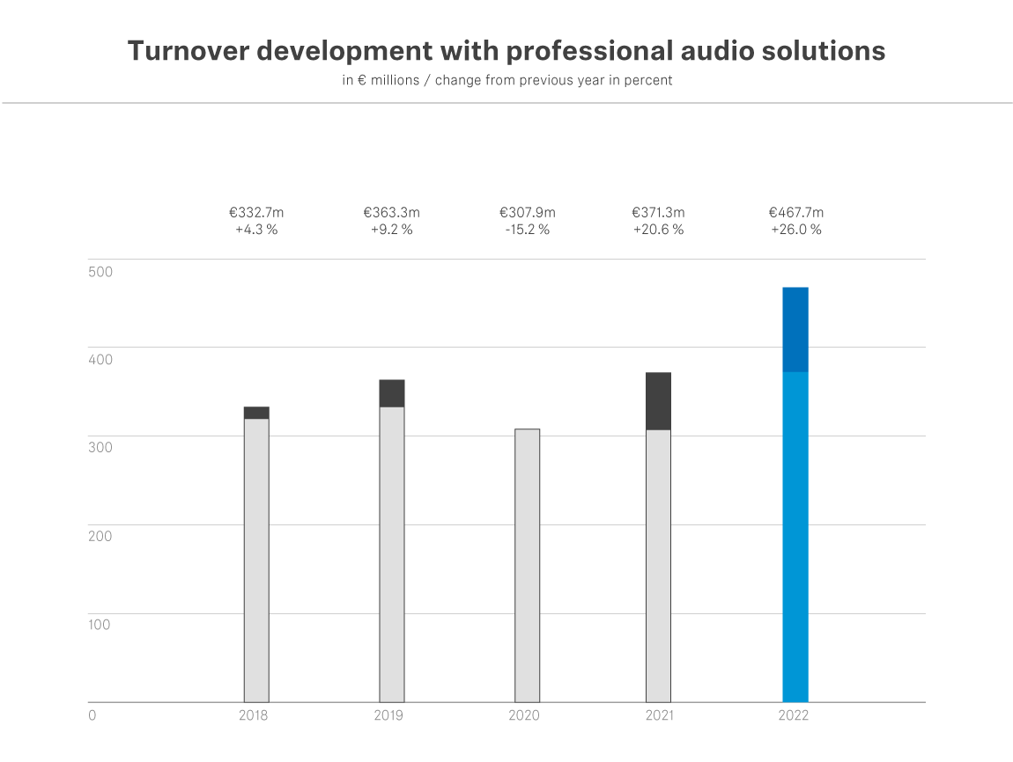
"The year 2022 has shown that the strategy we developed as a company was the right one,” says Co-CEO Daniel Sennheiser. “And it has shown us once again what our employees achieve through their competence, motivation and passion, even in challenging times. For that we are very grateful." The focus on the Professional Business has generated disproportionate growth, so that the company is expected to return to its original size more quickly than previously anticipated following the sale of the Consumer Business.
In total, the Sennheiser Group generated sales of 507.4 million euros in fiscal year 2022. The Consumer Business, which accounted for around half of total sales until 2021, was still included for two months in 2022. Total earnings amounted to 114.0 million euros before interest and taxes (EBIT). This includes special effects from the sale of the Consumer business.

Sales growth in all regions
The Sennheiser Group's sales growth was reflected in all regions. The Americas region generated a total of 177.8 million euros, making it the most dynamic market in global terms; the largest increase in sales was achieved here, at 41.1 percent. In the APAC region, sales amounted to 93.0 million euros, representing growth of 24.1 percent. The development in APAC is particularly noteworthy, as this market was most strongly characterised by the Consumer Business until it was sold. Sennheiser has maintained the Group's entire infrastructure in the region – this paid off in 2022 and led to a very positive business development in the Professional segment. Overall, the region recovered at a much slower pace due to the prolonged pandemic restrictions. EMEA remains the market with the largest sales at 196.9 million euros. Growth here was at 15.5 percent; there was a very positive development in the Business Communication area in particular in this region.
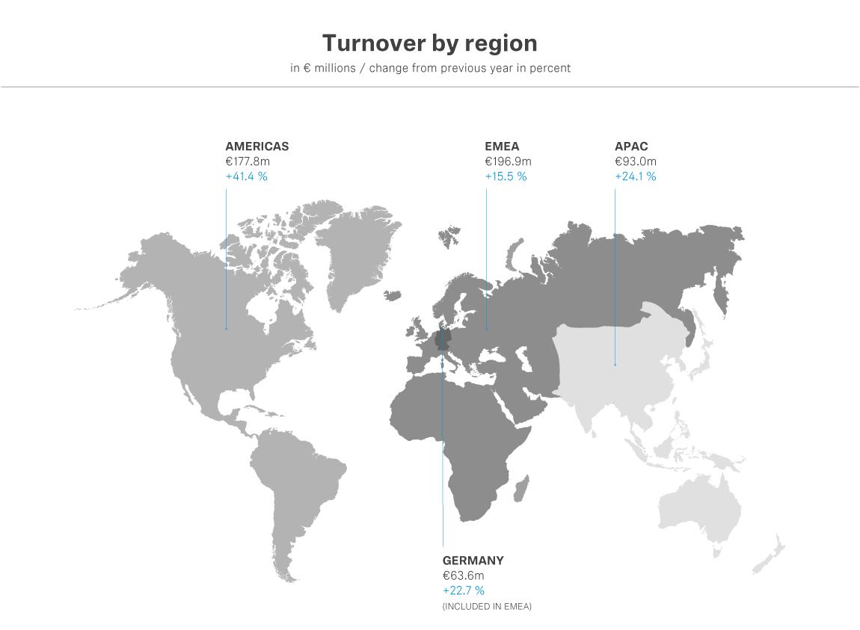

Sustainable investments in the future
"Based on our strategy, we have announced our intention to invest sustainably in the core competencies of the Sennheiser Group. Accordingly, we are building up forces and employees - especially in research and development and at our production sites," says Andreas Sennheiser, Co-CEO Sennheiser.
In 2022, the company invested a total of 41.8 million euros in research and development, which corresponds to around 8 percent of total sales. At the same time, R&D was repositioned as a central function within the Sennheiser Group, with the particular aim of being better able to develop the software portfolio and in a more effective way. Digital solutions that offer customers added value through a combination of hardware, software and services are the focus here. Research work was driven forward in the fields of artificial intelligence, cloud processing and future wireless technologies.
In parallel, the company is continuing to drive forward the conversion of its entire IT infrastructure with regard to digital business models. Here, Sennheiser has invested more than 4.5 million euros in 2022 and plans further investments in the double-digit millions in the coming years. With the aim of placing the customer even more strongly in the focus of all activities, investments in the harmonisation of the ERP landscape, the development of a Group-wide data architecture and the implementation of an agile Service Organisation are on the agenda.
The Sennheiser Group countered the uncertainties arising from geopolitical developments by investing in its supply chain. "We have constantly developed our supply chains and continuously expanded our own production capacities. This enabled us to be a reliable partner for our customers despite sometimes difficult supply situations. We have been able to meet almost all requirements last fiscal year," says Co-CEO Daniel Sennheiser. Currently, the company is focusing investment on strengthening its own production sites, including at its headquarters in Wedemark and on expanding the plant in Braşov, Romania. A total of 17.8 million euros was invested in these projects in 2022. "We firmly believe that our own production offers significant strategic added value. The challenges in the global supply chains last year confirmed this approach," said co-CEO Dr. Andreas Sennheiser. "In addition, this is the best way for us to ensure the quality of our Sennheiser and Neumann products, which has always distinguished us."
One emerging business area is Sennheiser Mobility. "With the increasing importance of electromobility, we are also positioning ourselves as a company in the automotive sector. Our goal: to play a decisive role in shaping the audio experiences of the future in this space," says Dr. Andreas Sennheiser. "Specifically, we see potential in the interaction between the AMBEO immersive audio technology and the Business Communication area: because in the future, the vehicle will also increasingly become the communication center for virtual meetings."
Co-CEO Daniel Sennheiser sets clear premises for the future: "To shape the future of the audio industry, we need the best team in the business. That's why we are continuously investing in our team." Andreas Sennheiser adds: "After all, all the products and services we offer our customers are based on the knowledge, experience and passion of our employees."

About the Sennheiser Group

Building the future of audio and creating unique sound experiences for our customers - this is the aspiration that unites the employees of the Sennheiser Group worldwide. The independent family-owned company Sennheiser was founded in 1945. Today, it is managed in the third generation by Dr. Andreas Sennheiser and Daniel Sennheiser and is one of the leading manufacturers in the field of professional audio technology.

sennheiser.com | neumann.com | dear-reality.com | merging.com

Press Contact
Sennheiser electronic GmbH & Co. KG
Mareike Oer
Corporate Communications & Brand
T +49 (0)5130 600-1719
mareike.oer@sennheiser.com

