Masters of Audio: RME Invites NAMM Attendees to ‘Learn from the Masters’ Through Performances, Dialog with Top Tier Musicians and Audio Professionals
Hollywood film composer Adam Barber, premier metal guitarist Michael Batio and pop star Andy Grammer’s FOH team will all present at RME’s booth — providing guidance on audio tools
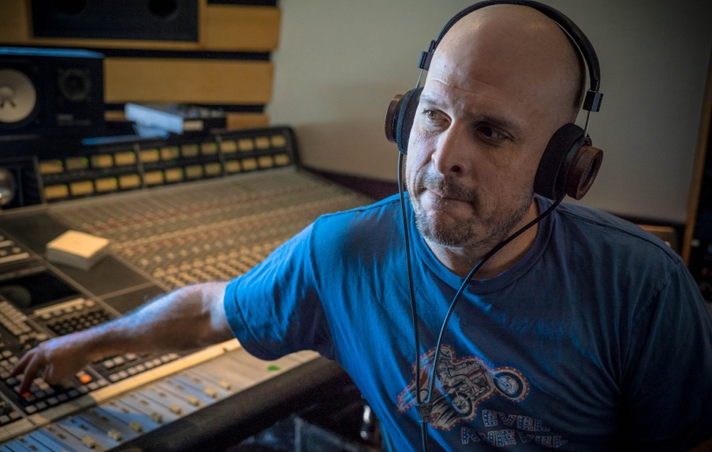
Anaheim, California, December 20, 2018 – Premium German interface manufacturer RME is pulling out all the stops at this year’s NAMM Show, hosting appearances at its booth 14702 every hour by a range of top audio professionals and musicians who are shaping the future of their respective disciplines. Appearances will include film composer Adam Barber, Andy Grammer’s FOH team, metal guitarist Michael Batio, legendary soul artist Ellis Hall, Icelandic drumming sensation Gulli Briem, Brazilian guitarist Lari Basilio and legendary bassist Chuck Rainey with veteran drummer John Martinez.
During their half-hour time slots, each artist will guide listeners on how they use RME equipment in their day-to-day musical process. The artist will present on RME’s new in-booth stage which features a 6 x 5 panel LCD television wall. Designed to not only to entertain, these educational sessions are intended to help instruct attendees on how to get the most out of their RME gear.
“This year, we are putting a focus on helping the consumer master their audio craft with RME’s equipment by their side,” said Derek Badala, Director of Sales, Americas for Synthax, RME’s distributor. “From our AVB- and Dante-compatible interfaces to our TotalMix software and our popular Babyface Pro USB interface, RME continues to be the leader of audio networking and high-performance solutions but selecting the best unit for you is only half the battle if you aren’t getting the most out of your gear. Our NAMM artists will share their RME experience and help shed fresh light on their everyday processes and applications.”
Crash Courses on RME Audio, Each Day of NAMM
A film composer for major motion pictures, including the 2014 horror film Last Shift and 2018’s London Fields, Adam Barber will explain how he uses RME’s TotalMix software in his score work Thursday, Friday and Saturday of the show at 10:30 a.m. Heavy metal guitarist Michael Batio will perform each day of the show at 11:30 a.m. while also explaining how using the Babyface Pro has helped him build tracks with low latency on albums in his personal recording studio.
At 12:30 p.m. every day of the show, Icelandic drummer Gulli Briem will perform through an Yamaha electronic kit while sharing how he uses Octamic XTC and TotalMix FX in the studio. The ‘Ambassador of Soul’ himself Ellis Hall will perform alongside a Babyface Pro at 1:30 p.m. Thursday–Saturday, while Andy’s Grammer’s FOH team will share how they have incorporated RME gear into their playback rig at 2:30 p.m. on Thursday, Friday and Saturday. Brazilian guitarist Lari Basilio will perform on Thursday–Saturday and share how RME equipment has played a major role in her recording and performing. Finally, legendary bassist Chuck Rainey and bass educator John Martinez of The Rhythm Intensive will play the booth on Sunday at 10:30 a.m. and 2:30 p.m.
Also, at 4:30 p.m. each day of the show, RME will be giving away a Babyface Pro For your chance to win, visit booth 14702.
For more on RME, visit rme-usa.com

About Synthax, Incorporated
Synthax Inc. is the exclusive USA distributor for RME digital audio solutions, Ferrofish advanced audio applications, myMix audio products, and ALVA cableware. We supply a nationwide network of dealers with these products for professional audio, broadcast, music industry, commercial audio, theater, military and government applications. For additional information, visit the company online at http://www.synthax.com.
Media Contacts:
Katie Kailus
Public Relations
Hummingbird Media
+1 (630) 319-5226
katie@hummingbirdmedia.com

Jeff Touzeau
Public Relations
Hummingbird Media
+1 (914) 602 2913
jeff@hummingbirdmedia.com

