Sennheiser EDUCATION Solutions
Effortless microphone management with Sennheiser Control Cockpit

Wedemark, 18 September 2019 – In the age of digital transformation, the education sector is feeling the winds of constant change as the needs of institutes and students alike evolve to take advantage of the benefits of new technology. With numerous universities and colleges using Sennheiser products and a portfolio that is perfectly customized for the educational sector, Sennheiser has recognized the importance of making the digital workflows on campus as simple and productive as possible. This is where Sennheiser Control Cockpit software is helping to change the game. With release 3.2.0 of Control Cockpit now available, it offers an intuitive, easy way to set up and manage all networked Sennheiser microphone systems such as evolution wireless G3 and G4, SpeechLine Digital Wireless and TeamConnect Ceiling 2. The easy management of campus-wide microphone systems saves IT teams’ time, cost and effort.

Sennheiser Control Cockpit software saves IT teams’ time, cost and effort, allowing them to centrally manage campus-wide microphone installations | 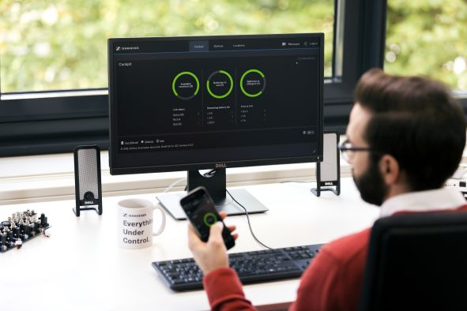

The convergence of IT and AV equipment has increasingly brought the management of AV assets into the domain of the IT department. As AV gear becomes part of the IT infrastructure, the opportunity arises to create fully digital AV management workflows. Today, the entire AV equipment of a campus can be managed via central control software, allowing for tailored workflows that increase reliability and optimize on-campus processes. This in turn helps to provide a focused learning environment.

Using optimised digital workflows, the IT team helps to provide a focused learning environment

Digital workflows on campus
“Digital workflows unlock wholly new ways of product interaction such as remote management of devices, and remote troubleshooting and support,” said Kai Tossing, Head of Product Management, Business Communication. “They shift tiresome routine tasks such as checking microphones’ battery status into the digital domain where they can be performed with greater ease and efficiency.”

The Sennheiser Control Cockpit software provides centralized monitoring and control for Sennheiser microphone systems ranging from evolution wireless G3 and G4 to SpeechLine Digital Wireless and TeamConnect Ceiling 2. The software provides IT staff with a real-time overview of all networked devices on campus, including their location and status, and is accessible from anywhere in the network on all common platforms.

To make routine procedures and workflows as convenient and efficient as possible, Sennheiser Control Cockpit offers a combination of automatic notifications, display of status information and the possibility to share responsibility and delegate tasks. Settings or firmware updates for microphones can be made remotely – as can troubleshooting, with error messages helping to identify problems and often allow for these to be rectified remotely too.

“Universities find that troubleshooting has become a lot easier,” said Kai Tossing. “When they get a phone call from a lecture hall saying that the microphone does not work it is often sufficient to take a look at the dashboard to see that the microphone has been muted or the sensitivity has been modified – things the IT staff can immediately rectify via the Control Cockpit.”

The advantages of a centralised control software are especially obvious when it comes to battery management. While “in the old days” the university’s IT staff had to visit every single lecture hall or classroom to check the battery status on each and every microphone, they now just need to take a look at the dashboard to identify all microphones with low batteries and their location.

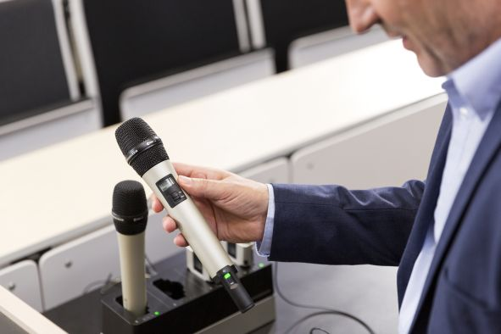 | Wireless microphone management made easy: Sennheiser Control Cockpit helps IT staff to ensure that mics are fully charged and in perfect condition

For campus-wide installations, a very helpful feature provided by Sennheiser Control Cockpit is the out-of-range detection for wireless microphones. When activated, the system administrator will be notified via e-mail and/or text when a wireless microphone leaves the range of the receiver, thereby avoiding situations where microphones get mixed up or misplaced on campus.

With the brand-new update to version 3.2.0, Sennheiser has further optimised workflows, providing graphical indication of the wireless link status, improved filtering for device types and the ability to select multiple charging units.

For more information about Sennheiser Control Cockpit and the software download, please visit www.sennheiser.com/control-cockpit-software.

To learn more about Sennheiser Education Solutions, please visit www.sennheiser.com/education.

The images included within this press release can be accessed here: http://sennheiser-brandzone.com/pincollection.jspx?collectionName={a659c16e-3e4c-456c-a8a1-8fa96da17bd7}

About Sennheiser
Shaping the future of audio and creating unique sound experiences for customers – this aim unites Sennheiser employees and partners worldwide. Founded in 1945, Sennheiser is one of the world’s leading manufacturers of headphones, loudspeakers, microphones and wireless transmission systems. Since 2013, Sennheiser has been managed by Daniel Sennheiser and Dr. Andreas Sennheiser, the third generation of the family to run the company. In 2018, the Sennheiser Group generated turnover totaling €710.7 million. www.sennheiser.com

Global Press Contact

Stephanie Schmidt
stephanie.schmidt@sennheiser.com
T +49 (5130) 600 – 1275

