Embargoed until 14 November, 10:00 a.m. CET

Reverb… Redesigned
Dear Reality releases EXOVERB, unlocking a new dimension of spatial perception in stereo productions

Düsseldorf, 14 November 2022 – Today, Dear Reality launches EXOVERB, a totally new reverb plugin that adds an as yet unheard three-dimensional depth and width perception to stereo productions. Blending the mix with the most natural reverb, the plugin offers 50 true-to-life acoustic scenes, relying on EXOVERB’s proprietary reverb engine with synthesized spatial multi-IRs. Incorporating the fundamentals of spatial hearing, EXOVERB enables enhanced control of the spatial distance perception, which will clean up the stereo mix, leaving more space for additional instruments.

EXOVERB provides 50 hand-tailored acoustic scenes in four categories (Ambiences, Rooms, Halls, and Plates), perfectly tuned for modern music production. Each preset is based on multiple synthesized impulse responses (IRs) developed with Dear Reality’s proprietary software and expertise in immersive audio. “Though spatial audio technology offers new perspectives on sound and the listener’s immersion, it is often overlooked that stereo can produce an immersive sound field with realistic depth, too – if done right,” explains Achim Fell, co-CEO of Dear Reality, adding that “with EXOVERB, we unlock this capability by applying the fundamentals of our spatial audio technology to our first pure stereo reverb plugin.”

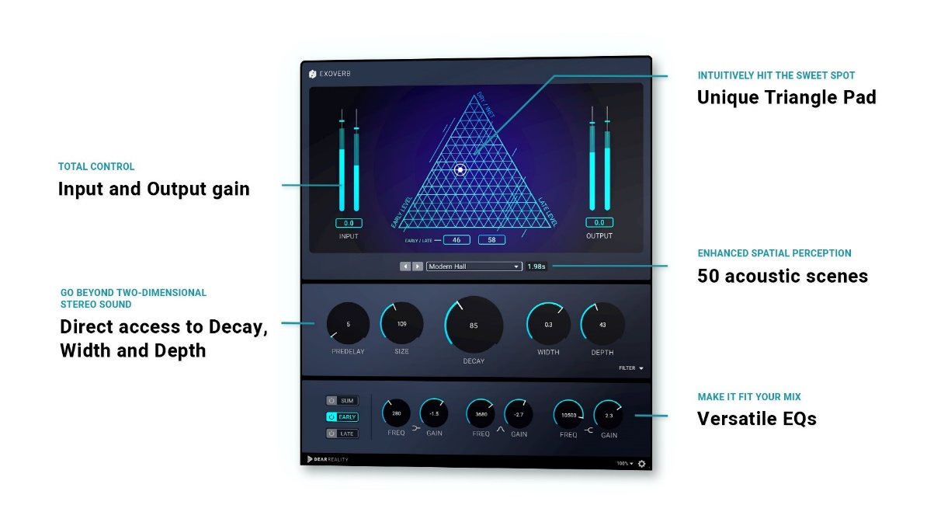
The EXOVERB user interface

In keeping with Dear Reality’s ease of use philosophy, EXOVERB features a straightforward user interface where the reverb can be perfectly adapted to the individual mix. An innovative triangle pad helps select the perfect blend of reverb, early reflections, and dry signals by setting the ratio of the early reflections and the late reverb on the x-axis and the level of dry and wet signals on the y-axis. Moreover, EXOVERB provides direct access to commonly used parameters such as Pre-Delay, Size, Decay, and Width, without the user having to dive into sub-menus as with many other reverb tools.

Speeds up the creative mixing process: EXOVERB’s innovative triangle pad lets you intuitively hit the sweet spot | 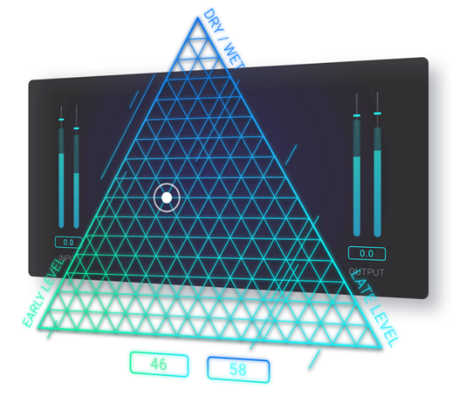

By default, EXOVERB provides a greater sense of depth with natural spatial separation. Using the Depth parameter, the front-back space of the mix can be further adjusted, thereby increasing the perception of depth in stereo mixes.

EXOVERB goes beyond two-dimensional stereo sound, relying on Dear Reality’s proprietary reverb engine with synthesized spatial multi-IRs | 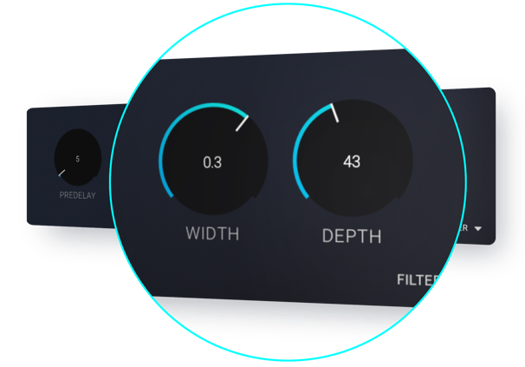

“The perception of auditory events is inseparably linked with their position in space,” explains Felix Lau, Product Owner at Dear Reality. “The fascination for this relationship between the position of sound in space and how its position is perceived and recreated by the listener’s brain is what has brought me into spatial audio in the first place. With EXOVERB, we are now making this relation in space accessible for stereo productions.”

EXOVERB glues together multitrack recordings with realistic reverb

Furthermore, EXOVERB provides three separate EQs to shape early reflections, decay, and summed signal. Each 3-band EQ includes a low-shelf, a parametric, and a high-shelf filter to get the optimal reverb sound for the mix.

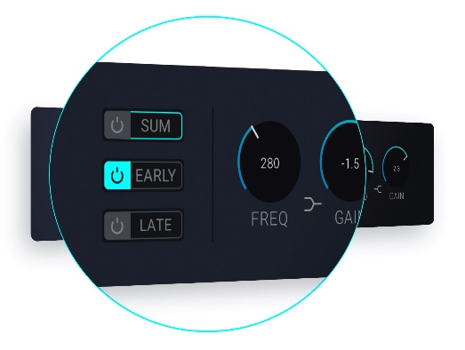 | EXOVERB offers three versatile 3-band EQs to provide maximum tonal flexibility

EXOVERB is available now in the Dear Reality store. During the introduction phase (until 30 November 2022), the plugin is available for USD 69/EUR 69/GBP 59 (+ local VAT), from 1 December, the price increases to USD 99/EUR 99/GPB 89 (+ local VAT).

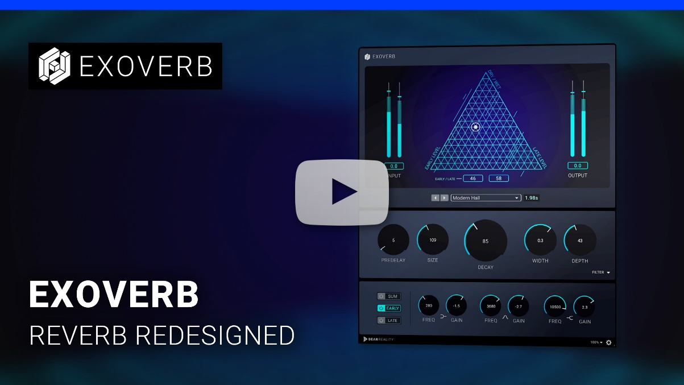
Watch the product video here.

(Ends)

The images accompanying this media release and additional photos can be downloaded here.

About Dear Reality
Dear Reality is a leading company in the field of immersive audio controllers, best known for its binaural, Ambisonics, and multichannel encoders with totally realistic room virtualization. The company’s products are used worldwide by sound engineers, sound designers, broadcasters, and musicians. Founded in 2014 by Achim Fell and Christian Sander, Dear Reality strives to deliver high-quality, cutting-edge 3D audio software for interactive and linear audio production. Since 2019, Dear Reality has been proud to be a part of the Sennheiser Group.

Global Press Contact

Kai Detlefsen
press@dear-reality.com

