Powersoft Continues its Growth and Investment in North American market

With increased regional sales presence and new service centers, company emboldens its North American infrastructure

Florence, Italy
March 18, 2019
Powersoft, the world leader in lightweight and energy efficient amplifier platforms, announced that it has fortified its sales rep and bolstered its service center network in North America. The announcement follows the opening of Powersoft’s North American headquarters, which was announced in January of last year.

“Our recent investments in our North American infrastructure reflect our continued growth in this region,” commented Luca Giorgi, General Manager, North America. “By strengthening our sales network and increasing the footprint and capabilities of our service centers, we will be able to serve our customers better and offer greater predictability.”

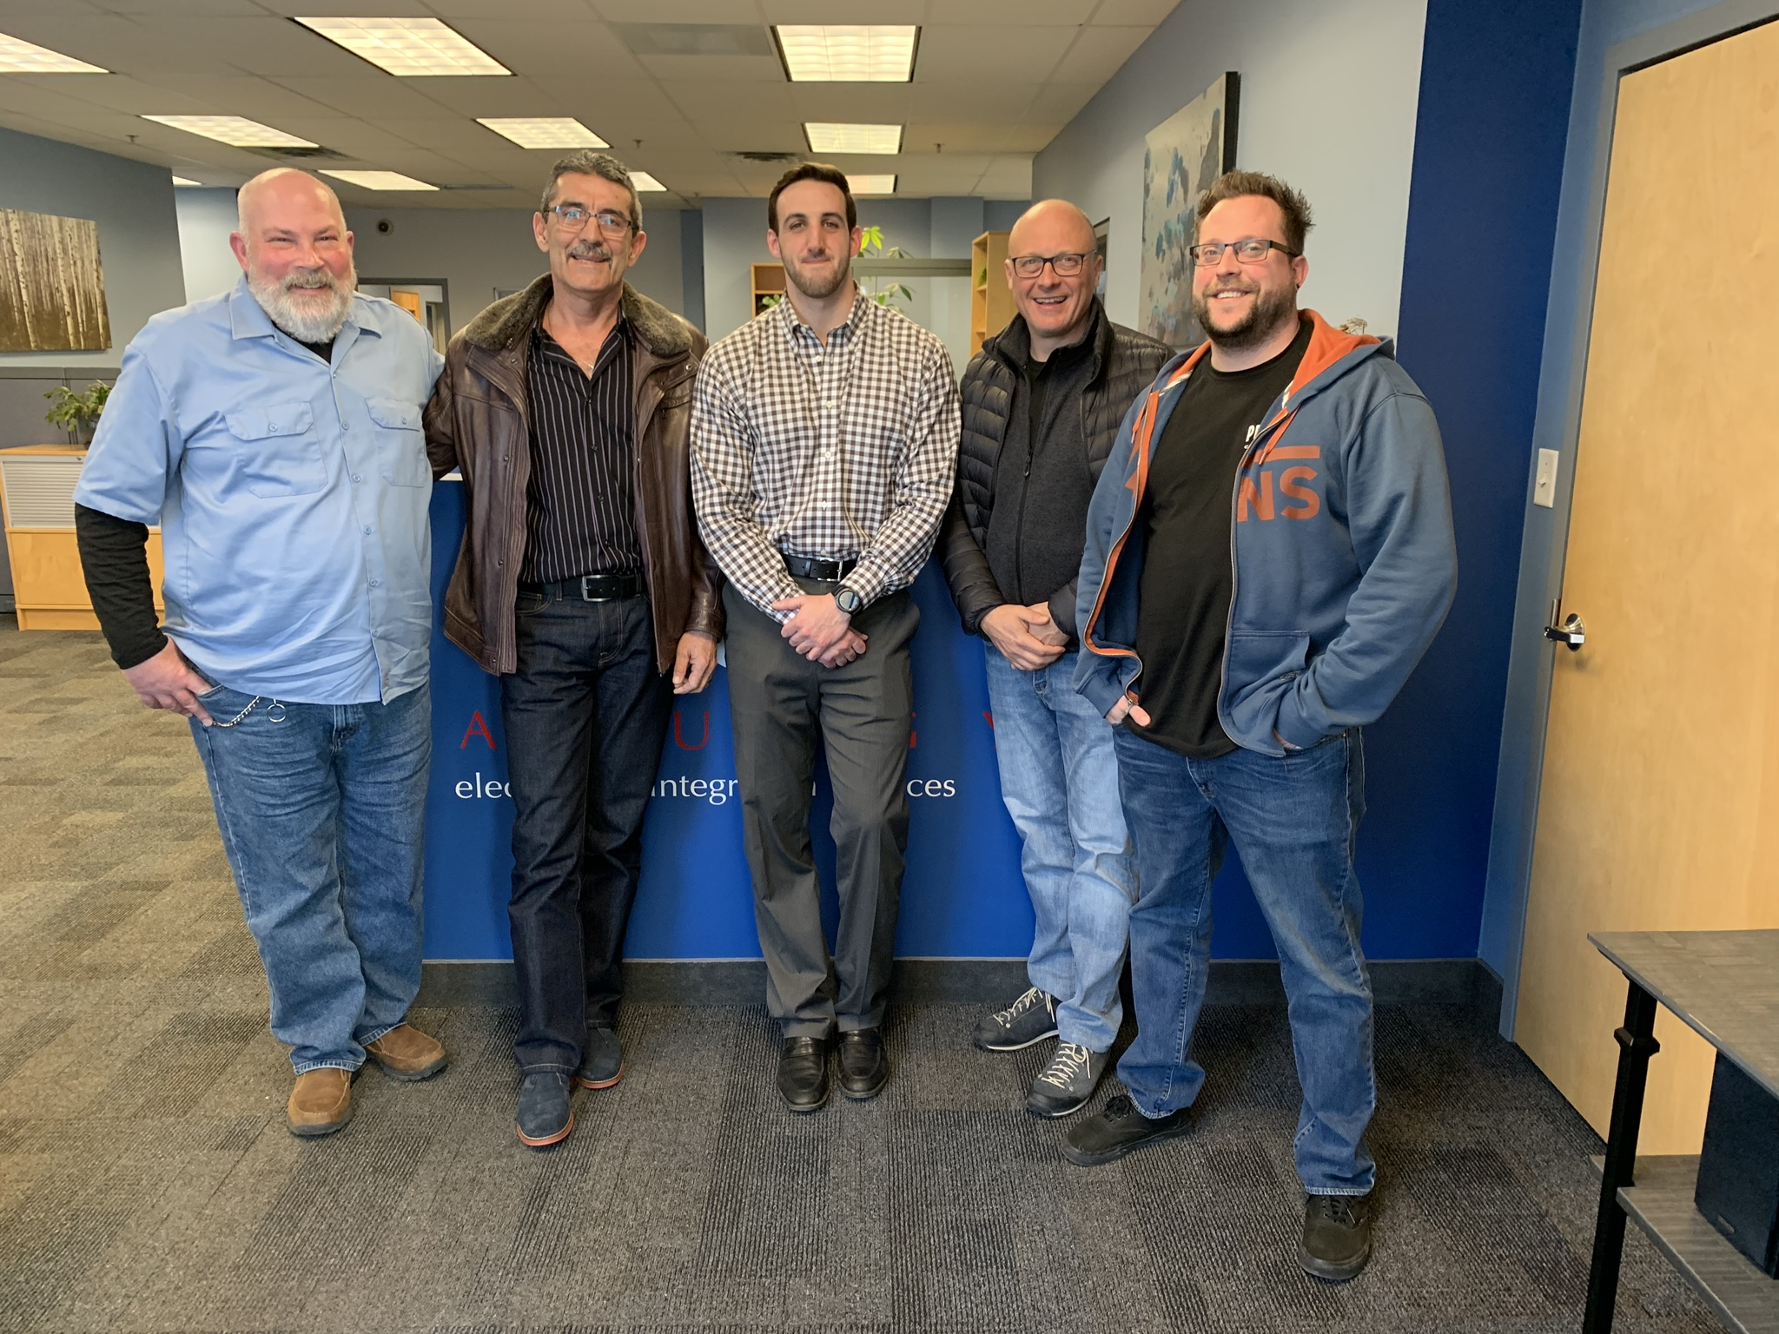
Refined and strengthened sales rep network
Recent investments in Powersoft’s North American infrastructure include the appointment of new rep firms in the Ohio Valley, New England and Upstate New York and New Jersey. McFadden Sales Inc. has been appointed to oversee the Ohio Valley region including Indiana, Michigan, Kentucky, West Virginia, western Pennsylvania and Ohio. Also, Lienau a/v associates, inc. has been appointed to provide turnkey sales services for Powersoft in the Mideast region, including Delaware, Virginia, Washington D.C., eastern Pennsylvania and upstate New York. In New England, Audio Pros will cover Maine, New Hampshire, Vermont, Massachusetts, Connecticut and Rhode Island.
The appointment of McFadden, Lienau and Audio Pros sees the leading amplifier manufacturer more than doubling its sales rep presence in these select regions, which the company sees as representing key potential growth geographies. “Our engagement of these rep firms is the result of our continuous effort to get closer to the needs of our customers. Further, we feel that each of these companies will be able to function seamlessly as an extension of our own brand, while embracing our culture and corporate values.”

New service centers create efficiency for customers
Powersoft also announced two new authorized service centers in North America – both of which will offer pre and post-sales support, testing and repair, reconditioning and full warranty service. The two new service centers, located in Rockwaway, New Jersey and Montreal Canada, add to the company’s pre-existing service center already located in Ventura, California. Both of the new service center operations have already received formal training on Powersoft’s rigorous equipment servicing and are now fully qualified to handle any equipment servicing need.

“Now that we have authorized service center locations across North America, we are able to handle customer needs more efficiently and expeditiously,” commented Luca Giorgi. “Having strategically located service centers also helps us keep a closer pulse on customer needs in different regions. This is all part of our strategy of becoming closer to our customers.”

Photo caption: From left: Mr. John Graziano (PanurgyOEM Service manager), Eugene Pope (Erikson Audio Canada Service manager), Mark Palumbo (PanurgyOEM Director of business development), Marco Mannucci (Powersoft Customer Care & Tech. Assistance Manager), Rick Woida (Powersoft US application engineer)

For further information

Francesco Fanicchi  POWERSOFT FIRENZE  francesco.fanicchi@powersoft.com  +39 346 9719798 | Jeff Touzeauy  Hummingbird Media  jeff@hummingbirdmedia.com  +1 (914) 602-2913

ABOUT POWERSOFT:
Powersoft is the world leader in lightweight, high power, single rack space, energy efficient amplifiers for the professional audio market. Founded in Italy in 1995, headquartered in Florence, Italy, with offices in Camarillo, CA, Powersoft couples the experience and precision of its production department with exceptional components to deliver products with perfect audio response and high-performance reliability. Its state-of-the-art amplifiers can be found in an array of markets, ranging from stadiums, sporting arenas, theme parks, performance venues and airports to convention centers, churches, and clubs, and are used by the world's leading tour sound companies. For more information, visit the Powersoft website: www.powersoft.com

