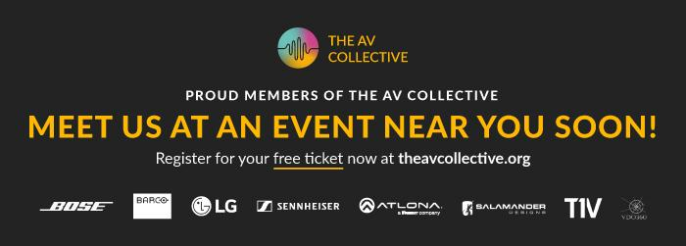

Sennheiser Joins Other Industry Leaders to Showcase the Latest AV Innovations During The AV Collective Roadshow 2022

Roadshow kicks-off in Toronto on July 14

Wedemark, July 11, 2022 – Sennheiser, the first choice for advanced audio technology that makes collaboration and learning easier, will be on the road this summer visiting cities around the world to meet with consultants, customers and integrators and share its business communications product portfolio. Along with some of its key partners and fellow AV Collective members, Sennheiser will make stops during the roadshow in the following cities:

- July 14 - Toronto
- July 21 - San Jose/Bay Area
- July 28 - New York
- August 4 - Chicago
- August 18 - Washington DC
- September 20 - London
- September 22 - Dublin
- October 20 - Leeds

Equipped at each stop with some of its most innovative products, including the TeamConnect Ceiling 2 beamforming microphone with TruVoiceLift and the TeamConnect Intelligent Speaker certified for Microsoft Teams Rooms, Sennheiser representatives will be ready to explain and how these and the rest of its business communications products can exceed your evolving AV needs.

The AV Collective was formed by a complementary group of AV manufacturers passionate about helping end-users deliver quality audio-visual content, whether you´re in the same room or the other side of the planet.

Register for a free ticket at one of the roadshow stops and spend the afternoon discussing your requirements and learning more at The AV Collective Tech Talks.

Get your free AV Collective Roadshow ticket now with code UCSEN22 at www.avcollectiveroadshow.com/events

*Limit 1 ticket per person. Registrations must be complete, and tickets must be shown upon arrival.

About the Sennheiser brand
We live and breathe audio. We are driven by the passion to create audio solutions that make a difference. Building the future of audio and bringing remarkable sound experiences to our customers – this is what the Sennheiser brand has represented for more than 75 years. While professional audio solutions such as microphones, meeting solutions, streaming technologies and monitoring systems are part of the business of Sennheiser electronic GmbH & Co. KG, the business with consumer devices such as headphones, soundbars and speech-enhanced hearables is operated by Sonova Holding AG under the license of Sennheiser.

www.sennheiser.com
www.sennheiser-hearing.com

Global Press Contact

Jeff Horan
+1 860-598-7539
jeffrey.horan@sennheiser.com

