For immediate distribution

Sounds of Summer: The Muni Amphitheater Selects Powersoft’s
Ottocanali, Duecanali Amplifier Platforms for Consistent Quality Performance
Multiple channel count, simple DSP and Dante integration
are key features for the seasonal outdoor theatre in Springfield, Illinois

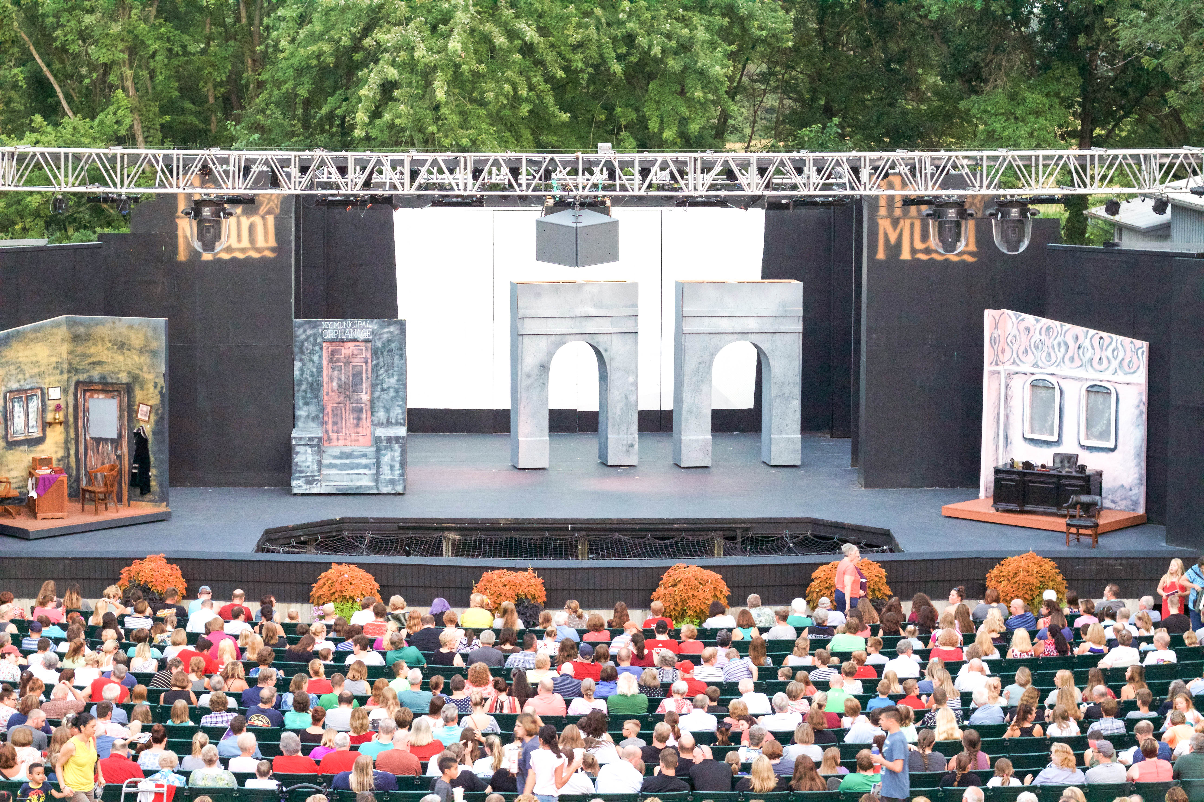
Springfield, IL, September 10, 2018 – When upgrading the sound system at The Muni, a locally revered natural amphitheatre now in its 53rd season, Trent Keeling, senior design consultant at Advanced Audio and Lighting Systems, selected two Powersoft power amplifiers — the Ottocanali 12K4 DSP+D with Dante and Duecanali 4804 DSP+D with Dante to power the outdoor systems LCR theatrical system.

An avid user of Powersoft amplifiers for the last five years, Keeling and his firm was in search for an amplifier solution that offered Dante connectivity to feed to The Muni’s upgraded Yamaha Q05 front of house console.

“I needed amplifiers that had Dante connectivity, but also filled some of the other important requirements such as quality DSP, multiple channels and power density in a small rack space,” Keeling explains. “The Ottocanali 12K4 DSP+D and Duecanali 4804 DSP+D fit the bill perfectly.”

When searching for the best amplifier solutions for The Muni’s Left-Center-Right (LCR) theatrical system, Keeling was drawn to the Ottocanali 12K4 DSP+D multiple channel count and sound quality along with the simplicity of the DSP programming of the Duecanali unit.

“The Duecanali amp’s DSP programming is very straight forward, and it offers some wonderful attributes like we’re able to control the overshoot with loudspeakers which makes up for signal loss,” explained Keeling. “We also liked the redundant analog rollover function for this application as we are not only feeding Dante, but also analog IO.”
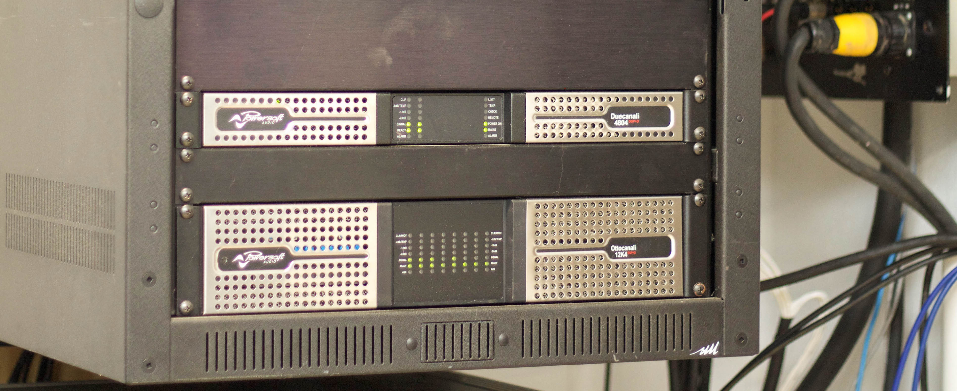
Solid Return on Investment
As a non-profit, The Muni raises funds strictly through its ticket sales, so Keeling was looking for amplifier solutions that would deliver for years to come.

“There’s obviously a few more affordable options on the market, but when performing upgrades for a non-profit venue like The Muni — where their money is precious and hard-spent — they’re looking for a return on their investment,” Keeling explained. “By using high-quality systems from Powersoft, you not only know they are going to work for years to come, but you can rest easy knowing the sound you’ll get from the amplifiers will be of the highest quality.”
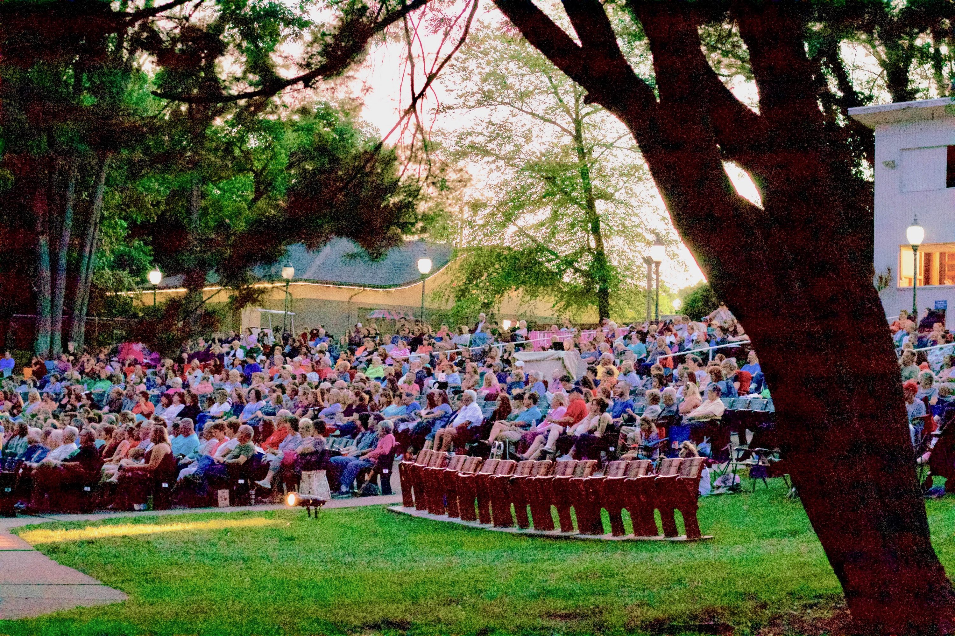
With four different production runs each summer, Keeling needed system that offered reliability night after night. “Each weekend we have a lot of people waiting to see the show, and we really have to hedge our bets on the reliability of our system,” explained Keeling. “I can’t have a show with doors at 7:00 and be like ‘Oh gosh, we have an amplifier problem.’ Reliability is key, and Powersoft affords us that.”

Quality Sound, Night After Night
In addition to reliable sound, Keeling turned to Powersoft for its unparalleled sound quality — which is critical for an outdoor performance venue. “I attribute some of the high-fidelity, high-intelligibility and musicality directly to the Powersoft amplifiers,” he said. “Quality loudspeakers benefit from quality amplification. The new coverage is very wide and very musical.”

A Storied Amphitheatre in Idyllic Surroundings
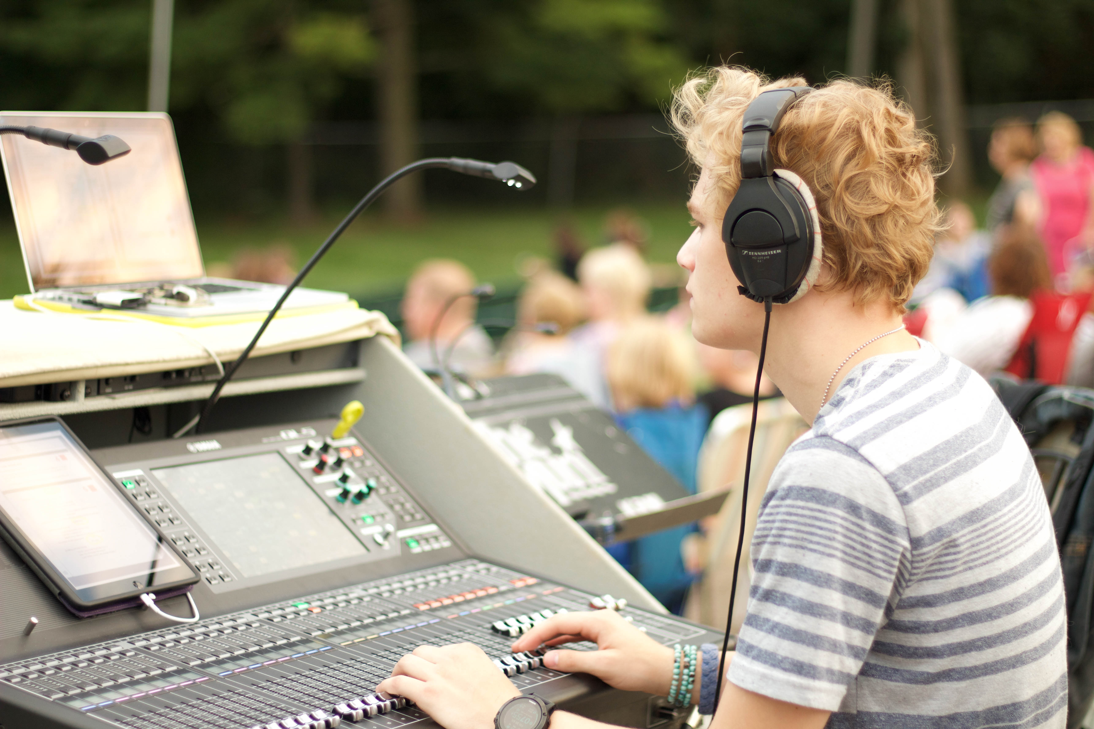
Located lakeside, The Muni amphitheatre put on live productions of “Little Shop of Horrors,” “Sister Act,” “Legally Blonde” and “Annie” this season and continues to be considered an institution in the Central Illinois community.

“It’s a really idyllic spot,” Keeling explained. “The theatre is cut into a berm and features a natural amphitheatre slope to it. It’s a great place to see a show. The level talent is really high — a lot of the members have real industry experience — so the acting and set design is very well done.

###

For further information, contact:

Jeff Touzeau (media contact)  Hummingbird Media  Tel : +1 (914) 602 2913  Email: jeff@hummingbirdmedia.com | Francesco Fanicchi  Powersoft (Florence, Italy)  Tel: +39 339 6381206  Email: francesco.fanicchi@powersoft.it

Or visit www.powersoft-audio.com
About Powersoft:
Powersoft is the world leader in lightweight, high power, single rack space, energy efficient amplifiers for the professional audio market. Founded in Italy in 1995, headquartered in Florence, Italy, with offices in New Jersey, , Powersoft couples the experience and precision of its production department with exceptional components to deliver products with perfect audio response and high-performance reliability. Its state-of-the-art amplifiers can be found in an array of markets, ranging from stadiums, sporting arenas, theme parks, performance venues and airports to convention centers, churches, and clubs, and are used by the world's leading tour sound companies. For more information, visit the Powersoft website at www.powersoft-audio.com.

