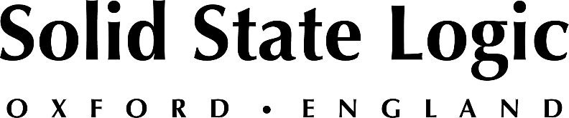

Solid State Logic Continues Expansion of its SSL Complete Subscription
with Latest Plug-In, X-Limit

X-Limit is a quick and easy way to increase the loudness of tracks, buses and masters without clipping, and is another essential tool in your SSL studio

Oxford, England, July 28, 2022 — Solid State Logic continues to expand its SSL Complete subscription offering with its latest plug-in, X-Limit. The new plug-in is available now in several formats including VST2, VST3, AAX and AU as part of the ever-growing SSL Complete subscription from $14.99 per/m (Ts&Cs apply). X-Limit is the fifth new plug-in added to the SSL Complete subscription offering in recent months.
X-Limit is an essential tool for a range of applications, including recording, mixing, mastering and live sound, given its extremely low latency performance. Producers, engineers and other content creators will appreciate its ease of use in the studio as an effective means of increasing the loudness of tracks, buses and masters — without clipping.
“We are delighted at this robust new addition to our plug-in portfolio, giving users another indispensable mixing tool that is both powerful and simple to use.” commented Jon Sandman, Plug-ins Product Manager at SSL. “Whether you are looking for extremely transparent limiting, colour and punch, or classic SSL glue, X-Limit has you covered.”
As with other SSL plug-ins, X-Limit excels at delivering concise visual feedback as well as providing a wide-ranging feature set and sonic options. The unique steering and ducking meters indicate how the limiting process might influence the stereo image of your signal and provides visual feedback on how to minimise stereo degradation while using the channel link control. Meantime, the all-in-one waveform and threshold display lets you easily set your threshold and ceiling against the incoming signal level.

Key features of the new X-Limit include:
Apple M1 Native Support: X-Gate is a universal binary, and features M1 Native support.
All-in-one visualiser: The all-in-one waveform visualiser and threshold/ceiling sliders let the user easily set parameters against the incoming signal level.
True Peak: True Peak mode engages SSL’s True Peak algorithm, ensuring that inter-sample peaks are effectively limited and providing momentary and max True Peak value readouts.
Channel Link: The Ducking and Steering meters provide intuitive visual feedback to understand the effect of limiting on the stereo, helping guide users towards the ideal amount of channel linking for minimum stereo degradation.
Styles function: Users can pick from four carefully designed limiter characteristics, including Transparent, Glue, Punch and Auto, allowing quick but versatile options for any occasion.
Gain Lock: Allows uses to easily lock the applied gain to quickly demo different presets and styles for any given source material.
Mix Control: When using the limiter to add punch rather than catch peaks, the Mix control enables users to dial back the effect.
Along with the SSL Complete subscription, X-Limit will also be available at a cost of $99 (ONLY $69 until August 28th).
For more information on the SSL X-Limit plug-in, please visit: https://store.solidstatelogic.com/

Solid State Logic is the world’s leading manufacturer of analogue and digital audio consoles and provider of creative tools for music, broadcast, live and post production professionals. For more information about our award-winning products, please visit: www.solidstatelogic.com.

###
For further information contact:
Jeff Touzeau
+1 (914) 602-2913
jeff@hummingbirdmedia.com

Ross Gilbert
+44 (0) 1865 842300
rossg@solidstatelogic.com

