The Murcian barber Salvador Oliver reaches for the second time in a row the final of the International Visionary Awards, one of the most important hairdressing awards in the world
The International Visionary Awards are one of the most important and demanding creative hairdressing competitions in the world. Held in London for 39 years, they aim to discover and recognize the most talented hairdressers and barbers of the world.

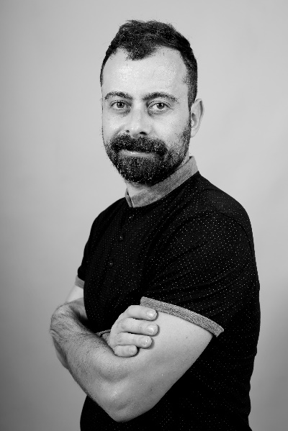
The barber Salvador Oliver, director of "La Barbería de Oliver", located in Fuente Álamo (Murcia), has managed to reach the final for the second consecutive time of one of the most prestigious milestones of the international hairdressing in the sector.
The International Visionary Awards were born to discover new talents to the world and are held during the great show of creative hairdressing Alternative Hair Show (London), created by Tony Rizzo. These awards have three categories, and in Best Male Collection the Murcian barber can obtain the highest award with his collection 'Égalité' (2021), inspired by "how human beings have achieved their rights in search for equality».

"The first virtual show of 2020 allowed Alternative Hair to reach an unprecedented global audience to share the skills of some of the best artistic hairdressers in the world, as well as fundraising for the Alternative Hair: Fighting Leukemia charity," the organization says.

On Saturday, October 9, the public will be able to watch the finals of the International Visionary Award, a competition created by Alternative Hair President Anthony Mascolo. An appointment that foreshadows thousands of viewers from all around the world.

Salvador Oliver started in creative hairdressing in 2013, when he decided to take the next step, fitting the “wisdom he had acquired like a puzzle” and thus being able to seek a greater national and international "caché’’. It is clear that our country enjoys a prominent position. According to Salvador, "in the last 10 years it has been shown that we have a very high level here, making us one of the best delegations in the world." In this edition, Spain will be represented by 29 finalist candidates spread throughout the country. Salvador Oliver aspires to get "the first place", though he does not forget that "it is super complicated", taking into account that "there are participants who have been international for many years" and "being in a field in which experience plays a very important role’’.

ABOUT SALVADOR OLIVER

Salvador Oliver runs La Barbería de Oliver, which follows the tradition inherited by his father combined with the latest trends and techniques in the sector. Passion for the profession runs in the family, his father founded this barber shop in 1969 on Calle San José de Fuente Álamo (Murcia) to move it in 1981 to Calle Onésimo Redondo, now Calle Ganaderos.

In 2000 he began doing internships in the family salon and training at the Dambell Academy in Murcia, which he finished in 2001. Since 2005 he has been the director of the salon and in 2014, he inaugurated a new stage in the barbershop changing the name to La Barbería de Oliver. But he also combines work in the barbershop with teaching. Thus, he is a professor at Nefer Center (Official Private Center of the Ministry of Education) and has collaborated with several of the most important brands in the world such as American Crew or Proraso giving training. Likewise, he is a Spanish ambassador for Matakki Scissors since 2019, he is also part of the artistic education team of Barberos 3.0, which only has five stylists in Spain, he is a member of the national and international technical-artistic team of Tahe and gives training in different schools of professional hairdressing. Salvador Oliver is a member of Club Fígaro, the most prestigious association in the Spanish creative hairdressing sector.

As a result of the recognition received from his fellow professionals, he has been hired by several of the most prestigious hairdressing firms in our country such as Olga García Estilistas, Salón Blue by Raquel Saiz and Centro Beta by Gonzalo Zarauza.

He was nominated for Best Male Collection at the 2018 TCT Awards, international hairdressing awards. The stylist continues to develop his career with enormous success, creating men's collections that occupy the front pages of the professional press and with publications of collections both nationally and internationally. In addition, La Barbería de Oliver was selected as the barber of the month by Peluquerías Magazine.

In 2020 and 2021 he has been selected as a finalist in the prestigious International Visionary Awards in the Men’s category.

