Sounds of Summer
Tune in to the best of the Great British summer with Sennheiser

Marlow, UK, 18 June 2020 – The first day of summer kicks off in a couple of days! With sunnier days on the forecast, unleash the sound of the season with the latest wireless over-ear headphones and earbuds from Sennheiser.
There's a soundtrack for every activity - whether it's walks to soak up the sun or kicking back and relaxing in the park. Sennheiser has compiled a list of its latest headphones so you can enjoy your favourite tunes this summer:
MOMENTUM True Wireless 2 (£279 RRP)

Stereo-quality sound, 28 hours of battery life, Active Noise Cancellation and customisable touch controls combine for the ultimate on-the-go audiophile experience this summer. Available via Sennheiser.com.

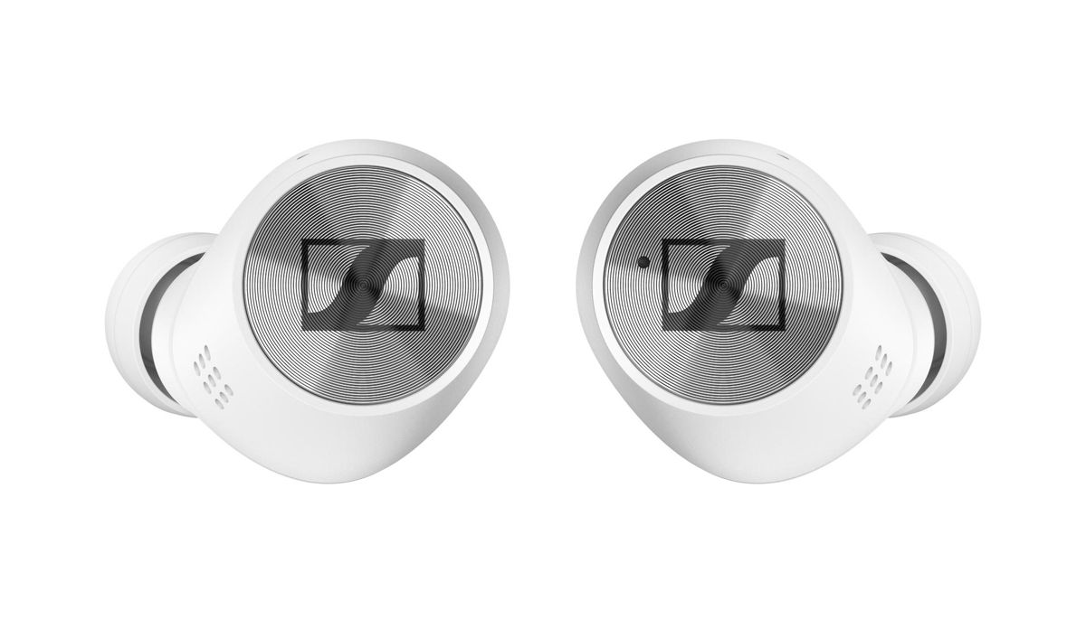
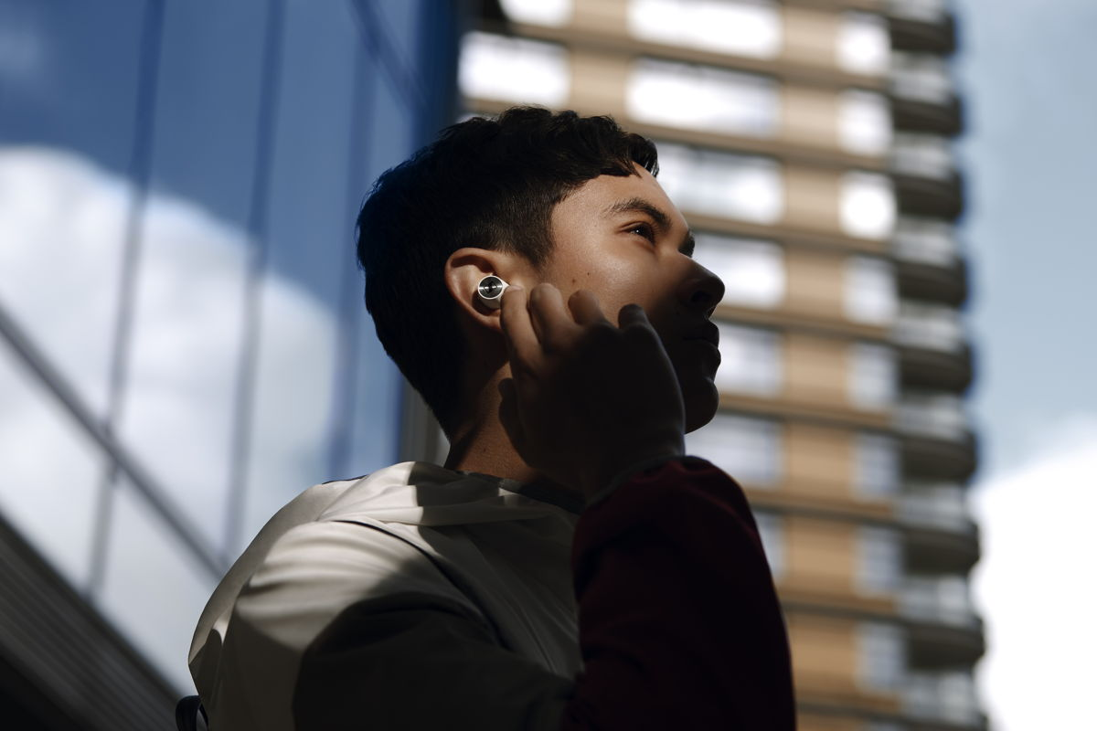

HD 450BT (£159.99 RRP)
Dial up the bass this summer with Sennheiser's HD 450BT. Delivering 30 hours of battery life, Active Noise Cancellation and customisable sound via Sennheiser's Smart Control App, you'll be reaching for them all summer long, and beyond. Available via Sennheiser.com.
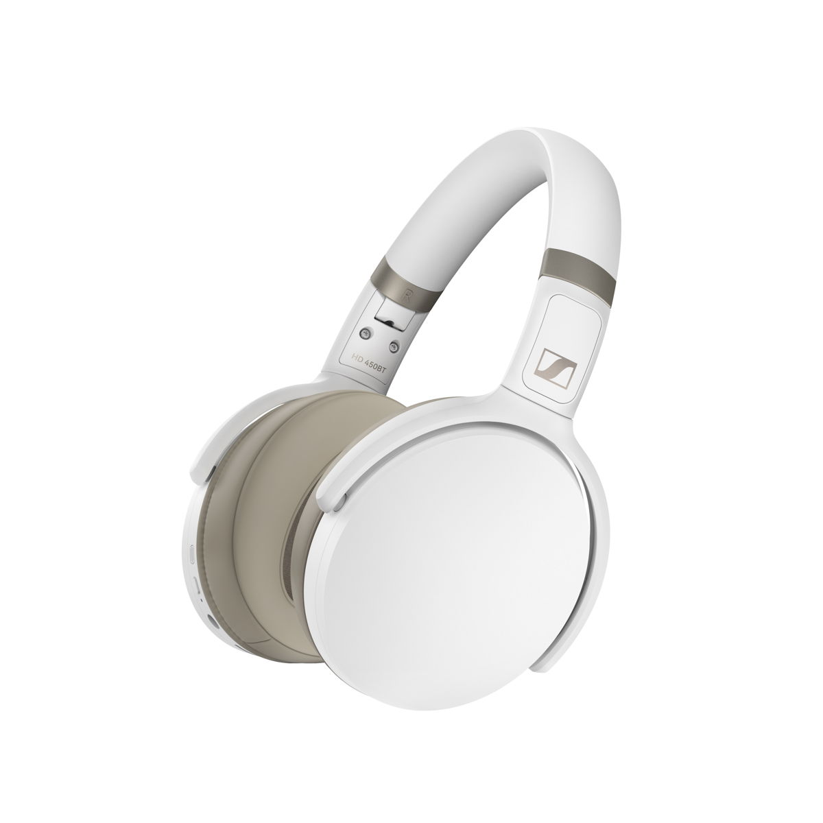

MOMENTUM Wireless (£349 RRP)

A premium finish in a sophisticated form factor, the MOMENTUM Wireless offer superior sound. For a limited time only, enjoy a free six month subscription to Tidal Premium with purchase - while supplies last. Details here.

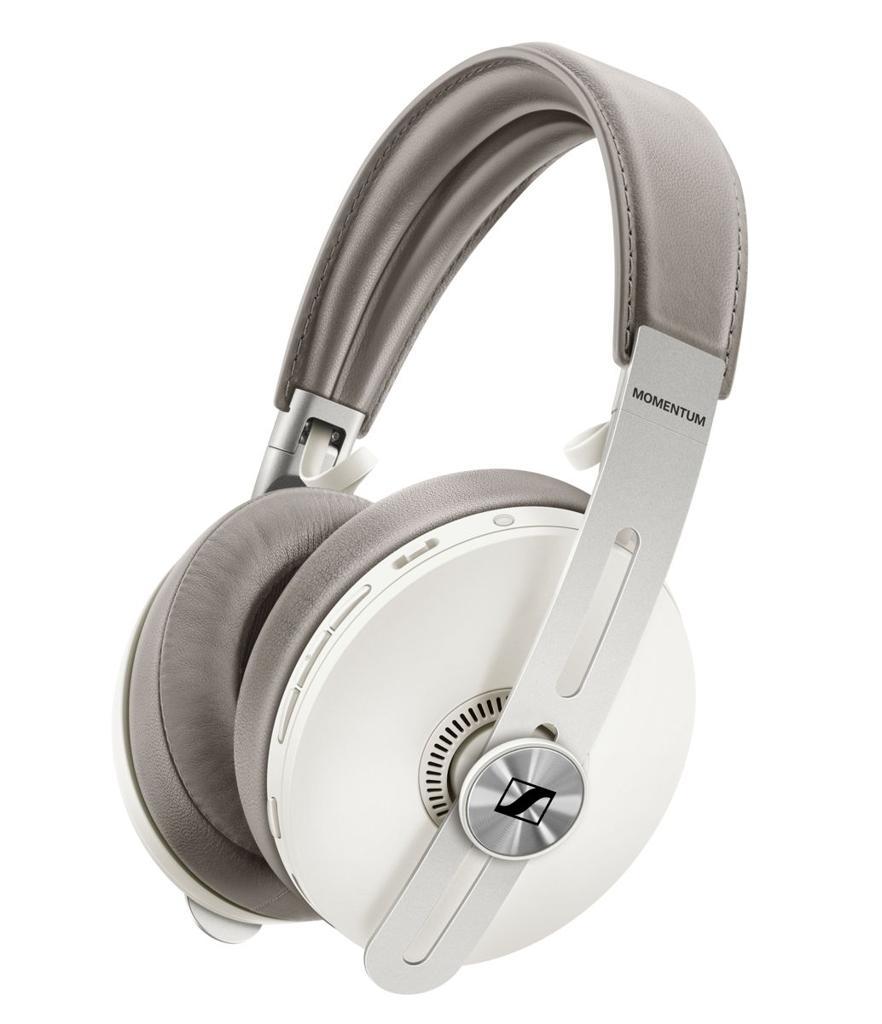
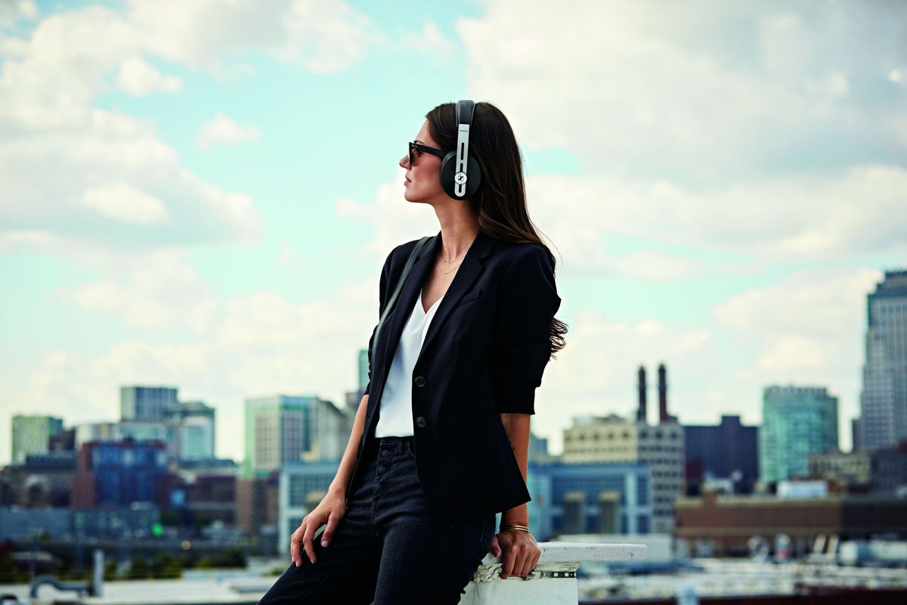

About Sennheiser
Founded in 1945, Sennheiser is celebrating its 75th anniversary this year. Shaping the future of audio and creating unique sound experiences for customers – this aim unites Sennheiser employees and partners worldwide. The independent family company, which is managed in the third generation by Dr. Andreas Sennheiser and Daniel Sennheiser, is today one of the world’s leading manufacturers of headphones, loudspeakers, microphones and wireless transmission systems. In 2018, the Sennheiser Group generated turnover totaling €710.7 million. www.sennheiser.com

Press Contact

Maik Robbe
maik.robbe@sennheiser.com
+44 (0) 7393 462484

