HAMILTON Tour Turns to PK Sound’s Gravity 30 Subwoofers, Harnessing Powersoft M-Force

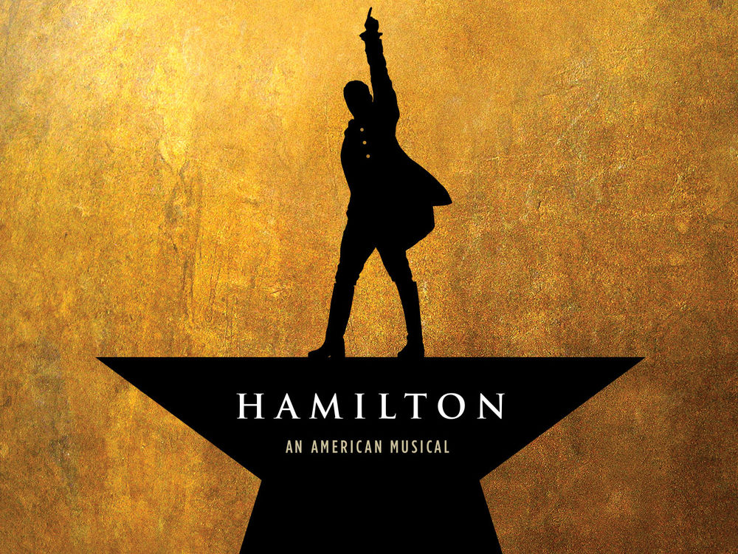

HAMILTON is one of the most successful productions to hit Broadway since Phantom of the Opera. Blending American history with hip-hop and the magic of live theater, the Pulitzer and Tony award-winning musical is now taking the Broadway smash hit across North America and overseas. Thanks to the powerful low-end sound reinforcement of PK Sound’s Gravity 30 subwoofers, featuring Powersoft's cutting-edge M-Force amplification technology, fans of the runaway hit will get to feel all the magic of the Broadway version of HAMILTON.

Broadway sound designer and Tony Award nominee, Nevin Steinberg, is intimately familiar with the challenges of moving a production from venue to venue while retaining peak sound performance. That is why he turned to the unique Gravity 30, M-Force subwoofer: to provide a visceral and totally unique experience.

"On a tour, agility and adaptability are paramount. Any show that is moving over just a couple of days and has to deliver a perfect opening night performance in a new venue every few weeks must be able to solve a wide array of challenges. For theater shows anywhere, but especially on tour, subwoofer real estate is very limited, so having a compact and efficient low-frequency delivery system like the Gravity 30 with Powersoft M-Force technology is incredibly helpful.", says Steinberg.

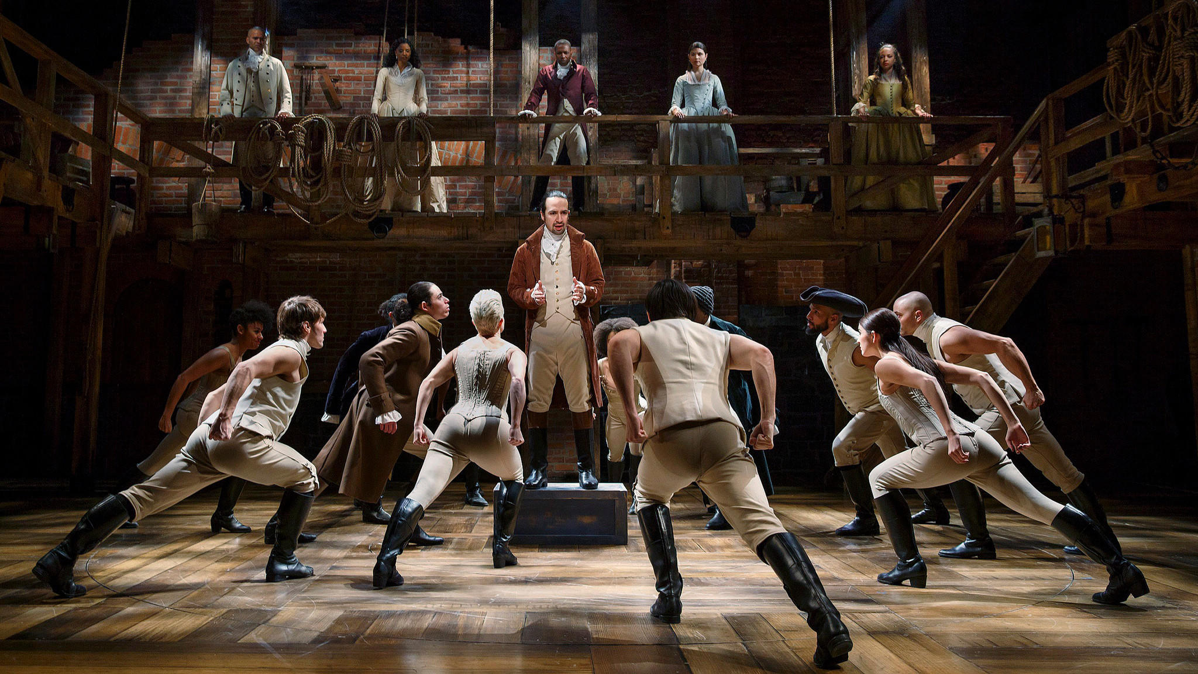

With portability considerations in mind, PK Sound worked to decrease the weight and dimensions of the Gravity 30 while maintaining powerful, transparent sound across the frequency spectrum. The finished subwoofer leverages superior cabinet design and the unique technology of Powersoft’s compact M-Force motor to achieve a remarkable output to size ratio. This made the Gravity 30 an easy choice for Steinberg, who chose to be the first to debut the tour-ready Gravity 30 subwoofers on the HAMILTON tour.

"I like how compact the subs are—and how the package just covers our needs without additional equipment. On previous productions of HAMILTON and on some of my other Broadway productions I use a collection of subwoofers to do the job. For the HAMILTON tour I’ve been able to rely solely on the Gravity 30."

PK Sound and Powersoft spent 3 years unifying and perfecting the technology required to produce a subwoofer with superior power and efficiency. M-Force Technology includes an innovative transducer based on a patented moving magnet, linear motor structure. This technology provides exceptional performance in power handling, electromagnetic conversion, operational reliability and maximum SPL, when compared to conventional moving coil systems.

“We worked very closely with Powersoft over the past 3 years to refine and perfect the Gravity 30. During that journey we’d built nearly every possible configuration that one can dream up, all in pursuit of a beautiful sounding subwoofer. We couldn't have done that without Powersoft - we are exceptionally pleased with the results in our Gravity 30 subwoofer.”, says PK Sound President and CEO, Jeremy Bridge.

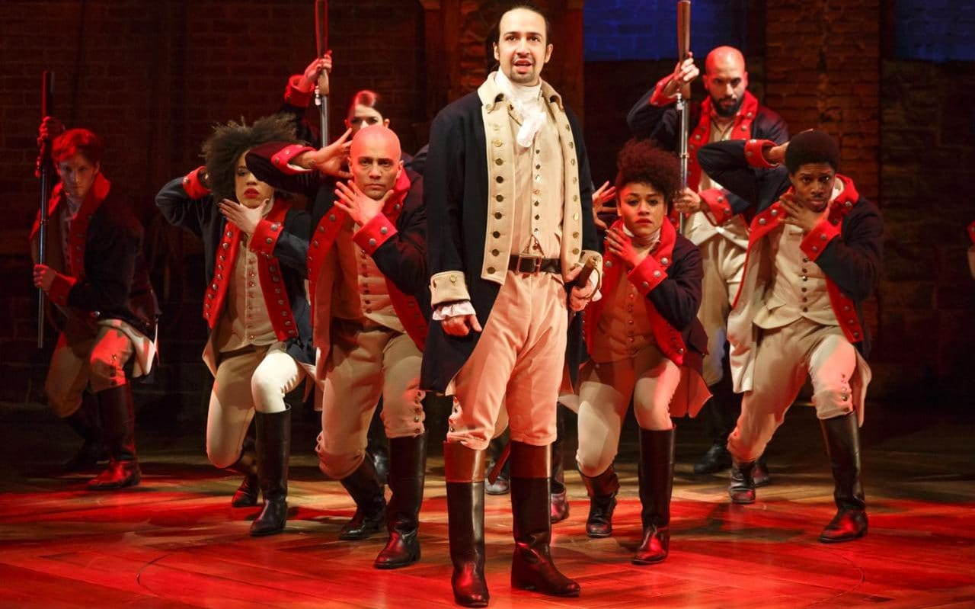

For a theatrical production of this magnitude, Steinberg and his team sought to make the experience as immersive as possible, maximizing audience engagement. The deep, articulate low-end provides the extra impact that brings audiences into the story and keeps them on the edges of their seats.

"HAMILTON produces an atypical amount of low-frequency information for a theater event. Everything from cannon fire to deep dance floor sweeps, to drum machine kick drums. The Gravity 30 is capable of delivering everything cleanly and effortlessly, from the transients down through the extreme low-end treats.", says Steinberg.

HAMILTON has successfully completed a sold-out run in San Francisco and Los Angeles that continued through December 30 is currently playing in London as well. The U.S. tour has only just begun and anyone eager to experience the blockbuster show coupled with PK Sound's new Gravity 30 high power subwoofers, can check out upcoming tour dates here.

"It was a great success in San Francisco, and since then that company has also settled into a very smooth run in Los Angeles. The show looks great on the West Coast, and there’s so much excitement for the production.", says Steinberg.

As the HAMILTON tour continues to excite audiences around the US, additional PK Sound Gravity 30 subwoofers have been specified for the tour’s UK leg, ensuring premium low-end for the next incarnation of this memorable theater experience.

To learn more about Gravity 30 visit PK Sound's product page here.

To learn more about Powersoft, please visit http://www.powersoft-audio.com/

