Manuel Mon wins International Hairstylist at the Contessa Awards

The Spanish hairdresser has captivated the jury who chose him the winner of the Contessa Awards in the International Hairstylist category. These are the most relevant creative hairdressing awards in Canada and one of the most rigorous on the planet in terms of the quality of the work presented.

The merit is extraordinary, since these award the highest excellence among the best hairdressers in the world, and also because it is the first time that a Spanish hairdresser has won. The proof is that prestigious professionals such as Mark Lesson (UK), Danny Pato (NZ), Joey Scandizzo (AUS) or Uros Mikic (AUS) have received this award.
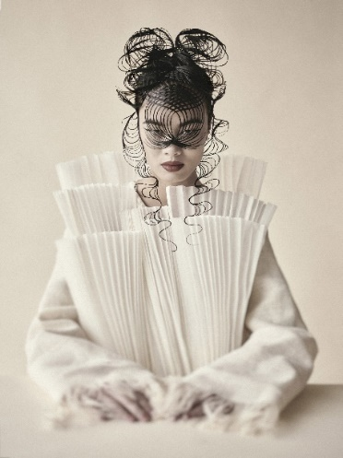
Canadian hairdressing leads the industry due to the high level of its hairdressers, as evidenced by these awards, which can only be entered by professionals with great technical and creative mastery. With "Origami" collection, the same with which he won the most important award of Spanish hairdressing, the Fígaro Awards, a few days ago in the ‘’Avant-garde’’ category, he stands as a brand new winner in the "International Hairstylist" category in Canada.

Manuel Mon has once again shown that he is one of the best in the world. For years he has been acclaimed in Spain for taking Spanish hairdressing to heights never achieved before. Now his enormous talent is once again recognized internationally, establishing him as one of the most influential professionals on the planet. He is a technical master who defies all the physical limits of hair, yet at the same time a creative capable of creating amazing images of an elegant and subtle beauty that he always moves.

This new recognition highlights the enormous talent that Manuel Mon has shown throughout his career and that now makes him the world leader in hairdressing.

Discover here the winning collection, ORIGAMI.

