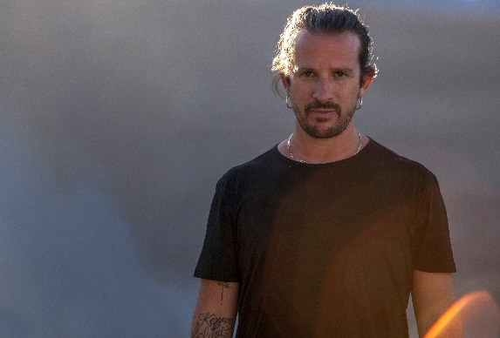

#DontStopTheMusic

Don’t forget to tune in! No matter where you’re staying in, the music will still come to you

Wedemark/Germany, April 20, 2020 – Sennheiser’s #DontStopTheMusic series continues with superstar DJ Luciano, Mambo Brothers, Wingenfelder and many more – all playing live from different parts of the world via @sennheiser on Instagram. Here are all the performance dates until the end of the month.

Live concert streams from Tuesday, April 21 to Thursday, April 30
Please follow @sennheiser on Instagram and switch on notifications in IGTV to receive alerts, as dates and artists may be subject to change at short notice.
- Luciano (@magikluciano):
Tuesday, April 21 at 16:00 UTC (12:00 New York time, 18:00 Berlin time)
- Mambo Brothers (@mambobrothers):
Tuesday, April 21 at 18:00 UTC (14:00 New York time, 20:00 Berlin time)
- Wingenfelder (@wingenfelder):
Wednesday, April 22 at 17:00 UTC (13:00 New York time, 19:00 Berlin time)
- Tom Pointer (@tompointermusic):
Wednesday, April 22 at 18:00 UTC (14:00 New York time, 20:00 Berlin time)
- Hämatom (@haematommusic):
Thursday, April 23 at 17:00 UTC (13:00 New York time, 19:00 Berlin time)
- Andro (@androearth):
Thursday, April 23 at 18:00 UTC (14:00 New York time, 20:00 Berlin time)
- Kevin Devine (@kevinpdevine):
Thursday, April 23 at 20:00 UTC (16:00 New York time, 22:00 Berlin time)
- DJ Deepak (Deepak Prashad) (@dee_prashad):
Friday, April 24 at 14:00 UTC (10:00 New York time, 16:00 Berlin time)
- Beyond the Black (@beyondtheblack_official):
Friday, April 24 at at 17:00 UTC (13:00 New York time, 19:00 Berlin time)
- Reece Lemonius (@reecelemonius):
Friday, April 24 at 18:00 UTC (14:00 New York time, 20:00 Berlin time)
- Banjaara (@banjaaralive):
Monday, April 27 at 16:00 UTC (12:00 New York time, 18:00 Berlin time)
- Jetty Bones (@jettybones):
Monday, April 27 at 19:00 UTC (15:00 New York time, 21:00 Berlin time)
- DJ Chris Wright & DJ Chris Metcalfe (@djchriswright) (@chrismetcalfemusic):
Tuesday, April 28 at 14:00 UTC (18:00 Gulf Standard Time, 10:00 New York time, 16:00 Berlin time)
- Schimmerling (@schimmerlingmusik):
Wednesday, April 29 at 17:00 UTC (13:00 New York time, 19:00 Berlin time)
- Remo Drive (@remodrivemn):
Wednesday, April 29 at 19:00 UTC (15:00 New York time, 21:00 Berlin time)
- MYLE (@i_am_myle):
Thursday, April 30 at 14:00 UTC (10:00 New York time, 16:00 Berlin time)
- faemmusic (@faemmusic):
Thursday, April 30 at 17:00 UTC (13:00 New York time, 19:00 Berlin time)

* A note on the time zones
The concert times are given in Coordinated Universal Time (UTC), with EDT and CEST added for convenience. EDT is short for Eastern Daylight Time, which is four hours behind Coordinated Universal Time. EDT is the time in New York, for example. CEST is Central European Summer Time, which is two hours ahead of UTC – Berlin or Wedemark time, for example.

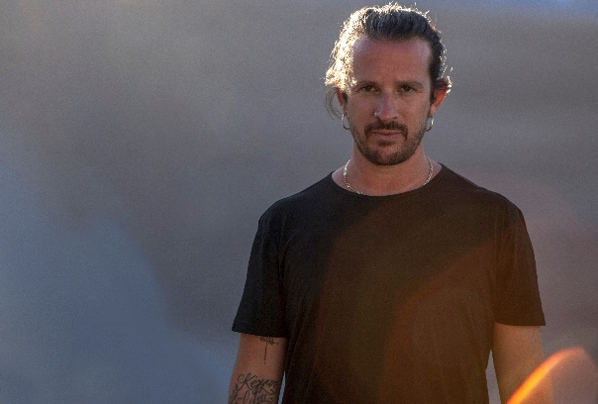
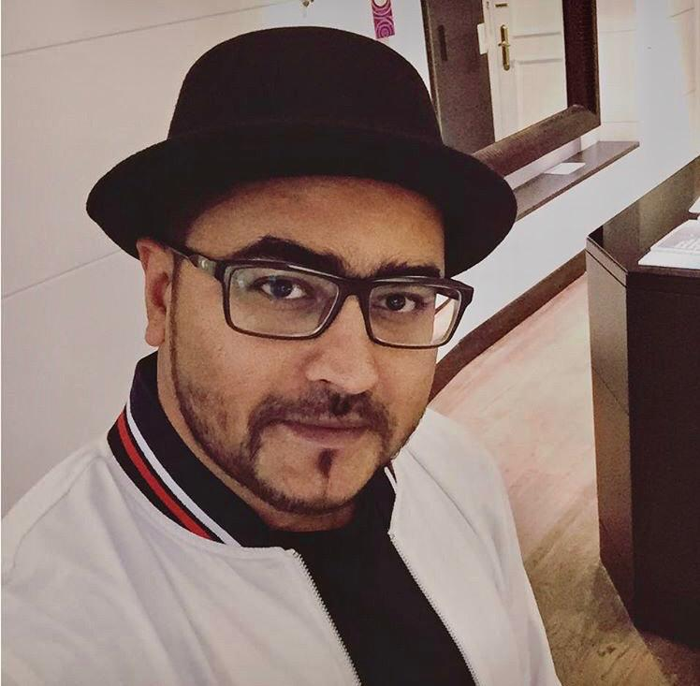

It’s free but why not donate to fight the coronavirus?
At Sennheiser, we’re delighted to be working with these fantastic artists to help spread positivity by putting on exclusive concerts. They’re totally free, but if you do want to say thank you, do consider supporting the WHO in its fight against the coronavirus:
https://www.who.int/emergencies/diseases/novel-coronavirus-2019/donate

For your social media channels:
Enjoy your favorite artists at home and check out the exclusive concerts in Sennheiser’s (@sennheiser) streaming concert series – live on Instagram! #DontStopTheMusic

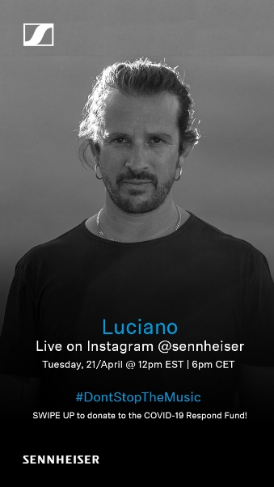 | 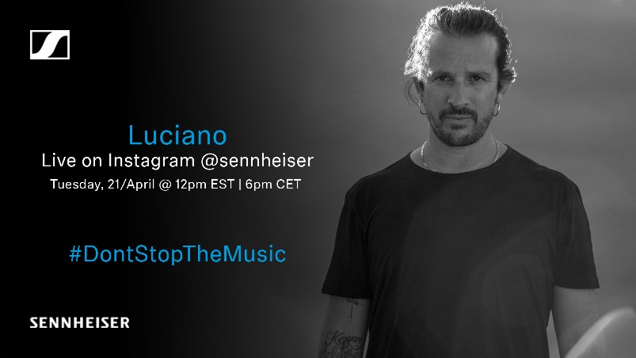
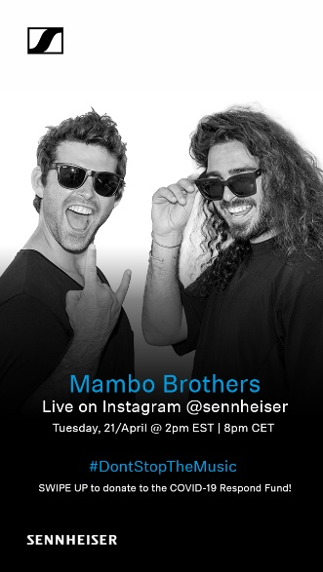 | 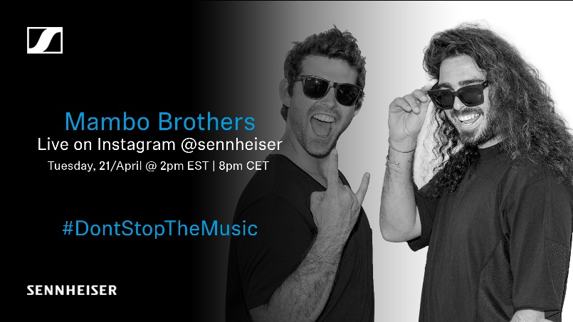
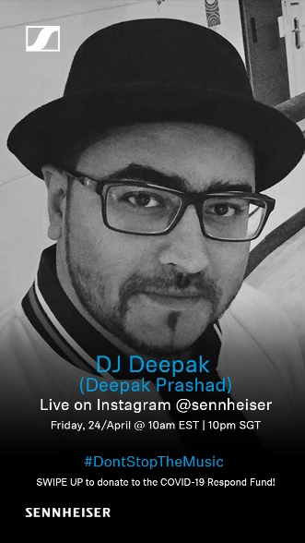

The images accompanying this press release can be downloaded at https://sennheiser-brandzone.com/c/181/wvtg5NFg.

About Sennheiser
Founded in 1945, Sennheiser is celebrating its 75th anniversary this year. Shaping the future of audio and creating unique sound experiences for customers – this aim unites Sennheiser employees and partners worldwide. The independent family company, which is managed in the third generation by Dr. Andreas Sennheiser and Daniel Sennheiser, is today one of the world’s leading manufacturers of headphones, loudspeakers, microphones and wireless transmission systems. In 2018, the Sennheiser Group generated turnover totaling €710.7 million. www.sennheiser.com

Press Contacts

Mareike Oer Stephanie Schmidt
mareike.oer@sennheiser.com stephanie.schmidt@sennheiser.com
T +49 0(5130) 600 – 1719 T +49 0(5130) 600 – 1275

