## Neumann and Merging Audio Interfaces Now Ship Dante Ready™

**Berlin, December 19th, 2024 – Neumann and Merging Technologies are proud to announce the availability of a Dante Ready™ option for their audio interfaces.**

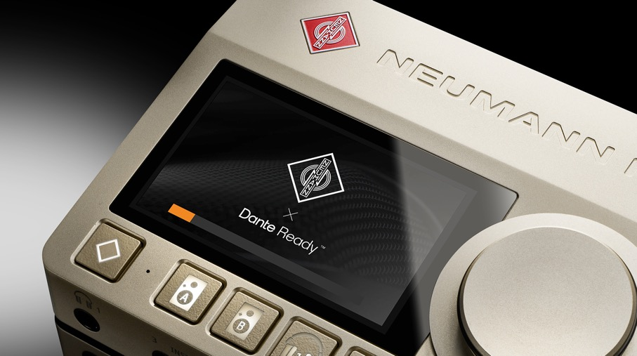

Merging Technologies, renowned for its state-of-the-art converters and pioneering audio-over-IP technology, has just released the third iteration of their audio mainframe Hapi. One major improvement over its predecessors is that Hapi Mk III comes Dante Ready™.

In addition, Merging’s groundbreaking Anubis SPS desktop interface now ships Dante Ready™ at no extra cost. The same applies to Neumann’s acclaimed MT 48 audio interface, which was developed in close collaboration with Merging Technologies. Both companies are part of the Sennheiser Group.

Acclaimed immersive music producer and mixing engineer Ronald Prent of Proper Prent Sound, known for his work with Depeche Mode, Simple Minds, Tina Turner and many others, had the opportunity to use the new Dante features before the official release:

„*I have put the MT-48 thru its paces, and I am really thrilled about how it works, especially the integration with USB to Dante or Ravenna is excellent. When on the road moving thru studios it easily integrates into any modern studio infrastructure in particular with all the Immersive formats, and when we use it with both Music- and Monitor-Mission it works very well in all cases. In short, it’s great and makes my immersive life so much happier!”*

Dante® is the leading Audio-over-IP (AoIP) standard, especially for live applications and installations. With the Dante Ready™ option, Merging’s Hapi Mk III and Anubis as well as Neumann’s MT 48 become compatible with a world of over 4,000 devices from more than 600 manufacturers.

Yasmine Riechers, CEO of Neumann and also responsible for Merging Technologies states that *“Adding a Dante option is a testament to our customer-centric approach and has no impact on Neumann’s and Merging’s commitment to RAVENNA/AES67. Both AoIP standards have their specific advantages depending on the use case. That’s why we’ve created an FAQ page to help customers choose the best solution for their needs.”*

**About Dante Ready and upgrades**

Dante Ready™ means, Audinate’s network standard is available to those who need it, but will incur no extra cost to those who do not require Dante. Ex-factory, Hapi Mk III, Anubis and MT 48 continue shipping with the pre-installed RAVENNA/AES67 firmware. The alternative Dante firmware is offered free of charge and can easily be installed using the MT Portal application. For Dante operation, a Dante channel I/O license must be purchased from Audinate.

For existing MT 48 customers and owners of Anubis SPS (Pro and Premium), a Dante Ready upgrade will be available soon. “We understand that existing end customers may wish to use Dante, even if it was not part of the original scope of the product they purchased. Therefore, we’ve worked hard to find a solution”, asserts Stephan Mauer, Head of Product. “From February 1, 2025, Neumann Service will offer a Dante Ready™ upgrade for older MT 48 and Anubis SPS devices.”

For more information, please visit the [Merging Technologies](http://www.merging.com) und [Neumann](http://www.neumann.com) websites, the [Dante-FAQ](https://zingtree.com/live/887759503) and Audinate's [Dante Ready](https://www.getdante.com/products/dante-enabled/dante-ready/) page.

Big thanks to Ronald Prent of [Proper Prent Sound](https://www.properprentsound.com/)

# About Neumann

Georg Neumann GmbH, known as “Neumann.Berlin”, is one of the world’s leading manufacturers of studio-grade audio equipment and the creator of recording microphone legends such as the U 47, M 49, U 67, and U 87. Founded in 1928, the company has been recognized with numerous international awards for its technological innovations. Since 2010, Neumann.Berlin has expanded its expertise in electro-acoustic transducer design to also include the studio monitor market, building upon the legacy of the legendary loudspeaker innovator Klein + Hummel. The first Neumann studio headphones were introduced in 2019, and since 2022, the company has increased its focus on reference solutions for live audio. With the introduction of the first audio interface MT 48, and its revolutionary converter technology, Neumann now offers all the necessary technologies needed to capture and deliver sound at the highest level. Georg Neumann GmbH has been part of the Sennheiser Group since 1991 and is represented worldwide by the Sennheiser network of subsidiaries and long-standing trading partners. [www.neumann.com](http://www.neumann.com/)

# About Merging Technologies

Merging Technologies SA is a Swiss manufacturer with over 25 years of experience in developing groundbreaking, professional audio and video products for a wide range of entertainment and media industries. With a dedicated user base in the elite end of the music, film, television, mastering and performances industries, Merging is committed to developing product ranges with unrivalled quality and flexibility, whatever the application. Merging builds tools for people who want more from their systems, have an innate need to push boundaries, and believe that quality always comes first. In 2022, Merging Technologies joined the Sennheiser Group to shape the future of audio technology with even greater impact. www.merging.com

**Press Contacts Neumann:**

|  |  |
| --- | --- |
| Dr. Andreas Hau  Content Marketing Manager  T +49 3041772415  Andreas.Hau@neumann.com | Raphael Tschernuth  PR + Marketing Manager  T +49 3041772467  Raphael.Tschernuth@neumann.com |