IBC 2019: Xytech Debuts New User Interface and Upgrades to MediaPulse, Providing Targeted Functionality to All Users

Additional upgrades to Personnel Manager and Transmission Module will also be highlighted

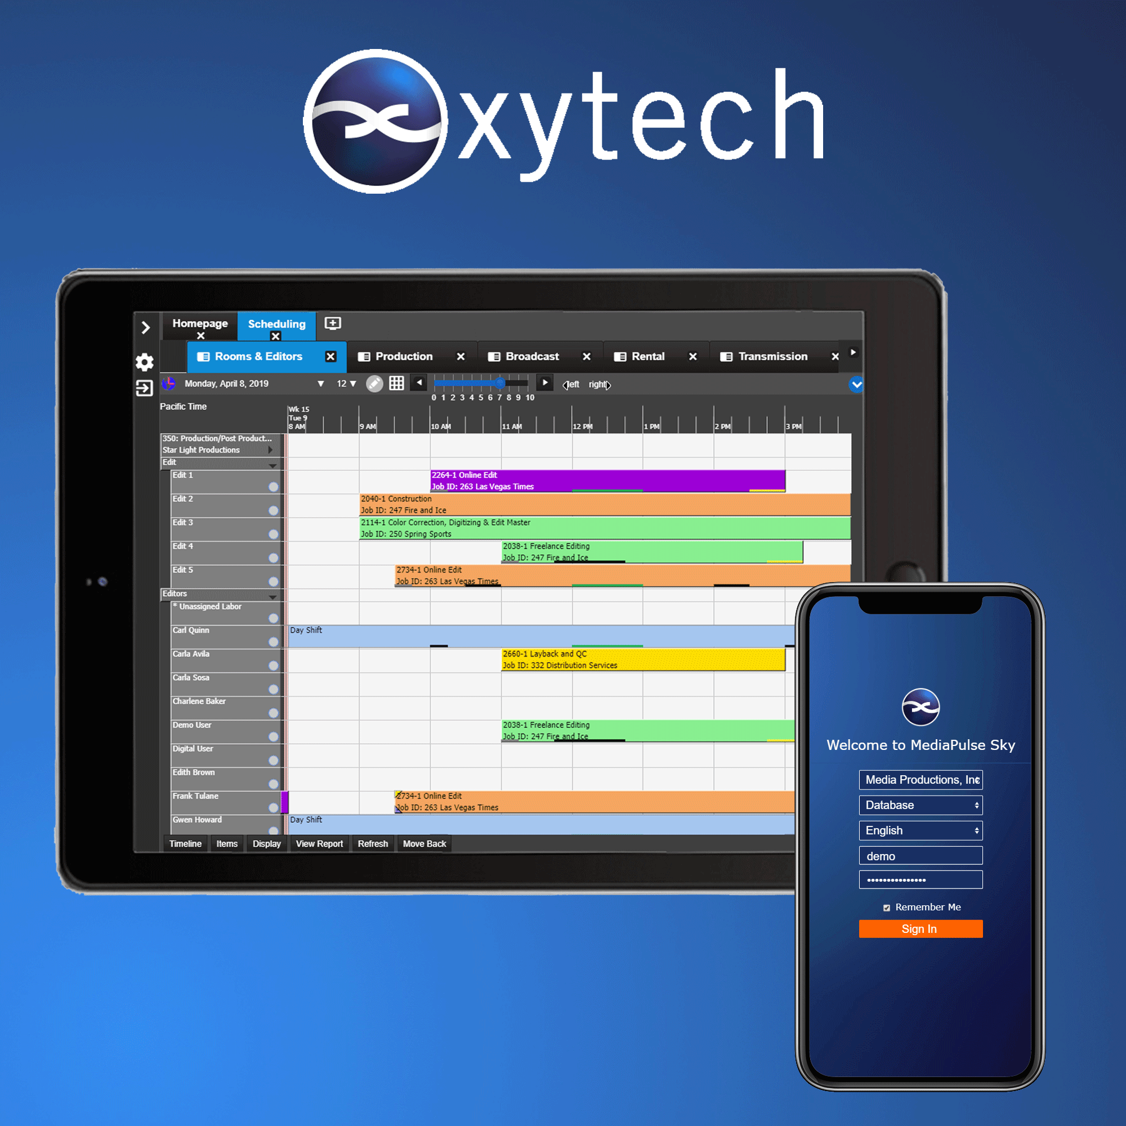
AMSTERDAM, August 27, 2019 — Xytech, leader in facility management software for the broadcast, studio, media services and video transmission industries, will highlight several major updates to its MediaPulse product line in Hall 6, Booth C22 during IBC 2019 from September 13-17 in Amsterdam.

One of the main features of MediaPulse being showcased is the completely re-designed user interface. This re-design is Xytech’s response to the recent market need to place targeted functionality in the hands of every staff member, freelancer and vendor in order to create a seamless end-to-end automated workflow. In order to do this properly, the UI is now completely intuitive and can operate on any device.

“MediaPulse 2019 delivers this much needed UI functionality,” said Greg Dolan of Xytech. “As the first consumer-grade UI in our market, this reimagining is responsive, molding itself to the device, and is available on prem or in the Cloud.”

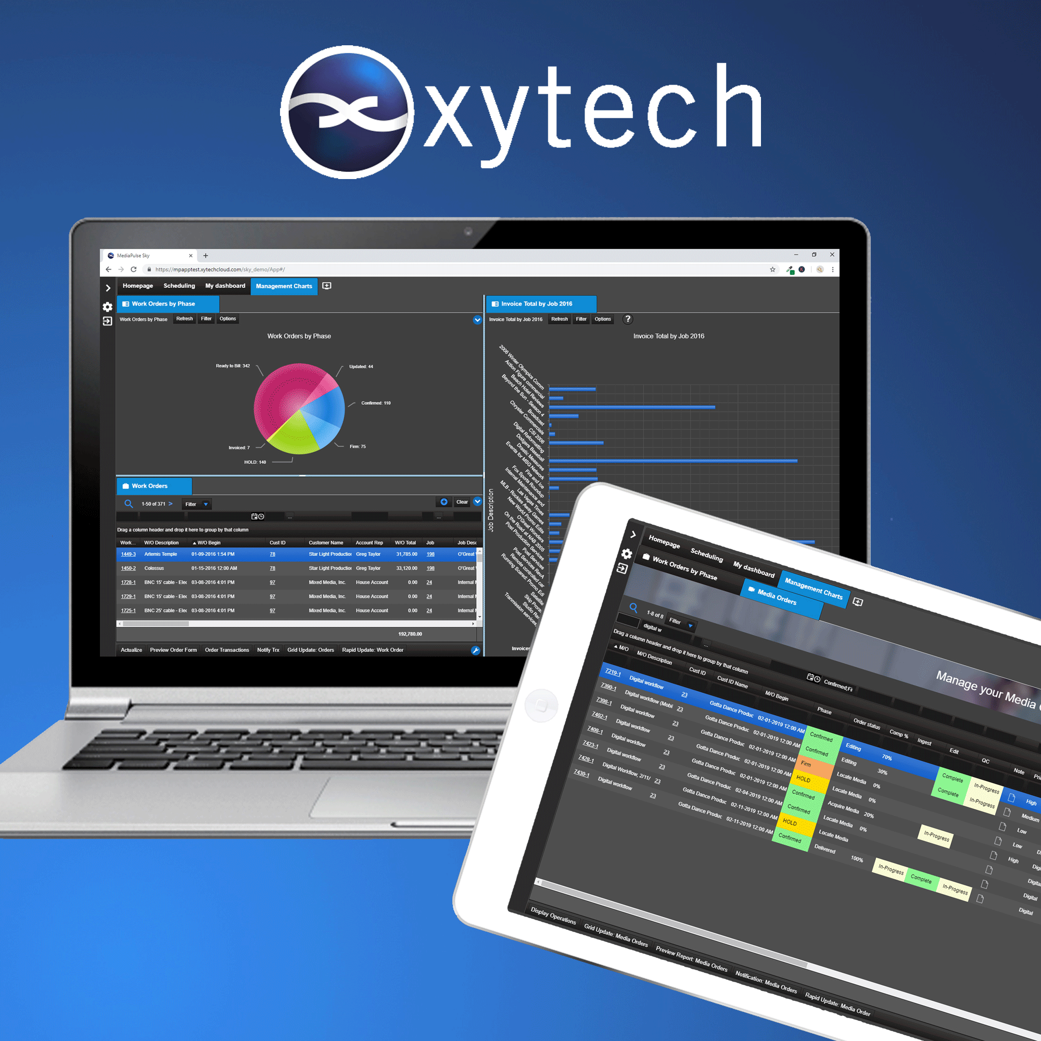
The new UI also contains a unique, integrated mobile experience for low touch users on phones. This is ideal for staff members needing to see schedules, accept assignments and actualize work hours.

Updates to Personnel Manager
Another key upgrade includes the update to the Personnel Manager to include real-time counters in the scheduling view to track any entitlements, work time, available time, overtime or any other classification managed by MediaPulse. The Personnel Manager rules engine has been upgraded to track all user-defined conditions, alert staff when thresholds are exceeded, compute costs and prepare timesheets. This specifically addresses the European Working Time Directive.

Updates to Transmission Module
In addition to the updates to the Personnel Manager, the Transmission Module has also undergone several upgrades. New functionality manages both technical compatibility and service compatibility. Users automatically create a technically correct circuit while simultaneously ensuring the selected devices fulfill the service required. This new functionality works hand-in-hand with device monitoring capabilities to make sure operators have a single source of truth for all transmission bookings.

The new user interface is available now in the 2019 version of MediaPulse.

Xytech will be exhibiting at the upcoming IBC 2019 from September 13-17, 2019. Located in Hall 6, Booth C22 Xytech will demonstrate the new features of its leading facilities management software MediaPulse. Those interested in scheduling an appointment may contact Alexandra Kuipers at akuipers@xytechsystems.com, +1(818)698-4958.
About Xytech
For more than 30 years, the world’s premiere media companies have depended on Xytech to run their businesses. MediaPulse is the only end-to-end solution for the complete content lifecycle. MediaPulse provides scheduling, automation, asset management, billing and cost recovery for broadcasters, media services companies and transmission facilities in a scalable platform-independent solution. For more information, visit xytechsystems.com.

Media Contacts:

Katie Kailus
Public Relations
Hummingbird Media
+1 (630) 319-5226
katie@hummingbirdmedia.com

Alexis Lipoff
Public Relations - EMEA
Hummingbird Media
alexis@hummingbirdmedia.com

Jeff Touzeau
Public Relations
Hummingbird Media
+1 (914) 602 2913
jeff@hummingbirdmedia.com

