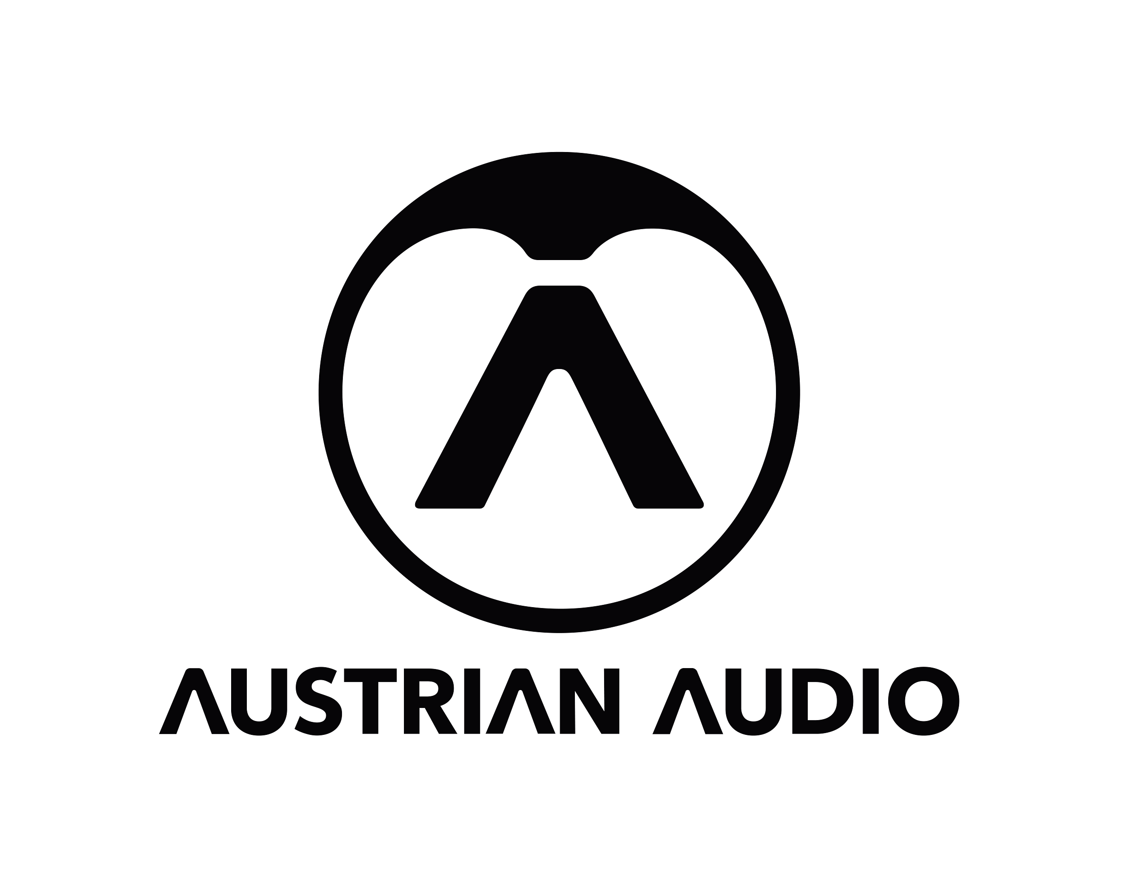

**Austrian Audio Wins Best High-End Headphones at 2024-2025 EISA Awards***The Composer recognized as standout reference headphones in Hi-Fi listening category*

**Vienna, Austria, August 15, 2024 —** [**Austrian Audio**](https://austrian.audio/) **announces that** [**The Composer**](https://austrian.audio/headphones/thecomposer/) **has won Best High-End Headphones in this year’s** [**EISA**](https://eisa.eu/) **(Expert Imaging and Sound Association) Awards. The award is Austrian Audio’s first recognition by the respected, long-standing association of consumer technology experts and is a ringing endorsement that marks the brand’s rapid ascent in the market. For more information about the 2024-2025 EISA Awards, please** [**click here**](https://eisa.eu/awards/hi-fi/)**.**

Established in 1995 and consisting of a community representing respected publications, organizations, and commentators from over 30 countries, the EISA Awards are a yearly celebration of innovation and excellence in the consumer technology industry.

“It is an honor to receive this award from EISA and our distinguished colleagues in the industry,” said Austrian Audio CEO Martin Seidl. “To be recognized for our first Hi-Fi product in its first year on the market is an incredible affirmation of our rising status in the pro audio market and to the skill and dedication of our design and production teams here in Vienna. We’re incredibly proud of The Composer and thankful for the industry and customer recognition that our young company has received for it.”

**Premium sound for refined listeners**Initially launched at the tail end of 2023, The Composer is a set of premium quality reference headphones designed for creative professionals and discerning music connoisseurs alike. Utilizing Austrian Audio’s peerless 49mm Hi-X Driver Design, The Composer offers an enveloping, full-frequency listening experience with rich, natural sound equally suitable for professional and personal use. The headphones are made in Austria using the highest quality components for a lifetime of peerless listening and enjoyment, and precisely crafted for an effortlessly comfortable fit.

For more information about the Austrian Audio Composer, please [click here](https://austrian.audio/headphones/thecomposer/).

**About Austrian Audio**

Austrian Audio opened its doors in 2017 following the closure of the AKG offices in Vienna and set out to create something new, challenging, and respectful to its heritage. The new company started with a core team of previous AKG personnel from management, acoustics, electronics, test and measurement, mechanical design, RF/wireless, and software/firmware, bringing 350 years of cumulative engineering experience to the new company.

For more information, visit [austrian.audio](https://austrian.audio/).