Sound Synergy: First Baptist Concord Selects myMix for its Universal Simplicity, Quality Sound

J Sound Services finds myMix portable recording interface/monitoring solution to be a simple, sonic match for Tennessee-based mega church
West Hills, Tennessee, October 23, 2017 — myMix, a network-based audio mixing and recording system which features easy operation while meeting the highest audio demands, has been chosen by First Baptist Concord church as its recording interface thanks to its simplicity of operation and high quality sonic performance.

Nashville, Tennessee-based J Sound Services, the audio/visual company behind the installation, recently installed eight myMix units at the mega church’s West Hills, Tennessee, location which holds two contemporary-style services every Sunday to a congregation of about 250 parishioners for each service. J Sound Services’ CEO Jason Spence chose the portable recording interfaces for the church because of its no-hassle set up, comprehensive functionality and ease of operation.

“We have clients as young as their teens and as old as 60s using the myMix — especially in our house-of-worship installations,” Spence explained. “We don’t do a lot of training, but we’ll do a brief introduction — but with myMix that’s all anyone needs. Our clients are usually able to operate the system within minutes.”

In addition to its ease of use and easy integration with any brand of console or system, the myMix’s remarkable sound quality is what keeps Spence reaching for the system every time he does a house-of-worship installation.

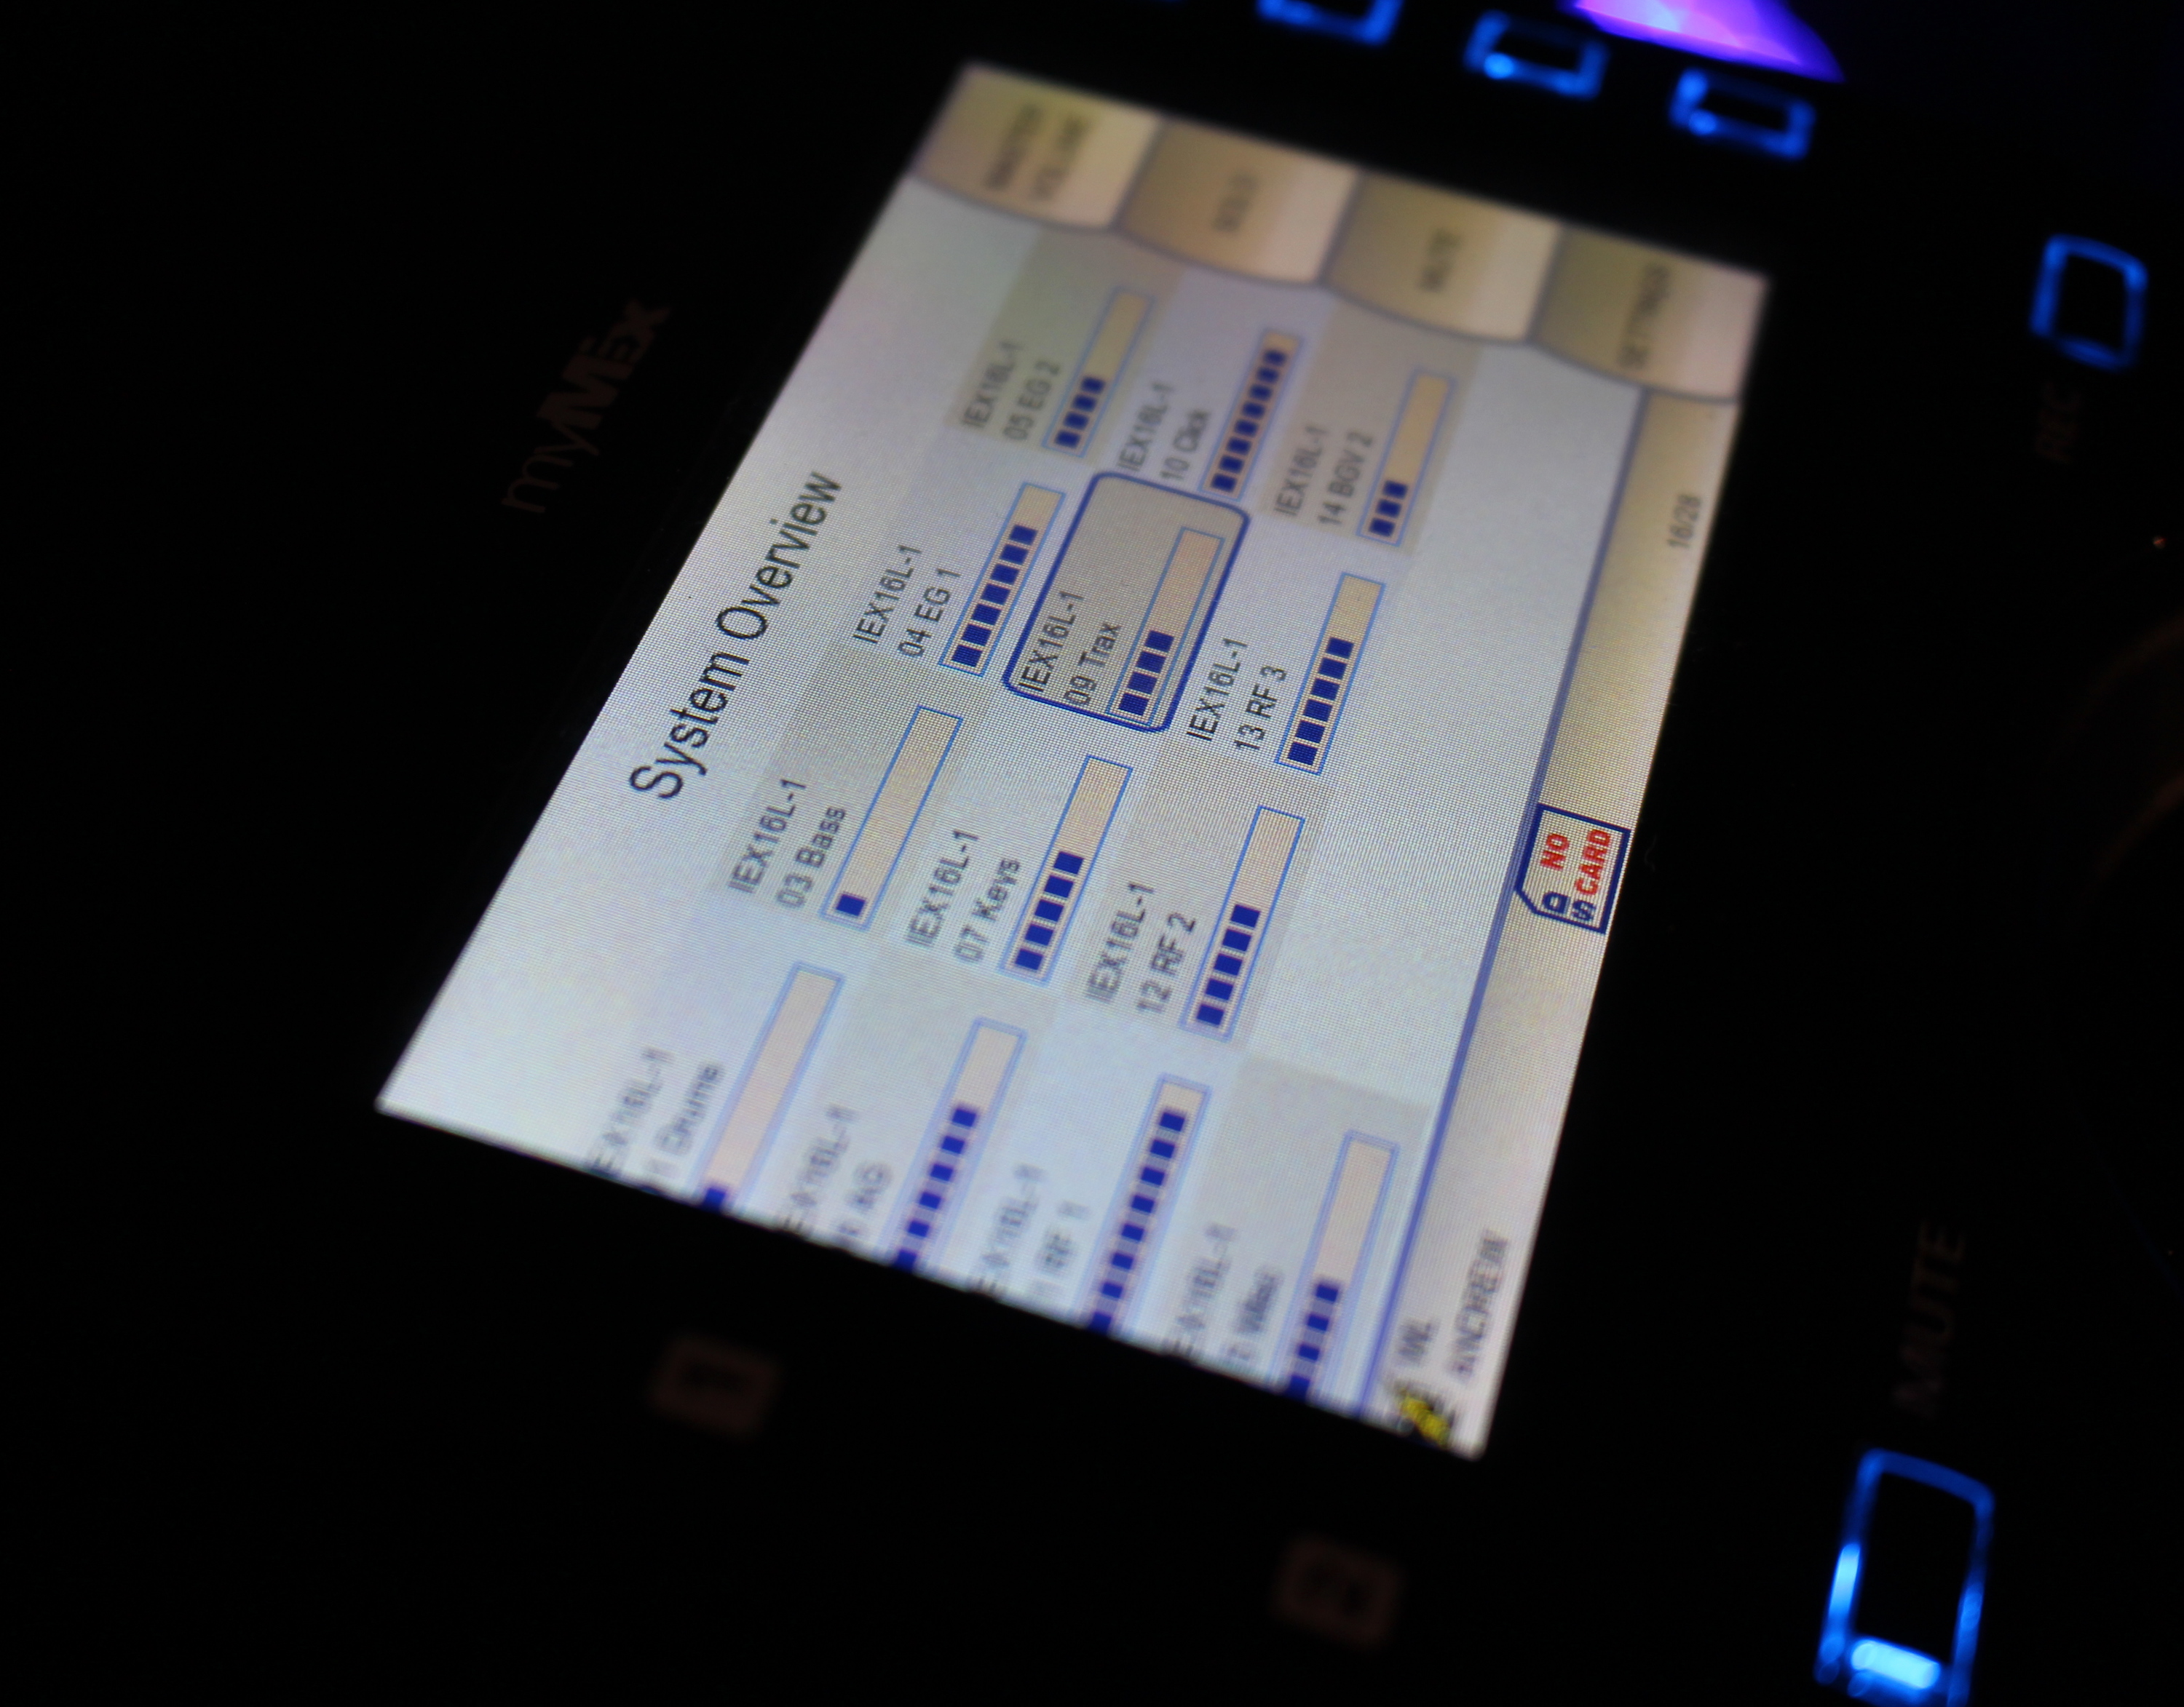
“I haven’t found another recording interface that sounds this good,” he said. “Other products can be useful tools, but they’re uninspiring to listen to and that absolutely affects how performances translate. The audience reception is directly reflected by how comfortable thge musicians are on stage. It finally becomes inspiring when musicians stop thinking about their monitors anymore, and myMix handily solves this challenge by delivering great sound quality."

Simplicity at the core
Luke Lasater, audio engineer at First Baptist Concord’s West Hills location, said the church has been startled by the difference in sound quality. “As an engineer, I appreciate the high quality at which myMix delivers sound to the musicians,” Lasater said. “I often receive comments from the musicians about how great their in-ear mixes sound using the myMix.”

First Baptist Concord’s setup features an IEX-16L-A fed via Toslink from a Yamaha CL3’s ADAT MY Card. A combination of directs out and aux mixes make up the 16-channel input list for the eight myMix units. On any given week, the church will have up to eight musicians on stage using the myMixes. Most are hardwired to the headphone outputs on each unit, while the vocalists and worship leaders use the line-outs to feed to Shure PSM300 wireless IEM units in stereo.

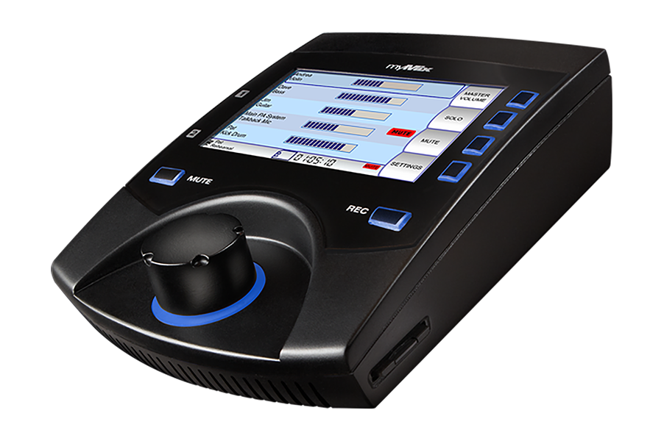
“Since the devices are powered remotely from the network switch, a single-network cable to power the unit and pass audio means a clean stage and easy setup,” Lasater explained. “The simple, but extremely effective user interface on the myMix is perfect for musicians who need to be focused on playing, not trying to mess with their in-ear mixes. We as engineers often forget that musicians are not engineers, and should not be subjected to systems that are difficult to learn or operate. The simple tools of level, pan, a great sounding tilt EQ and a single FX engine means there isn't anything for those on stage to have ‘trouble’ with. However, having the FX means a vocalist can add some verb on their voice to put it in a space and not be isolated in their ears, or a guitar player can use the tilt EQ to help balance other instruments to his. Even with the proliferation of personal mixers in the market, all of the musicians we have had come across our stage have raved about how simple the system is to use and how great it sounds.”

For more information, visit mymixaudio.com.
For more information on J Sound Services, visit jss.net.

About myMix

Part of the Synthax family, the North American distributor for RME, myMix is a personal monitor mixing and recording system featuring local network inputs and can operate either self-contained or integrated with any analog or digital mixing consoles. Thanks to its ease of use, the myMix is ideal for on-stage performances, studio monitoring as well as installed applications such as houses of worship.

Media Contacts:
Jeff Touzeau
Public Relations
Hummingbird Media
+1 (914) 602 2913
jeff@hummingbirdmedia.com

Katie Kailus
Public Relations
Hummingbird Media
+1 (630) 319-5226
katie@hummingbirdmedia.com

