**PGA TOUR Studios Selects Sennheiser Spectera for New State-of-the-Art Campus**

***Leading Sports Broadcaster Deployed the Wireless Audio Ecosystem to Manage Multiple Studios and Demanding Production Schedule with Simultaneous Broadcasts***

**Ponte Vedra Beach, FL — July 22, 2025 —** [**Sennheiser**](http://www.sennheiser.com)**, the manufacturer building the future of audio for 80 years, today announced that PGA TOUR Studios recently deployed the new Spectera bidirectional wireless audio ecosystem across its new campus in Ponte Vedra Beach, Florida. As the leading sports broadcaster responsible for extensive live PGA TOUR coverage and diverse studio shows, the PGA TOUR Studios audio team required a system that could not only support a state-of-the-art facility that houses seven dedicated studios but also seamlessly manage up to 11 shows broadcasting simultaneously in an environment that would be packed with competing RF signals.**

**Simplifying Complex Demands in a Multi-Studio Environment**

PGA TOUR Studios required a wireless solution that could keep pace with the demands of a fast-moving, multi-studio production environment. Spectera emerged as the ideal choice for its technical capabilities, along with the way it simplified installation and allowed the engineering team to focus on production rather than infrastructure.

*The comprehensive PGA TOUR Studios setup includes two Spectera base stations, supporting a total of 24 microphones and IFB monitors, distributed across the facility with seven dedicated antennas to ensure optimal coverage. A television studio with a large screen
*

The new system needed to offer effortless transitions between studios and a dramatically simplified management interface. The challenge was evident, and soon, so was the solution. Enter Spectera, Sennheiser’s wideband, bidirectional wireless ecosystem.

**Seamless Integration of Sennheiser Spectera**

Sennheiser’s Spectera is the world's first wideband, bidirectional wireless ecosystem. Unlike traditional wireless audio setups, it doesn’t rely on a complex mix of separate systems for microphones and in-ear monitors or interruptible foldback (IFB) monitors — each on their own frequencies and requiring painstaking channel and guard band planning. Spectera takes a fundamentally different approach, bringing microphones, IFBs, and control data together on a single wideband RF channel, managed from a compact 1RU base station. This innovation fundamentally simplifies how wireless audio is handled in live production. PGA TOUR Studios strategically implemented Spectera as the backbone audio infrastructure of their new campus.

*With a highly demanding production schedule, PGA Tour Studios required a truly resilient audio solution, leading them to deploy Spectera.*

“Our original vision was to implement a building-wide RF system that offered seamless coverage across all studios, regardless of location,” said Ricardo Landaeta, Manager of Audio Broadcast at PGA TOUR**.** “We have seven studios, each with three or four talents, and our goal is to run six shows weekly with a maximum of four talents per show, operating four days a week for 12 hours. Resilience, quality, and versatility are important. With Spectera, talent can easily transition between studios by simply grabbing a pack, and guest integration is smooth.”

Spectera’s real breakthrough is that it allows both microphone and IFB channels to run together in the same 6 or 8 MHz bandwidth, managed centrally. Up to 64 audio channels (32 in, 32 out) can be handled from a single rack unit, a task that used to require a tangle of receivers, transmitters, and careful manual frequency calculations. The bidirectional SEK bodypacks operate as a mic or line transmitter and an IFB receiver at once, reducing gear and cabling for everyone on stage. Operators are also able to remotely monitor and control packs, thanks to Spectera’s continuous two-way link.

*Spectera mic packs being charged at the base stations to ensure quick replacement in the field or on the studio floor.*

“It’s rewarding to see the system commissioned and performing precisely as Ricardo and his team envisioned,” added Valerie Seward, Broadcast Engineer at PGA TOUR Studios. “We’re managing up to 10 shows concurrently, and engineering has enabled talents to work across multiple studios without impacting audio quality. Our main goal was to deliver a pristine audio environment and foster clear communication for our talents, and we’ve achieved and exceeded that goal without needing any backend changes.”

The comprehensive PGA TOUR Studios setup includes two Spectera base stations, supporting a total of 24 microphones and IFB monitors, distributed across the facility with seven dedicated antennas to ensure optimal coverage. There are plans for this setup to be expanded to six base stations and additional packs in fall of 2025, providing building wide coverage, and hardware redundancy. The system expansion is incredibly simple.

The infrastructure cost savings were an important factor in selecting Spectera. The system does not rely on RF-over-Fiber converters, combiners and amplifiers, or 3/4 inch RF cable, all of which add large overhead to the cost of the system. In the case of Spectera, base stations are connected to antennas using standard ethernet cable, and the antennas are POE, further simplifying the setup.

“The commissioning process was remarkably swift and straightforward,” added Joel Latimer, Audio Engineer A1, PGA TOUR. “It took just 10 minutes to turn it on, set it up, and showcase what it can do. The ease of use took all of us pleasantly by surprise.”

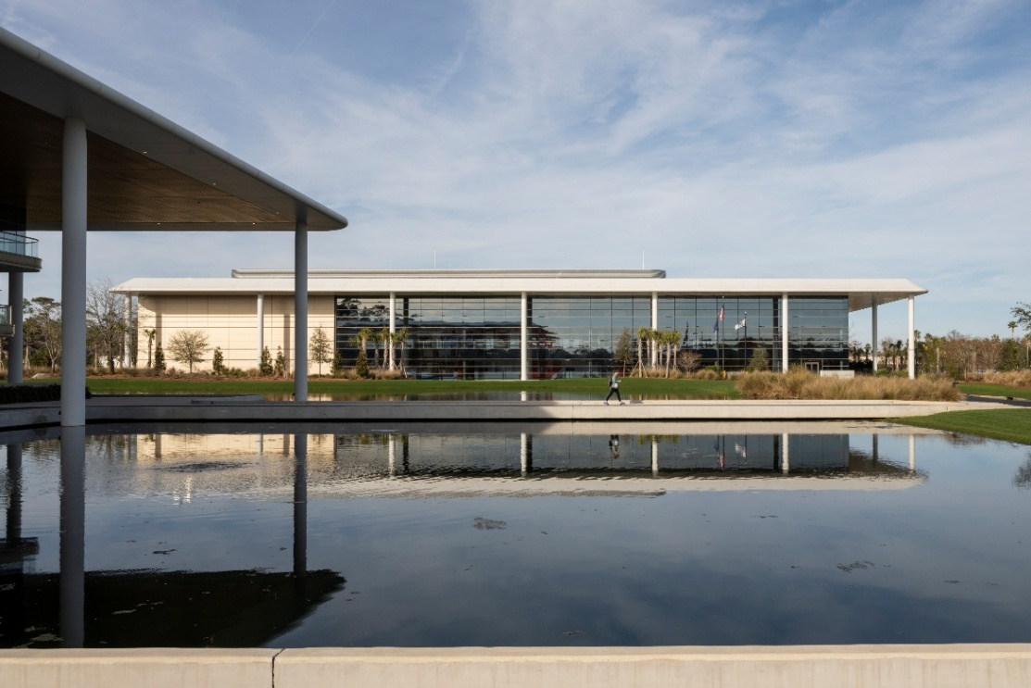This rapid deployment allowed the system to go live quickly; in just over two weeks of extensive testing in early January, they had full confidence to deploy Spectera to fully operational status and actively supporting on-air broadcasts across four studios.

*Spectera’s RF signal covers the entire campus via base stations connected to POE antennas using standard ethernet cable.*

**Unprecedented Reliability and Streamlined Workflow**

For PGA TOUR Studios, Spectera demonstrated an indispensable level of RF resilience and stability, even in the most demanding broadcast environments. During a period of heightened activity such as THE PLAYERS Championship, the campus is surrounded by a massive truck compound generating a large amount of external RF signals. Despite these difficult conditions and numerous internal shoots occurring at the same time, the Spectera system did not experience a single dropout, hit, or interference issue.

Notably impressive to the team was an instance when a bodypack from the largest, geographically furthest studio still received signals while being carried into the lobby on the opposite end of the building, showcasing the system’s remarkable range and reliability.

*Field swapping battery packs is made incredibly convenient by Spectera*.

The system’s “set it and forget it” simplicity has streamlined PGA TOUR Studios’ workflow. Talent can move between different studios without worry, pick up any available pack, and immediately be operational without the need for any backend reconfigurations or manual adjustments. Engineers can swap out depleted batteries during live broadcasts, significantly cutting down on delays to production. The process of going live again after a battery swap now takes a mere 7 seconds. Spectera easily integrated with PGA TOUR Studios’ existing Dante and Calrec 2110 audio environments, ensuring that even with signal conversion occurring, there was no discernible delay or compromise in audio.

“Our expectations for stability have been met even with other studios and activities happening around us. Battery life has also been surprisingly good – we’ve even seen packs last up to seven hours on new batteries,” said Latimer. “The key is that we want everything to run smoothly, and nothing has gone wrong. We really like the software as well; it provides a fantastic visual reference for everything that’s happening with each pack. Especially when mixing a show, we can quickly check the battery and RF levels. If there’s any signal loss, we can immediately identify it and communicate with engineers to allocate resources. Spectera is incredibly intuitive!”

The PGA TOUR Studios audio team have set up Spectera as such that they have access to all base stations from all computers around the facility. Using Spectera WebUI for each base station, they can continuously monitor the health of microphones, IEMs/IFBs, and antennas, as well as critical battery and RF levels. The audio team can log into any base station from anywhere on their network as needed. This real-time visual representation is invaluable for proactive management, helping to prevent unexpected issues and ensuring system integrity both before and during live shows.

*PGA TOUR LIVE broadcasting with Spectera in studio 2B of the campus.*

Spectera’s versatility makes it integral to a vast array of PGA TOUR Studios’ productions. It’s consistently used across numerous live tournament coverages, including four streams for PGA TOUR LIVE on ESPN +, PGA TOUR Champions, and Korn Ferry Tour on GOLF Channel. It is also the core system for popular studio shows including *The Drop* on GOLF Channel, *On the Range* on GOLF Channel and YouTube and the *Creator Classic Series presented by YouTube*, with the latter frequently utilizing seven to eight packs simultaneously with talent distributed across three different studios within the building.

As participants in the Spectera Pioneer Program, the engineering team at the PGA TOUR Studios initially approached the deployment with a combination of optimism and caution, anticipating a need for backup solutions. That proved unnecessary as the team has been impressed with the system’s performance, which consistently exceeded any prior expectations. This confidence now even extends to firmware updates, which can be done efficiently via the software without needing to pull every pack, a stark contrast to previous systems.

“As far as expectations, we didn’t quite know what to expect,” said Landaeta. “We were one of the very first in the entire country to use Spectera, which was an honor, but it was still a prototype. We weren’t expecting it to be as solid as it is, and we’ve been lucky to have had this fantastic experience. We had backups in case of failure, but we’ve never needed to deploy them. We were cautiously optimistic. Now we’re just optimistic about its continued success!”

Following delivery, the team conducted thorough system testing to assess its performance and resilience. The system exceeded the required standards, which led to an earlier deployment, with a backup maintained as a precaution. After a few days of use, Ricardo Landaeta jokingly remarked that he had “an unhealthy amount of confidence in the system”, a perfect one-line summary indicating that even though the audio team was keeping an eye on Spectera's performance and reliability, the system was delivering without issues. There was no engineering drama, no late nights, the system just worked as expected out of the box.

Sennheiser Spectera is responsible for radically transforming the audio workflow at PGA TOUR Studios, providing a reliable, versatile, and intuitively managed wireless system. Its proven capability to thrive in demanding RF environments and to integrate seamlessly into complex broadcast workflows has made it a crucial tool utilized for their diverse profile of productions.

“We strongly encourage others in the industry to try it out and see for themselves,” said Seward. “We know that it sounds unbelievable that we have an RF system that hasn’t taken a single hit, but it’s true! Everyone here at PGA TOUR Studios would highly recommend Spectera — in every sense — it’s been a dream come true.”

###

**About the Sennheiser Brand – 80 Years of Building the Future of Audio**

We live and breathe audio. We are driven by the passion to create audio solutions that make a difference. This passion has taken us from the world’s greatest stages to the quietest listening rooms – and made Sennheiser the name behind audio that doesn’t just sound good: It feels true. In 2025, the Sennheiser brand celebrates its 80th anniversary. Since 1945, we stand for building the future of audio and bringing remarkable sound experiences to our customers.

While professional audio solutions such as microphones, meeting solutions, streaming technologies and monitoring systems are part of the business of Sennheiser electronic SE & Co. KG, the business with consumer devices such as headphones, soundbars and speech-enhanced hearables is operated by Sonova Holding AG under the license of Sennheiser. [www.sennheiser.com](http://www.sennheiser.com)

[www.sennheiser-hearing.com](http://www.sennheiser-hearing.com)

**Local Press Contacts**

Daniella Kohan

[daniella.kohan@sennheiser.com](mailto:daniella.kohan@sennheiser.com)

+1 (860) 227-2235

Peter Schuyler

Peter@ingearpr.com

+1 (917) 496-8970