Xytech’s MediaPulse Supports Take 1 with its Ambitious Growth Trajectory

The transcription, access services and localization leader deploys MediaPulse for its major growth area, Access Services
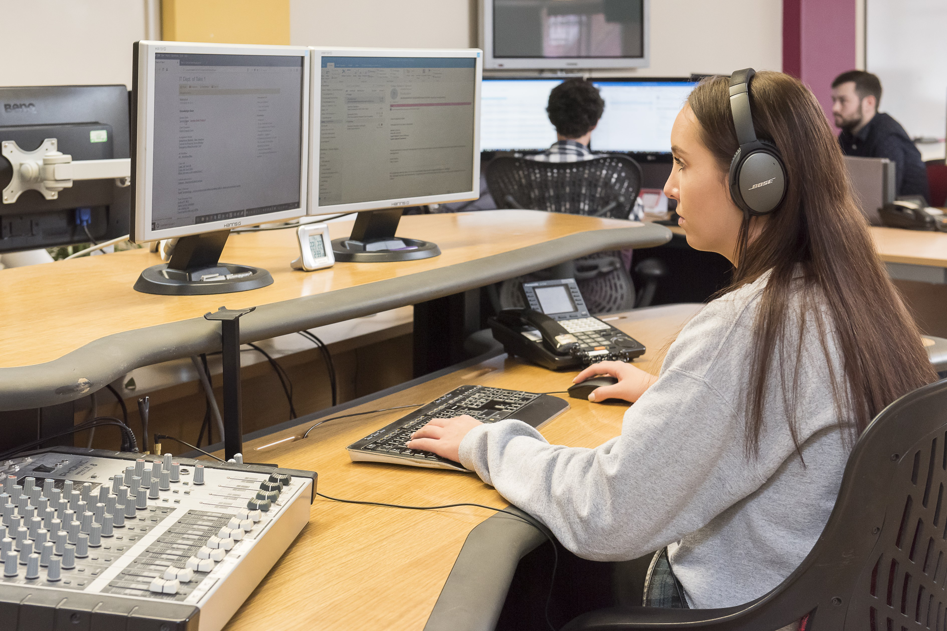
London, UK, September 28, 2021 — For over 20 years Take 1 has established itself as a premier transcription, access services and localization provider trusted by major networks, including Discovery, Sky and BBC Studios. To continue this path of success, Take 1 recently deployed Xytech’s MediaPulse to manage its rapidly growing portfolio of services. Since the deployment, the company’s Access Services offering has experienced dramatic growth, with the entirety of its resource scheduling and workflow managed with MediaPulse.

“Take 1 has been known for media-grade transcription for decades, so when our clients started asking us to work on their access services work, we were well placed to do this, particularly as we had recently integrated the MediaPulse system,” said Stephen Stewart, COO of Take 1. “We also successfully utilized the MediaPulse Development Platform to tie our existing systems together, creating links between our internal and third-party platforms.”

With the growth in Access Services, MediaPulse’s collaborative platform provided Take 1 a seamless environment and easy interoperability across its internal ecosystem. This allowed the US and UK teams to collaborate effectively on the same projects and guarantee high-quality turnaround deliveries for Take 1 customers.

“Beyond the success of our access services area, we also expanded our localization services,” added Stewart. “Take 1’s international network of in-territory linguists and partner studios allows us to provide multilanguage voice services, in-studio and remote foreign-language audio services through our partner studios worldwide, all coordinated using MediaPulse.”

Take 1 plans to implement the entire spectrum of the MediaPulse product offerings across the company as it embarks on strong growth trajectory.

“Our goal is to migrate all our product areas onto MediaPulse so we have a common resource management platform to integrate with all our internal systems and other ‘best of breed’ third party tools,” he said. “We trust Xytech’s MediaPulse existing features and future upgrades will ensure they continue supporting us on our ambitious growth.”

“It has been a real pleasure working closely with Take 1 over the past few months and to see just how much they are getting out of our Media Ordering module and integration capabilities,” concluded Matt Waldock, VP EMEA at Xytech. “From the very start, both Take 1 and Xytech could visualise the way MediaPulse could help transform Take 1’s business. With the help of our Professional Services team, Take 1 had both the ambition and skill to quickly embrace the options Media Ordering offered them, for building workflows and integrations, as well as dashboards to present summarised views of data to help them manage by exception. We take great pride in both our software capabilities and Professional Services team on this project and look forward to working with Take 1 as they continue to grow.”

About Xytech
For more than 30 years, the world’s premiere media companies have depended on Xytech to run their businesses. MediaPulse is the only end-to-end solution for the complete content lifecycle. MediaPulse provides scheduling, automation, asset management, billing and cost recovery for broadcasters, media services companies and transmission facilities in a scalable platform-independent solution. In April 2021, Xytech acquired the ScheduALL brand of enterprise resource management software for broadcasters and media companies, providing end-users with an even more robust product roadmap and greater global service offerings. For more information, visit xytechsystems.com.

About Take 1
Take 1 makes video accessible by unlocking the power of words. The company leverages data-driven workflows to provide high-quality transcription, access and localization services to the media and entertainment industry. With offices in the UK and US and a global workforce, Take 1 has a heritage of 20 years in the broadcast industry and a reputation for providing fast, reliable services and unrivalled accuracy.
Visit www.take1.tv for more information.

Media Contact:
Katie Kailus
Public Relations
Hummingbird Media
katie@hummingbirdmedia.com

