For immediate distribution

Sweetwater’s GearFest 2018 Sees Continued Increase in Attendance, Sales
A-list performances, gear exhibits and over 200 workshops draw record crowds to the nation’s largest
customer-focused music trade show
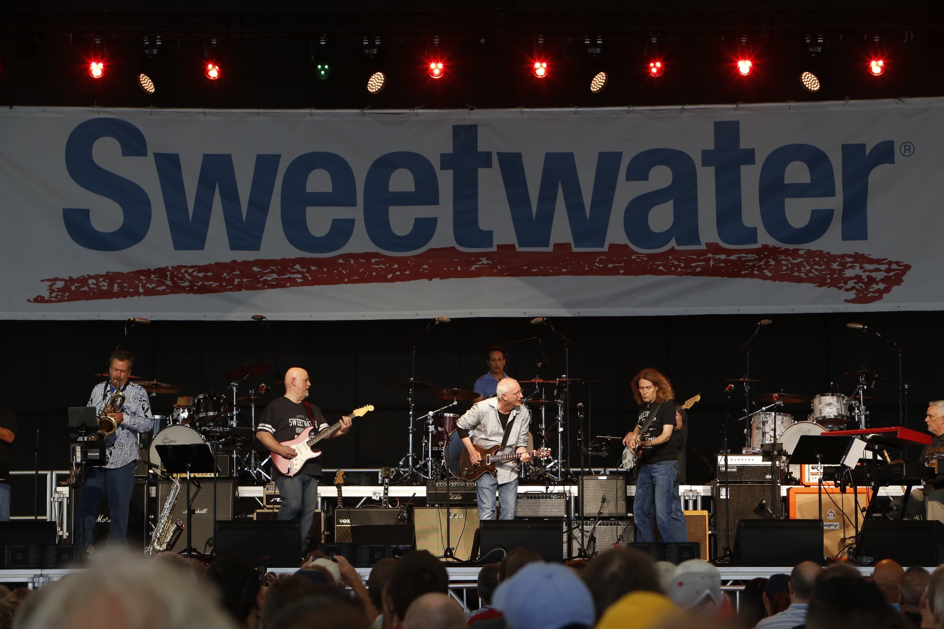
July 1, 2018, Fort Wayne, IN — For the 17th year, Sweetwater hosted its annual GearFest on Friday, June 22 and Saturday, June 23, 2018 at its campus in Fort Wayne, Indiana, drawing record crowds with more than 15,000 attendees from across the world — including guests from Australia, Brazil and Japan. This year’s event also saw a 15-percent increase in music equipment sales during the event.
Considered the nation’s largest customer-focused music and pro-audio trade show, GearFest 2018 offered something for every music lover — from over 200 workshops to new gear releases from top musical instrument manufacturers to performances by some of the biggest names in the industry, including Greg Koch, Peter Erskine and John Scofield.
“We are thrilled that GearFest continues to attract more and more musicians from across not only the U.S., but the world, who are searching for a unique music experience unlike any other,” said Steve Dwyer, Senior Director of Brand at Sweetwater Sound. “Through GearFest, Sweetwater is reaching today’s music creation community and bringing them the opportunity to learn and interface with some of the brightest minds in the music industry. We are certain that anyone who attended GearFest walked away with a new piece of knowledge and are ready to take their passion for music to the next level.”
For those who couldn’t make the event, Sweetwater live streamed select panels, performances and workshops on Facebook Live so everyone could be a part of the GearFest experience. The live streamed videos can be viewed at: https://www.sweetwater.com/gearfest/watch-live/.
Unforgettable Performances
Inspiring the crowd, this year’s GearFest was full of memorable, impromptu performances by some of the biggest names in the music industry, including guitarist Nita Strauss who took the stage during her seminar with Nick Bowcott and performed an impromptu performance of Pantera’s “Walk” as a tribute to the late Pantera/Damageplan drummer Vinnie Paul.
Another unforgettable performance came when drummer Steve Ferrone, who has worked with top talent like Tom Petty, Eric Clapton and Duran Duran, learned that his former bandmate — keyboardist, arranger and music director Greg Phillinganes — was also at GearFest. The two legends connected and jumped onstage, entertaining the audience with a spontaneous rendition of Clapton’s “Pretending.”
Serious ‘Master’ Classes
Performances aside, GearFest also offered attendees the opportunity to learn from some of the best and brightest in the industry during expert panels and workshops which featured names like Periphery guitarist Misha Mansoor, drummer and producer Russ Kunkel, and former Megadeth guitarist Chris Broderick. The more than 200 workshops and seminars covered such topics as getting discovered on YouTube, music creation with computers, and tips on improving technique and theory.
A perennial GearFest favorite, this year’s Producer’s Panel offered a high-powered discussion on what it takes to be a producer, how to help artists perform their best and what makes a song great. The panel was made up of Sylvia Massy (Tool, Prince), Neal Pogue (TLC, Pink), Kevin Killen (Shakira, U2), Fab Dupont (Jennifer Lopez, Bon Jovi), Chris Lord-Alge (James Brown, Prince) and Rich Chycki (Dream Theater) along with Sweetwter’s own Mitch Gallagher moderating the panel.
Among the most popular of the events was “Getting Great Electric Guitar Tone” which featured Butch Walker (Taylor Swift, Panic! at the Disco), Buddy Miller (Emmylou Harris, Robert Plant), Tim Pierce (Bon Jovi, Bruce Springsteen), Lyle Workman (Bourgeois Tagg, Todd Rundgren), and panel moderator and Nashville session star Corey Congilio. During this session, the group dug deep into capturing electric guitar tones and demonstrated the power of Universal Audio’s OX.
Next year’s GearFest 2019 will be held June 21-22nd.

About Sweetwater
Since 1979, Sweetwater has been committed to giving music makers the ultimate shopping experience. As a pioneer of ecommerce in the early 1990’s, Sweetwater has methodically leveraged the internet to expand their business. As a result, Sweetwater.com now serves as the #1 online retail destination for music gear in the United States. Whether it's Sweetwater's human approach to building personal relationships with their customers, the numerous free value-adds or their unparalleled "too-good-to-be- true" customer service, Sweetwater.com continues to be the preferred shopping destination for music makers — whether beginners or rock stars.

About Sweetwater Studios
Sweetwater Studios is a wholly owned subsidiary of Sweetwater Sound, Inc., the largest online music instrument retailer in the country. With three world-class studios designed by Russ Berger and access to a greater diversity of musical equipment and professional audio gear than any other recording studio in the world, Sweetwater Studios is able to accommodate just about any recording, mixing or mastering project, no matter how simple or complex. With renowned staff producer Mark Hornsby at the helm, who has worked on many Grammy-award winning albums, Sweetwater Studios also has an exceptional staff of producers, engineers, session musicians and studio technicians. For more information on Sweetwater Studios, please visit http://www.sweetwaterstudios.com.
Media Contacts:
Jeff Touzeau
Public Relations
Hummingbird Media
+1 (914) 602-2913
jeff@hummingbirdmedia.com

Katie Kailus
Public Relations
Hummingbird Media
+1 (630) 319-5226
katie@hummingbirdmedia.com

