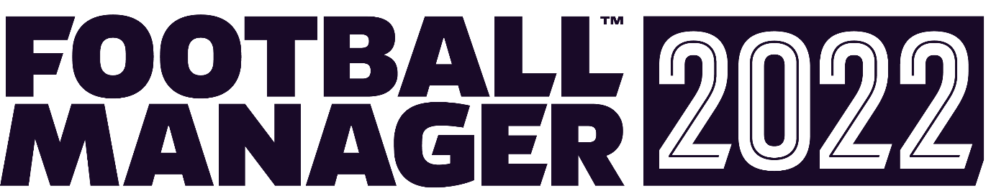

FOOTBALL MANAGER 2022 COMING NOVEMBER 9TH 2021
Available for the first time on Day One with Xbox Game Pass™

London, England – 9th September 2021 – Football isn’t just about being the best and winning; success means more when it’s earned, and fans can take on the challenge of earning success for their favourite club in Football Manager™ 2022. The latest release in Sports Interactive™’s and SEGA®’s iconic series will debut on November 9th on Steam, the Epic Games Store, and the Microsoft Store.
Football Manager Xbox Edition also makes its return following a successful campaign last season. Tailored for the Xbox™ ecosystem, FM22 Xbox Edition will release alongside the PC/Mac title on November 9th.
Both FM22 and FM22 Xbox Edition will be available with Xbox Game Pass™ on Day One, in a historic first for the series. Xbox Game Pass for PC members can enjoy the unparalleled depth and realism of FM22 while Xbox Game Pass for Console members can handle the managerial essentials from the comfort of their sofa with FM22 Xbox Edition. Both titles will be available to Xbox Game Pass Ultimate members.
Miles Jacobson, Sports Interactive’s Studio Director, said: “FM22 will break new ground for the Football Manager series as we arrive on Day One with Xbox Game Pass. The success of our return to Xbox last year surpassed even our expectations and we’re delighted to be expanding our partnership with Microsoft to give Game Pass members the chance to experience the closest thing to being a real football manager.”
FM22 brings new, progressive ways for managers to find their winning edge and instil their footballing style to cement their legacy as a managerial great. We’ll be unveiling new game features in the coming weeks across the Football Manager social channels and the Football Manager website.
From today until launch, fans who pre-purchase FM22 (for PC and Mac), from a SEGA-approved digital retailer* will receive a 10% discount and the chance to kick-off their managerial career ahead of schedule with Early Access to FM22. Pre-purchase directly from the Microsoft Store will be available soon.
Early Access will be available via Steam, the Epic Games Store, and the Microsoft Store roughly two weeks** prior to the official street date, and single player careers started in that period can be carried across to the final game.
Football Manager 2022 Mobile (on iOS and Android) is also lacing up for the new season and will be available on November 9th with feature information to be unveiled in October.
Full release details on Football Manager 2022 Touch, including our return to Nintendo Switch™ are coming soon.
For more information on the FM22 series on all platforms, visit www.footballmanager.com
-Ends-

*Early Access is available from SEGA-approved digital retailers only; please check here for an exhaustive list of digital retailers and more details as to what constitutes a SEGA-approved retailer.
**Early Access may go live at different times on different platforms
About Sports Interactive™:

Sports Interactive (SI) is the world’s leading developer of sports management simulations. Founded in 1994, SI became a wholly owned subsidiary of SEGA in 2006. Based in Stratford, East London, the SI team includes more than 200 full-time staff members, supported by a network of roughly 1,000 part-time researchers across the globe. SI is an official partner of many major football leagues and organisations, including the Bundesliga, LFP, the EFL and the League Managers Association, as well as numerous charities and not for profit organisations. Further information on the studio and its work can be found at www.sigames.com.
About Football Manager™:
Football Manager (FM) is the world’s leading football management simulation title. With more than 50 countries to manage in and a database of over 800,000 players and staff it offers an incredibly detailed and immersive experience. In FM you make all of the key decisions, from signing (and selling) players through training, team selection and tactics as you take your team to the top of the footballing world while carving out your own philosophy and strengthening your club’s identity. FM has grown to become more than just a game and has embedded itself in the football industry; the FM database is used by several clubs to help shape their recruitment strategies and thousands of professional footballers and backroom staff members are committed fans of the game. FM has become an integral part of modern fan culture; the game has not only enhanced the collective footballing knowledge of its players but has been the inspiration for several books, a stand-up comedy show and even a feature length documentary. For more information on Football Manager, visit www.footballmanager.com.
About SEGA® Europe Ltd.:
SEGA® Europe Ltd. is the European Distribution arm of Tokyo, Japan-based SEGA CORPORATION, and a worldwide leader in interactive entertainment both inside and outside the home. The company develops and distributes interactive entertainment software products for a variety of hardware platforms including PC, wireless devices, and those manufactured by Nintendo, Microsoft and Sony Interactive Entertainment Europe. SEGA wholly owns the video game development studios Two Point Studios, Creative Assembly, Relic Entertainment, Amplitude Studios, Sports Interactive and HARDlight. SEGA Europe’s website is located at www.sega.co.uk

