**flydubai marks the start of a new chapter with the arrival of the Boeing 737 MAX 8**

ALL on board: Enhanced aircraft performance

flydubai’s all Next-Generation Boeing 737-800 fleet has helped drive the airline’s rapid expansion to date. With the introduction of the Boeing 737 MAX 8, there are even more opportunities for flydubai to expand its network, to add frequency to high density routes, and to continue to open up underserved markets while remaining true to its low-cost principles of cost efficiency and flexibility. The aircraft unrivelled personalised onboard experience is coupled with a number of the industry’s best innovative new technology designed to enhance the aircraft efficiency and performance.

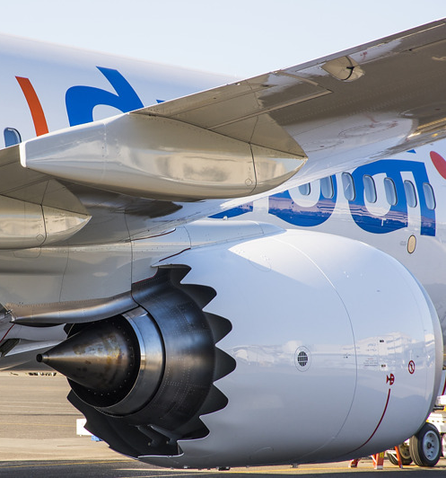

**Advanced engine technology**

The 737 MAX employs the most advanced engine in the world: CFM International’s LEAP-1B. It partners 787 engine technology with the reliability of the CFM56.

**Noise reduction**

The 737 MAX latest quiet-engine technology, reduces the noise footprint of the aircraft when comparing it with the Next-Generation 737.



**Fuel efficient**

The 737 MAX has been designed with efficiency in mind, so it uses significantly less fuel per seat than the original Next-Generation 737. The MAX 8 is expected to consume 14% less fuel than the current Next-Generations 737.



**Environmentally friendly**

The 737 MAX is more environmentally friendly with a design that aims to reduce carbon emissions, estimated to be as much as 50 percent below international limits for nitrogen oxides.



**Efficient design**

The 737 MAX has aerodynamic updates, including a new winglet design to take advantage of natural laminar flow and thereby improve fuel efficiency.

The new 737 MAX Advanced Technology winglet increases fuel efficiency by 1.8%.

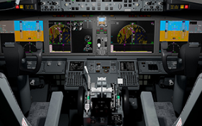

**Flying excellence**

The 737 MAX has a state-of-the-art flight deck, which provides the foundation for expanding capabilities in navigation and data management for many years to come. With new, larger 15-inch display screens, pilots are able to get more information for less effort.