eneloop™ puts more energy into its green vision
Panasonic increases its support to help preserve the environment

Zellik, 15 September 2016 – Panasonic Energy Europe will soon close the fourth edition of the eneloop European Photo Challenge. This European contest has been designed to target photographers but also to support environmental charities and organisations. During the contest there are prizes for the photo that receives the most votes and two donations of €5000 to the organisations giving nature a helping hand.

In doing so Panasonic highlights the importance that the brand places on sustainability, by not just offering superior environmentally friendly products with its rechargeable eneloop batteries, but also by providing financial support to organisations that share its green vision – Panasonic will tell us more about their environmental credentials at photokina, the international trade fair in Cologne.

In the previous edition of the contest, Natuurpunt was one of the environmental organisations lucky enough to benefit from a 5000 euro donation. The Flemish organisation will use the funds to improve habitats for beavers and otters – two mammals rarely found in Belgium. Panasonic also donated 5000 euros to the WWF Belgium with the money being allocated to the Romanian organisation The Center for the Rehabilitation of Orphan Bear Cubs. All environmental organisations associated with the current contest can be found on our website.

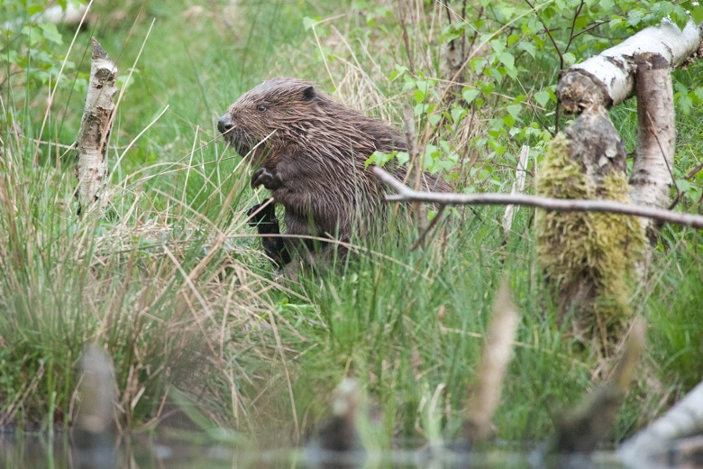 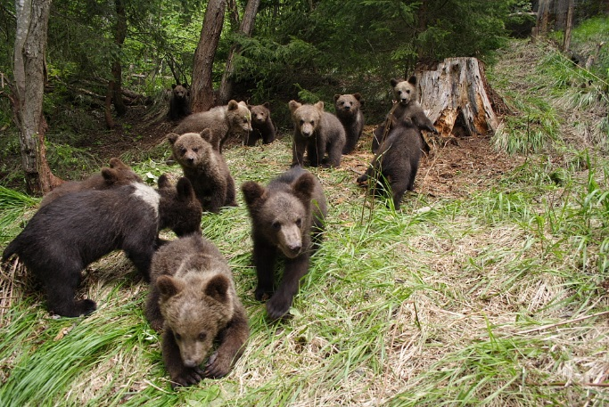
© Wim Dirckx (Natuurpunt) © Leonardo Bereczsky (WWF)
Panasonic donates 5000 euros to help Belgian beavers and otters (via Natuurpunt)
and orphaned brown bear cubs in Romania (via WWF).

‘Summer’ is replaced by ‘Ocean’
The Summer edition of the eneloop European Photo Challenge is coming to an end with the winner to be announced on the 14 October 2016 – the lucky winner will receive a Panasonic HC-VX870-video camera worth 680 euros, a set of eneloop batteries and a smart & quick charger. Find out more about taking part and view the most popular summer photos so far by visiting the website.
The theme of the next edition, which will run from the beginning of October until the end of December, will be ‘Ocean’. The photographer that snaps the Ocean themed photo with the most votes will win a Lumix DMC-FT5 worth 330 euros. The top prize will be handed over in mid-January and full details about the photography contest can be read here.

Green batteries in various shades of blue
eneloop is Panasonic’s ‘green’ rechargeable battery, now available in stunning shades of ‘blue’ in a new limited edition Ocean pack. The batteries can be recharged up to 2100 times, last longer than alkaline batteries and perform better at low temperatures (as low as -20°C). Furthermore they supply energy for longer than traditional Ni-MH batteries. Traditional Ni-MH batteries fail to work once the voltage drops below 1.1 volts, whereas eneloop batteries keep the voltage level over 1,1 volts for a longer time. For photographers who use very high drain equipment, eneloop can therefore be the difference between missing and capturing that perfect shot.

Find out more about our innovations at photokina
Panasonic will soon be exhibiting its green credentials at the photokina trade fair for the photographic and imaging industries – between 20 and 25 September in Cologne (hall 3.2, Konrad Adenauer Saal). The press conference will take place on 19 September 2016 from 12.30 to 1.30 pm. Afterwards, journalists will be given time to ask questions on eneloop, the European Photo Challenge or any other products within the company’s battery range at the Panasonic booth. This world renowned brand was previously shown at the IFA trade fair in Berlin (from 2 to 7 September), where its innovative products were received with enthusiasm from the audience.

Interested in an interview or visit? Then send a mail to Vicky Raman via Vicky.Raman@eu.panasonic.com.

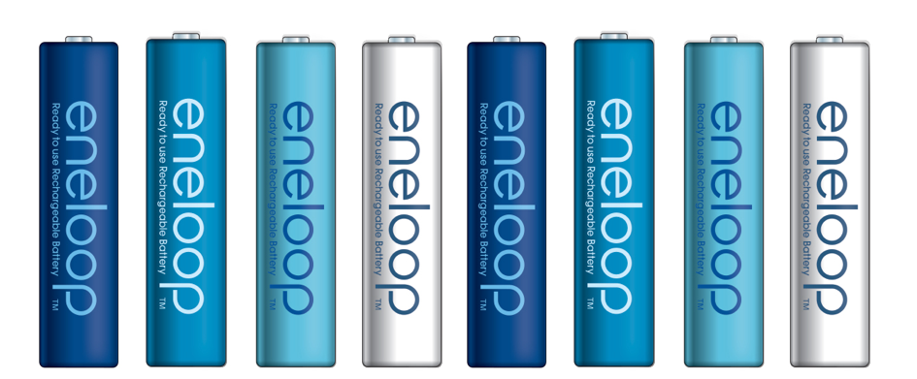

More info about previous eneloop contests? Check out http://www.ark.be/en/pressroom.

About Panasonic Energy Europe
Panasonic Energy Europe is headquartered in Zellik, near Brussels, Belgium. The company is part of the Panasonic Corporation, a leading global manufacturer of electronic and electrical goods. Panasonic’s vast and lengthy experience in the consumer electronics field has helped make Panasonic the largest battery manufacturer in Europe today. The European production facilities are located in Tessenderlo, Belgium, and Gniezno, Poland. Panasonic Energy Europe supplies ‘mobile’ energy solutions to more than 30 European countries. The company’s diverse product range includes rechargeable, chargers, zinc carbon, alkaline and specialty batteries (such as zinc air, photo lithium, lithium coin, micro alkaline, silver oxide).
For more information, visit: www.panasonic-batteries.com.

About Panasonic
The Panasonic Corporation is a leading company worldwide in the development and manufacture of electronic goods for a wide range of private, trade and industrial uses. Panasonic, based in Osaka, Japan, in financial year ended 31 March 2015 posted consolidated net sales of around 57.28 billion EUR. Panasonic is committed to creating a better life and a better world, continuously contributing to the evolution of society and to the happiness of people around the globe.
More information about the company and the Panasonic brand name at www.panasonic.net.

PRESS CONTACT

ARK Communication
Ann-Sophie Cardoen
Content & PR Consultant
T +32 3 780 96 96
ann-sophie@ark.be
www.ark.be

Panasonic Energy Europe NV
Vicky Raman
Brand Marketing Manager
T +32 2 467 84 35
vicky.raman@eu.panasonic.com
www.panasonic-batteries.com
www.panasonic-eneloop.com

