**Media release**

**22 June 2016**

**Is this the cleverest, cleanest vacuum ever produced?**

**-Brand behind cult kitchen gadget Thermomix launches new vacuum designed to help homeowners cut down on cleaning time-**

The German company behind cult kitchen cooker/blender the Thermomix has launched its new Ultimate Homecare System; a multi-functional, hi-tech upright vacuum cleaner. Known as the Kobold VK200, it is designed to carry out a range of time-saving cleaning tasks using a variety of snap-on attachments that will mirror the ‘got to have’ success of the Thermomix.

Vorwerk, which counts celebrities including TV property expert Sarah Beeny and consumer journalist Alice Beer amongst its fans, has aimed the vacuum at homeowners who love combining the latest technology with a device that actually does what it says on the tin.

Vorwerk’s new Kobold VK200 – the bigger and better brother to its current VK150 model - combines intuitive use with a timeless design focused on deep cleaning everything from your Grandma’s ten year old hearth rug to the shiny tiled kitchens of an über modern Chelsea penthouse.

***Use on everything from hard floors to mattresses***

As well as being at home on all kinds of floors, including tiles, wooden floorboards, laminate and carpet, the VK200 has five main interchangeable attachments that snap on and off in a matter of seconds to allow homeowners to tackle dirt and dust around the house – from floors to soft furnishings and mattresses.

Novel yet highly practical features include a handy soft furnishing attachment - known as the PB440 Electric Upholstery Brush – that rotates up to 4,000 times a minute to vibrate dust and dirt particles to the fabric’s surface and then suck them away into the VK200’s three in one filter bag that is certified as suitable for allergy sufferers.

There’s also the SP530 DuoClean head, which uses two suction channels to pick up large dirt particles and wipe away stubborn marks at the same time – a lifesaver when cleaning hard floors.

***The ability to deep clean mattresses and beds***

Perhaps most impressive of all is the VK200’s specialist MR440 mattress vacuum attachment, which - when used with the brand’s Lavenia cleaning powder - rapidly vibrates dead skin, dirt particles and dust mite droppings to the mattress surface using hundreds of rubber strips and sucks them out of harm’s way.

Retailing from £749 through to £1,499, the company has affectionately named it the ‘Rolls Royce of vacuum cleaners’ and has spent eight years in product development to ensure it is worth every penny.

Dr Thomas Rodemann, Chief Executive at Vorwerk Elektrowerke and the man behind the VK200 said:

“Good design is crucial to the Kobold VK200, and it has to represent our values of high performance, outstanding quality and practicality.

The way people clean their homes is changing, and as technology becomes more advanced, people need appliances that save time whilst continuing to do a great job.

The VK200 design remains modern and highly practical, but doesn’t follow trends as it will stay in use for years to come thanks to its excellent durability and our ‘built to last’ ethos.”

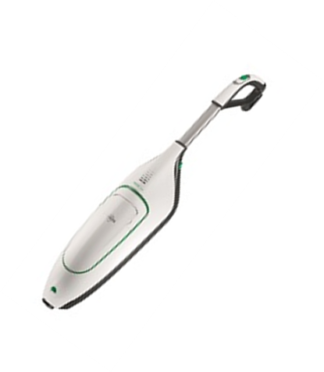

**The ‘tech spec’**

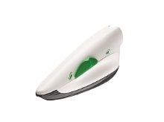

**Kobold VK200 body** – the main component of the upright system uses a series of optional attachments to deliver outstanding cleaning results across a range of surfaces.

**Kobold PB440 Electric Upholstery Brush –** the classic choice for cleaning upholstery with a highly effective approach that brushes and vacuums at the same time down to the very last fibre.

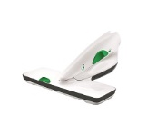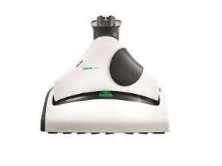

**Kobold MR440 Mattress vacuum** – perfect for deep-cleaning mattresses with a cleaning agent and brush which effectively ‘beats’ the mattress and immediately picks up the dirt.

**Kobold SP530** **DuoClean –** the hard floor cleaner uses just 100 millilitres of water to pick up debris and then mop up to 20 square metres of hard floor.

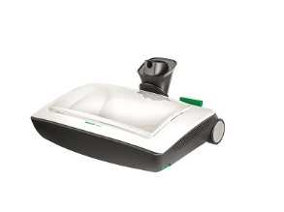

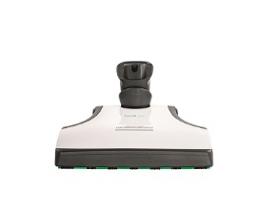

**Kobold VF200 Carpet Freshener** – a dual-action attachment which automatically sprinkles Kobosan Cleaning Agent and then works it into the carpet brushes the surface clean.

**Kobold EB400 Automatic Electric Brush** – including automatic floor detection which scans the floor 16 times per second to identify the surface and ensure each gets the right treatment.

**-ENDS-**

**For more information about the Vorwerk Kobold VK200 vacuum cleaner, go to** [**https://kobold.vorwerk.co.uk/home/**](https://kobold.vorwerk.co.uk/home/)

**To download this press release, go to** [**https://vorwerk-uk.prezly.com/**](https://vorwerk-uk.prezly.com/)

**To download hi-res images, go to** [**https://vorwerk-uk.prezly.com/media**](https://vorwerk-uk.prezly.com/media)

**For media enquiries or interviews with the Vorwerk UK team, please email** [**alex@faith-pr.co.uk/stefanie@faith-pr.co.uk**](mailto:alex@faith-pr.co.uk/stefanie@faith-pr.co.uk) **or call 01484 599 886**

**Follow Vorwerk UK on Twitter:** [**@VorwerkUK**](https://twitter.com/vorwerkuk)

**Find Vorwerk UK on Facebook:** [**Vorwerk UK**](https://www.facebook.com/KoboldVorwerkUK/)

**Cont.**

**Purchasing information**

**The Vorwerk VK200 can be purchased via an in-home demonstration booked online** [**here**](For%20more%20information%20about%20the%20Vorwerk%20Kobold%20VK200%20vacuum%20cleaner,%20go%20to%20https:/kobold.vorwerk.co.uk/home/)**.**

**The Vorwerk VK200 ranges in price from £749 - £1,499 depending on specification, see below:**

**Specification and pricing information**

**Package One - £749**

* **Upright vacuum cleaner with EB400 Automatic Electric Brush**

**Package Two - £849**

* **Upright vacuum cleaner with EB400 Automatic Electric Brush & accessory pack including:**
* **Crevice nozzle set**
* **Flexo-nozzle**
* **Telescopic tube**
* **Soft nozzle**

**Package Three - £1,049**

* **The Standard Hard Floor System including:**
* **Upright vacuum cleaner with EB400 Automatic Electric Brush**
* **Accessory pack**
* **SP530 DuoClean**
* **PB440 Electric Upholstery Brush**
* **MR440 mattress vaccum**
* **Deep cleaning mattress attachment**

**Package Four - £1,199**

* **The Standard Carpet System including:**
* **Upright vacuum cleaner with EB400 Automatic Electric Brush**
* **Accessory pack**
* **PB440 Electric Upholstery Brush**
* **MR440 mattress vacuum**
* **Deep cleaning mattress attachment**
* **VF200 carpet freshener**

**Package Five - £1,499**

* **The Standard Carpet System including:**
* **Upright vacuum cleaner with EB400 Automatic Electric Brush**
* **Accessory pack**
* **SP530 DuoClean**
* **PB440 Electric Upholstery Brush**
* **MR440 mattress vacuum**
* **Deep cleaning mattress attachment**
* **VF200 carpet freshener**
* **SP530 DuoClean**

**The history of Vorwerk**

Vorwerk & Co. KG was founded in Wuppertal in 1883. During the course of its 130-year history, the company, originally a carpet factory, has grown into a highly diversified, global corporate group. Vorwerk nevertheless remains a family enterprise to this day.

Since 1930, Vorwerk’s core business has been the direct selling of high-quality products. The Vorwerk product range includes household appliances (the Kobold vacuum cleaner and the Thermomix kitchen appliance) and the first-class JAFRA cosmetics. The akf banking group, the Vorwerk carpet factories and the HECTAS Group as an associate company all belong to the Vorwerk entrepreneurial family. Superior products and a special customer approach are something all divisions have in common, and what makes Vorwerk so special.

Vorwerk provides jobs for 622,000 people worldwide, of whom 40,000 work as sales advisers and representatives in the household appliances segment, 570,000 as JAFRA Cosmetics consultants, and 12,545 as employees. Vorwerk generated a business volume totaling more than 3,1 billion euros in 2013 and operates in 70 countries.

Vorwerk products have been available in the UK market during the last 30 years.