CHRISTIAN RÍOS
CHRISTIAN RÍOS HAIR COUTURE

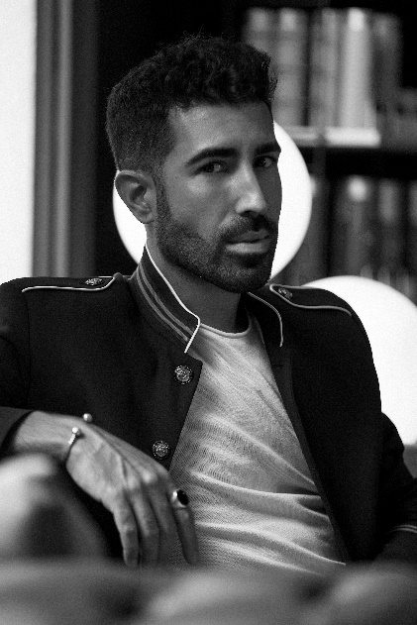
Christian Ríos is a hairdresser who embodies an artistic and multidisciplinary skillset. His passion and curiosity for design, fashion, styling, gardening and gastronomy are evident. From a young age, Christian travelled through the universe of art and creativity, looking for a clear vocation in which he could focus and develop his talent.

Sometimes we find people along the way who show us our own worth. Christian was lucky enough to meet Clemente, the owner of a hairdressing salon he used to go to; Clemente, intuiting the emerging capabilities of his client, encouraged him to train and enter the world of hairdressing and styling. That's how Christian Ríos began his career, starting out as an apprentice and working his way up to manager in a salon with a team of 15 people.

Understanding the need to acquire technical skills and creative passion, Ríos places great importance on training with fellow peers, such as Miguel Griñó in BCN, with Make Up Forever at the Stick Art Studio and in the academies of Raffael Pages. He continually expands his experience and knowledge through various courses: colouring in Italy with Gogem, avant-garde with Anne Veck and cutting in London with Roberto Masciave, among others.

Currently, he is the head of his own hairdressing business, “Christian Ríos Hair Couture Salon”, located in the old town of Vilanova i la Geltrú. The business is located in what was formerly an old wine store and later, a gardening shop. A renovated space in a unique and cosy environment, surrounded by nature, with simple designs that feature high ceilings and exposed iron beams, and which also includes individual pieces of furniture chosen in various antique shops.

Christian Ríos Hair Couture Salon offers a unique and complete experience with a team of professionals whose careers speak for themselves. Their constant dedication to continuous training enables them to offer complete, comprehensive advice on each and every process and hair treatment, innovative cutting and colouring techniques. The salon can also boast of the exclusive use of 100% organic products.

Nominations and awards:
- Finalist Hairnews Awards 2020
- Finalist Fígaro Awards 2020, best male collection category
- Runner Up International Visionary Awards 2020, cut & color category
- Finalist AIPP Awards 2020/2021, Mens and Best Colour categories

