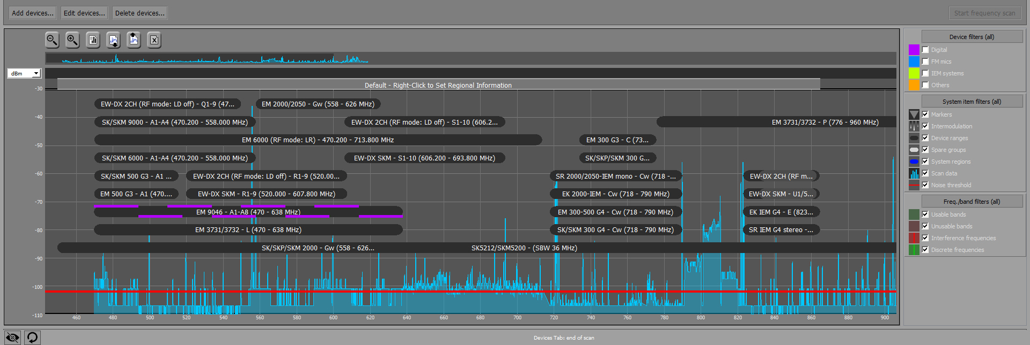 Wireless Systems Manager
Sennheiser launches version 4.6.0 to include EW-DX EM 2 microphone receiver in tool

Wedemark, 14 April 2023 – Sennheiser has announced an update of its Wireless Systems Manager software for Windows and macOS platforms, which will be available immediately after NAB. Providing efficient frequency management, monitoring and control for large Sennheiser wireless set-ups, version 4.6.0 will support the EW-DX EM2 two-channel receiver, the latest member in Sennheiser’s digital line-up.

“The Wireless Systems Manager has been an essential software tool for frequency managers and audio engineers for some time. Version 4.6.0. now extends its efficient workflows to include EW-DX,” comments Thomas Doerbaum, WSM product manager. “We already outfitted the first productions and shows that use EW-DX with a beta version of the software, and are excited to announce the official update for all EW-DX users to streamline their workflows.”

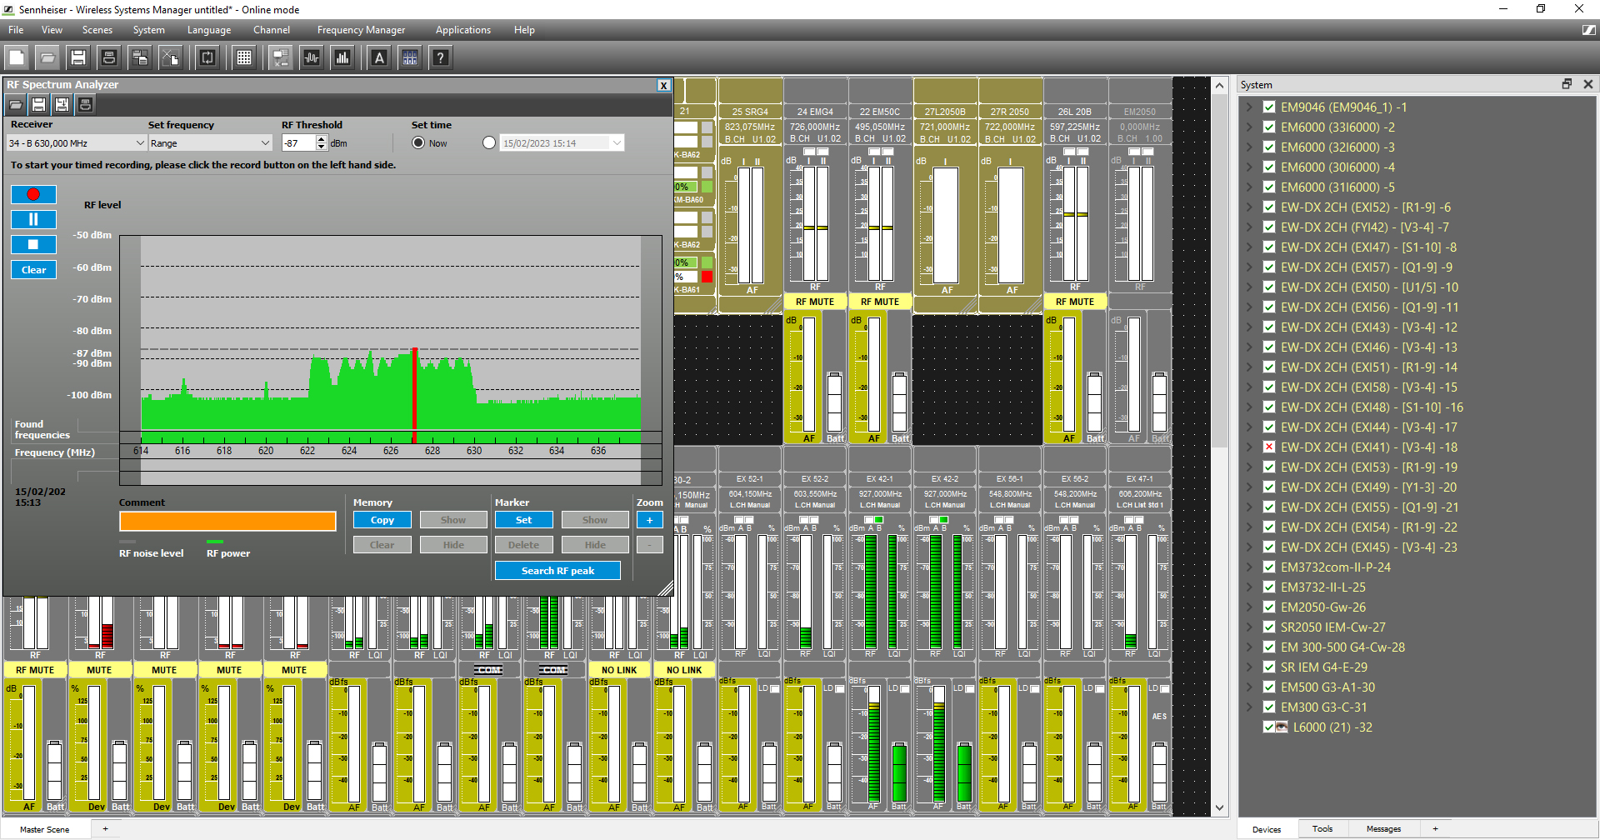 | The Spectrum Analyzer gives you detailed information about the RF environment you are operating in

Features supported include automatic device discovery in the network, remote configuration of device setting and channel properties, monitoring, and provision of firmware updates for EW-DX devices. EW-DX EM 2 has been integrated into the “Professional Setup” function as well as the Spectrum Analyzer and the RF Level Recorder features. Not yet included are Easy Setup and Channel Sorting. “These will follow in the upcoming releases,” says Doerbaum.

The software can be downloaded for free from April 20 at www.sennheiser.com/wsm.

(Ends)

The images accompanying this media release can be downloaded here.

About the Sennheiser brand
We live and breathe audio. We are driven by the passion to create audio solutions that make a difference. Building the future of audio and bringing remarkable sound experiences to our customers – this is what the Sennheiser brand has represented for more than 75 years. While professional audio solutions such as microphones, meeting solutions, streaming technologies and monitoring systems are part of the business of Sennheiser electronic GmbH & Co. KG, the business with consumer devices such as headphones, soundbars and speech-enhanced hearables is operated by Sonova Holding AG under the license of Sennheiser.

www.sennheiser.com
www.sennheiser-hearing.com

Global Pro Audio Press Contact
Stephanie Schmidt
stephanie.schmidt@sennheiser.com
+49 (5130) 600 – 1275

