Press information

EVOC COMMUTING Capsule Collection 2023
World premiere COMMUTE A.I.R. PRO 18: an airbag backpack for cycling

EVOC Sports, global market leader for backpacks with back protectors is introducing the world’s first bike backpack with integrated airbag technology and is hereby endeavoring to reduce the risk of injury for commuters from now on. The COMMUTE A.I.R. PRO 18 is the heart of the new EVOC COMMUTING Capsule Collection, the first dedicated EVOC range targeted at the future-oriented segment of bicycle travel in urban areas. The products within this range offer innovative approaches regarding the protection of cyclists in traffic and well-thought-out, contemporary transport solutions.

· First bike backpack with airbag and back protector
· New EVOC-COMMUTING range from 2023
· Concept presentation on the iAA Mobility (07.-12.09.21) in Munich
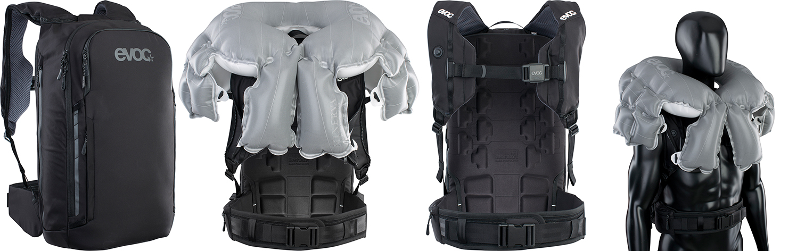
Mobility, especially in urban areas, is changing rapidly. Congestion of motor vehicle infrastructure in cities, growing environmental awareness and a mega trend towards a healthier lifestyle are facilitators of this change. Poor bicycle infrastructure fuels fear of accidents and the resulting injuries which is what constitutes one of the main inhibitors of bicycle traffic. This is what sparked EVOC to make bike commuting safer and more comfortable with the products of the COMMUTING line from 2023.

From zero to safe in 0.2 seconds
Safety first in the urban bike jungle: the COMMUTE A.I.R. PRO 18 backpack combines the protection of the innovatively integrated airbag technology with the integrated LITESHIELD-PLUS back protector (EN 1621; level 2). This provides optimum protection for the neck, shoulders, collarbones, as well as the chest area. The airbag system was developed in collaboration with Minerva-AS GmbH specifically for the application in bike backpacks for commutes to work, school or leisure activities.
The heart of the system is a sensor-controlled, inflatable airbag protector with a volume of 18 liters. It is activated and deactivated by opening or closing an electric, magnetic buckle on the chest strap. The USB-chargeable sensory unit analyses the position of the backpack up to 1,100 times per second. Once the defined deployment criteria are met, e.g. in a crash, the airbag inflates within 0.2 seconds and unfolds its protective effect. This reduces the impact forces and braking acceleration (HIC – head injury criterion) on the cyclist by up to 80%.
The airbag is mechanically deployed via the activation of an e-igniter. Once deployed and checked for damage, the system can be reused with a new cartridge.
In addition, the backpack made of recycled Polyester, offers all the features any modern cyclist could wish for on their daily trips to work or leisure activities: a laptop compartment with lateral quick access, organizer compartments, pockets for glasses and smartphone, an elastic lateral pocket, a height-adjustable hip belt for perfect fit made of AIRO-FLEX, as well as seamless shoulder straps to minimize friction. If the removeable back protector shows visible signs of damage after a crash, it will be replaced in line with the FREE PROTECTOR CRASH REPLACEMENT. (RRP: 900 €, available from Spring 2022)

The COMMUTE PRO 22 backpack protects large sections of the spine and back with its light, integrated LITESHIELD-PLUS back protector (EN 1621-2; level2) and is the ideal companion, as well as the perfect transport solution for inner-city traffic. The ingenious compartment management, including a separate laptop compartment, organizes your everyday life “on the go” and reflective prints provide more safety and visibility. The ideal ventilation helps you keep dry even on the hottest summer rides. Aside from the smartphone and laptop compartments with lateral quick access, a separate compartment for glasses and multi-functional attachment straps offer perfect organization at all times. The backpack made of 100 % recycled Polyester includes FREE PROTECTOR CRASH REPLACEMENT. (RRP: 230 €, available from Summer 2022)

The spacious COMMUTE 22 with its minimalist style is the ideal transport solution for daily rides through the city. The backpack’s 22 liter main compartment has a wide opening and provides easy access to all its contents. The 3D-moulded back portion offers great ventilation and a maximum of comfort. Special prints reflect car headlights and hereby provide the necessary safety in traffic. It features a 15” laptop compartment, a smartphone compartment, both with lateral quick access, a compartment for glasses, as well as multi-functional attachment straps. (RRP: 170 €, available from Summer 2022)
The EVOC COMMUTING range is completed by the 16 and 26 liter DUFFLE BACKPACKs which are already available in the EVOC TRAVEL line. They feature convenient accessories like a rain cover, a smartphone pocket and a bottle. The water resistant backpack made of 100 % PVC free outer material withstands any shower and the variable aluminium buckle on the lid lets you adapt its size to the contents. Cleverly positioned pockets and easy-to-reach lateral compartments for a laptop, a smartphone, keys in the back section keep everything within reach at all times. (RRP: 140 €, available from Autumn 2021)
Protection as a business model
EVOC Sports GmbH is an owner-operated company based in Munich specializing in the development and production of functional sports backpacks with protective features and sports travel gear. Since the company’s founding, Bernd Stucke and Holger Feist have been managing directors. The team at the headquarters currently includes 20 employees in the areas of sales, marketing and product design.
Today, EVOC is the global market leader for backpacks with back protectors, which are mainly focused on ambitious mountainbiking and wintersports, as well as bags for travelling with bikes. The well over 100 product models available in the segments BIKE, SNOW, TRAVEL and PHOTO are sold through a network of distributors in 32 countries around the globe. In future, COMMUTING products will compliment this portfolio.
Premiere on the iAA Mobility 2021
On the iAA Mobility, from September 7th to 12th 2021 in Munich, EVOC will present their new concept for the COMMUTING range, as well as the COMMUTE A.I.R. PRO 18 – backpack with innovatively integrated airbag technology - for the first time. The range will be available for sale from 2023.

As at: 09/2021

Subject to modifications and amendments

Media contact: press@evocsports.com

