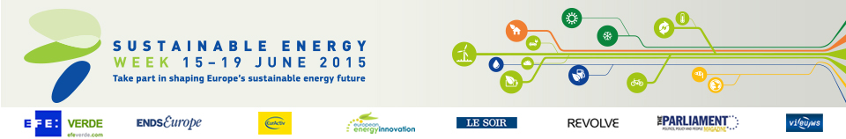

Energy Days in Lithuania (1)

- Business and the future of sustainable energy: from EU policy to practical measures
Date: 16/06/2015
Time: From 9:30 to 13:30
Location: Vilnius

