Sennheiser TeamConnect Ceiling helps St. John’s University create ‘classroom without borders’
Patented beamforming technology, ease of installation and reliability make TeamConnect Ceiling the perfect solution for University’s state of the art classroom experience

New York City, June 12, 2019 — St. John’s University, a post-secondary research university with 21,346 full and part time students and five campus locations around the world, is an academically rigorous institution and a founding member of college sports’ famous Big East Conference. With its primary campus located in Queens, New York, St. John’s offers more than 100 bachelor, master, and doctoral degree programs as well as professional certificates. Recently, the University began standardizing the technology within its classrooms, conference rooms and meeting spaces and settled on Sennheiser’s TeamConnect Ceiling as its primary audio-conferencing solution.

St. John’s University, a post-secondary university with 21,346 full and part time students, recently installed several Sennheiser TeamConnect Ceiling units across its campus.

(Image courtesy of St. John’s University)

With an international student body and dynamic faculty that are pushing the boundaries of modern post-secondary education, St. John’s primary goal in implementing Sennheiser’s TeamConnect Ceiling conferencing solution was to provide greater flexibility for its faculty, while delivering the best possible communications experience: “When we look at an AV solution, it is meant to facilitate communication, whether inside or outside of the classroom,” says Eric Alvarado, Director of Academic Technology, St. John’s University. “Teaching is at the point where the traditional walls of a classroom are no longer a limitation; so, our spaces have to perform and be flexible.”

The university began a comprehensive upgrade of its classroom technology in 2014, realizing that some of the equipment was dated and that a new, cohesive standard was required. The team proceeded to evaluate the technology needs of each of the five schools of the University, and created a journalized classroom standard with the intent of applying and replicating this standard in each classroom. The new system would need to accommodate the wide-ranging needs of the faculty, and provide the ability to be remotely monitored, managed and measured.
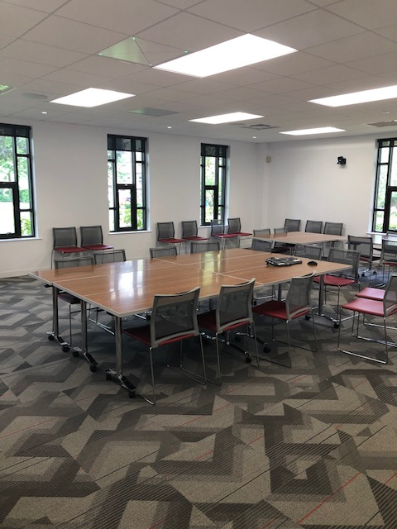 | In St. John’s University’s Inclusivity Resource Center, a Sennheiser TeamConnect Ceiling provides intelligible audio for a wide range of communication needs.  (Image courtesy of St. John’s University)

Starting from a known position
Before settling on the TeamConnect Ceiling solution, St. John’s had already been utilizing Sennheiser wireless microphones across its campus. “We started installing the wireless mics in Manhattan around 2013 and we probably have well over 300 wireless microphones from Sennheiser at this point,” explains Salvatore Frucci, Audiovisual Systems Engineer, St. John’s University. “I met our Sennheiser sales representative, Tom Conte, at InfoComm in 2015 and we set up time to demo the TeamConnect Ceiling system, and it was quite impressive. This was the catalyst that started the process of us installing them here on the campus.”
“The great thing about TeamConnect is that it really follows your voice around the room with the beamforming technology,” Frucci continues. “This feature caught our attention pretty quick, and as we started deploying them, the difference in intelligibility was night and day.” Currently, St. John’s has TeamConnect Ceiling units in four locations: its St. Augustine Faculty Development Classroom has two of them in one of its larger spaces, and three other units are located in conference rooms across the University’s main campus in Queens.

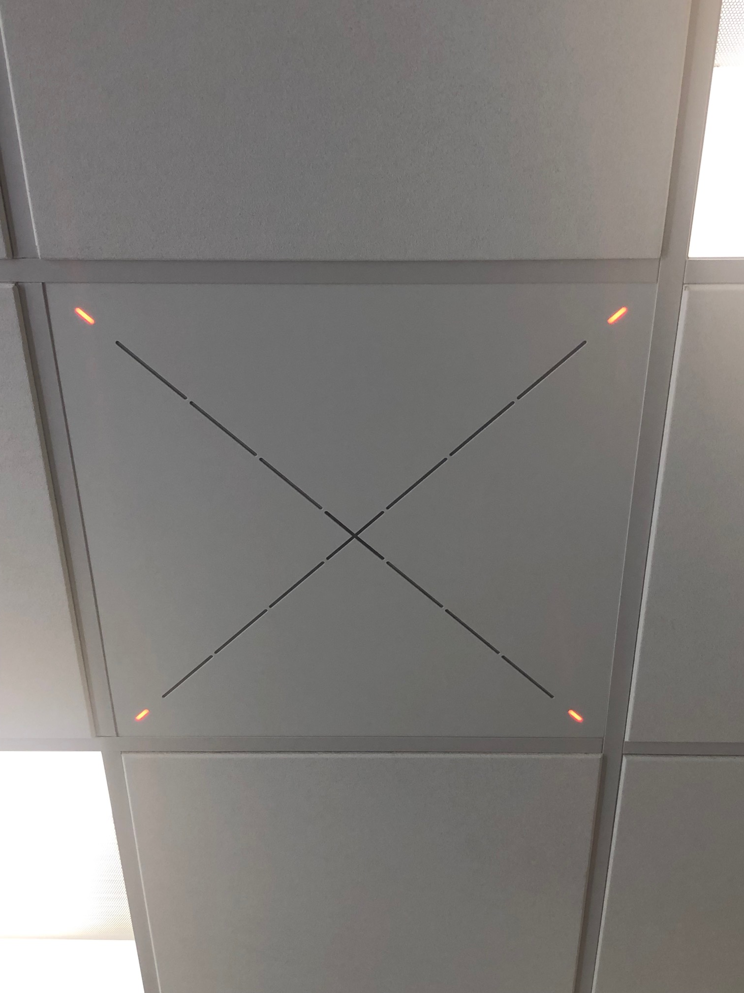 | A close up of Sennheiser’s Team Connect Ceiling at St. John’s University. The 2’ x 2’ tile is aesthetically seamless and easy to install.  (Image courtesy of St. John’s University)

Getting smart with TeamConnect Ceiling
The technology team at St. John’s appreciates TeamConnect Ceiling not only for its performance and reliability, but for its ease of installation and ‘plug and play’ operation. “It only uses one microphone output into your DSP, so as far as the installation, you are basically just dropping in a 2’ x 2’ tile into the ceiling,” explains Frucci. “There is only one wire running back into your equipment rack, and one wire going into your sound system. Many other products on the market consume up to 8-16 inputs on your interface. This makes configuration easier and also saves rack space.” Once it is installed, the software guides the user through the set-up process. “You do minimal configuration and it really works out of the box,” says Frucci.

Perhaps most importantly, the unit is simple to use for the faculty. On entering the room, they turn the system on and it is fully operational. “With the TeamConnect Ceiling in our rooms, our faculty can focus on delivering content and it picks up everything. If there is a question asked in the back of the room, the professor doesn’t have to repeat the question for the benefit of others who couldn’t hear it — because now everyone can hear it. That becomes key in recording lectures or in important review classes,” Frucci explains.

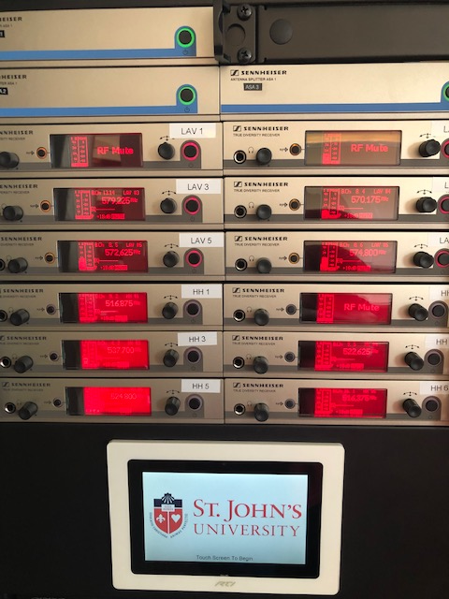 | By using the Sennheiser Control Cockpit software, St. John’s University is able to remotely monitor and manage its networked audio devices.  (Image courtesy of St. John’s University)

All systems ‘Go’ with Control Cockpit
Now that St. John’s has several TeamConnect Ceiling units installed, the Sennheiser Control Cockpit software is being used to monitor and manage the status of the network enabled microphones across campus — including TeamConnect Ceiling units and several other Sennheiser microphones across campus. By using Sennheiser Control Cockpit, the team can gain status information at a glance and make adjustments for one or multiple devices at the same time.

“We are using Control Cockpit to remotely check the battery levels of our microphones, as well as frequency placement of our wireless mics,” says Frucci. “We have 80 rooms in one building, so you have to be very careful with frequency assignments. Control Cockpit helps us manage this and ensure that all our frequencies are aligned so we don’t have any performance issues.”

With TeamConnect Ceiling up and running, and as the University explores possibilities of rolling it out in other locations, Sennheiser’s latest conferencing solution is helping St. John’s stay at the cutting edge of learning communication. “For us, the notion is that everything has to be consistent from classroom to classroom,” concludes Alvarado. “It makes the user experience more flexible and a lot easier. Also, the number of support calls have fallen off the table because it just works.”

To learn more about St. John’s University, please visit http://www.stjohns.edu. For more information about Sennheiser’s TeamConnect Ceiling solution, please visit https://en-us.sennheiser.com/tcc2.

About Sennheiser
Shaping the future of audio and creating unique sound experiences for customers – this aim unites Sennheiser employees and partners worldwide. Founded in 1945, Sennheiser is one of the world’s leading manufacturers of headphones, microphones and wireless transmission systems. With 21 sales subsidiaries and long-established trading partners, the company is active in more than 50 countries and operates its own production facilities in Germany, Ireland, Romania and the USA. Since 2013, Sennheiser has been managed by Daniel Sennheiser and Dr. Andreas Sennheiser, the third generation of the family to run the company. In 2017, the Sennheiser Group generated turnover totaling €667.7 million. www.sennheiser.com

Local press contact Global press contact

Jeff Touzeau Stephanie Schmidt
jeff@hummingbirdmedia.com stephanie.schmidt@sennheiser.com
+1 (914) 602-2913 +49 (5130) 600 – 1275

