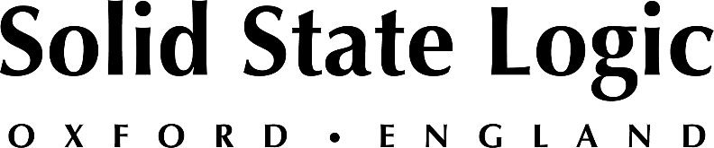

NAB 2022: Solid State Logic to Feature its New SSL Live L650 Console and V5 software, Best-In Class Solution for Next-Gen Production Environments

Be among the first to experience SSL Live L650 and the latest V5.0 software, SSL's flagship solution for installed sound & events, houses of worship and touring.

LAS VEGAS, April 5, 2022 — Solid State Logic [Las Vegas Convention Center, Booth C8008] will be featuring its new SSL Live L650 console and V5.0 software at the 2022 NAB Show, scheduled to occur at the Las Vegas Convention Center between April 23 -27. Arrange a feature overview and be among the first to experience the SSL Live 650, SSL's flagship solution for touring, event production, houses of worship and installed sound.

The SSL Live V5.0 software, which will be demonstrated in conjunction with the SSL Live L650 console, offers a powerful set of integrated control solutions for L-Acoustics' L-ISA and Meyer Sound Spacemap GO, Shure ULX-D and Axient Digital Mic Control, providing control over key features from within the SSL Live console ecosystem, in addition to new processing tools: Blitzer, Sorcerer and much more.

SSL's Fernando Guzmán, Live Product Specialist who has just completed a round of SSL Live Certified training, will be on hand to offer feature overviews as well as an introductory session of both SSL Live 650 and V5.0. for interested attendees. Space is limited and a prior appointment is required. For more information or to book an appointment, please visit: https://bit.ly/SSLLiveatNAB22
"The SSL Live L650 is a powerful solution for both touring professionals and house of worship operators," says Fernando Guzmán. "Built on our flexible Tempest processing engine and utilizing our legendary SuperAnalogue™ audio technology and, as all SSL Live consoles, legendary SSL processing tools, the L650 is the most flexible, scalable and powerful SSL Live console to date. Its remote capabilities and make it nimble and scalable for many touring or house of worship applications, while the sound quality, workflow and dependability are exactly what you would expect from SSL."

During NAB 2022, the SSL Live team will also be on hand to discuss new features of the new SSL Live V.5.0 software, SOLSA, as well as its 'Plus Processing Packs' for the entire SSL Live console range as users look to keep their current SSL Live inventory at the cutting edge of production capabilities.

Interested attendees of the 2022 NAB Show can use SSL guest code LV8385 for free access prior to April 8th. To book an appointment, consultation, or demonstration, please visit the SSL events page at: https://www.solidstatelogic.com/events/nab-show.

Solid State Logic is the world’s leading manufacturer of analogue and digital audio consoles and provider of creative tools for music, broadcast, live and post production professionals. For more information about our award-winning products, please visit: www.solidstatelogic.com.

###
For further information contact:
Jeff Touzeau
+1 (914) 602-2913
jeff@hummingbirdmedia.com

Ross Gilbert
+44 (0) 1865 842300
rossg@solidstatelogic.com

