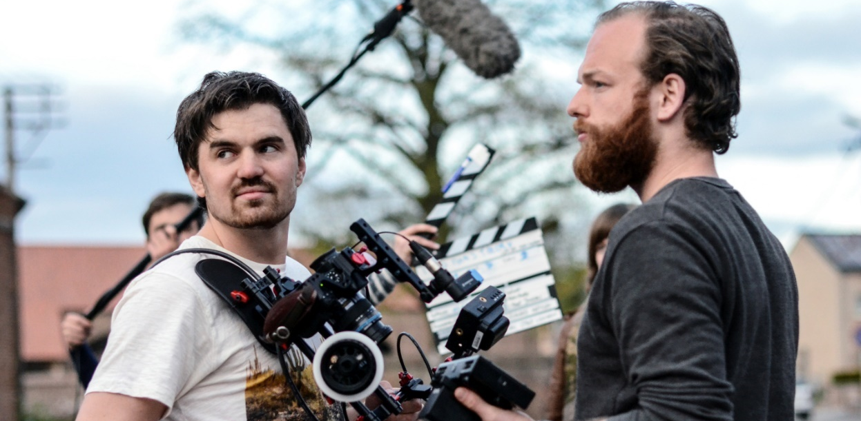

“We’re excited to be back at NAB”
Sennheiser, Neumann and Dear Reality showcase state-of-the-art audio solutions

Las Vegas, March 31, 2022 – Visitors to NAB are invited to experience the combined power of three brands at booth No. C6715: Sennheiser, Neumann and Dear Reality will show expert tools that broadcasters – and webcasters – can count on every day. Describing the breadth of solutions on show that includes new and upcoming products, Mark Posgay, Senior Vice President Sales, Professional Audio, Americas, comments: “We’re excited to be back on the NAB show floor and see our customers face to face. We will have great solutions for pristine audio capture, reliable monitoring and best-in-class immersive mixing waiting for them.”

The Sennheiser Group booth features an experience zone that will present a complete Dolby Atmos® mixing workflow complemented by products from Dear Reality and Neumann. Visitors can immersively mix and monitor Atmos ‘on the go’ using Dear Reality’s dearVR SPATIAL CONNECT, dearVR MONITOR and dearVR PRO plus a pair of studio headphones. As the zone is additionally fitted with a 5.1.4 AES67-based Neumann monitoring system, visitors will be able to listen to a benchmark reproduction of the mix results. Additional demonstrations will be presented every hour, showing how broadcast engineers can work in remote, on the go setups with Dear Reality’s software tools or in a fully-fledged studio environment with Neumann monitors.

Sennheiser products at NAB
Sennheiser will showcase all the audio equipment that broadcasters need to deliver superior sound to their audiences. The range includes everything from premium shotgun microphones like the MKH 8060 and MKH 416 to leading-edge wireless tools like the EK 6042 camera receiver, which works seamlessly with Sennheiser’s digital and analog wireless microphones.

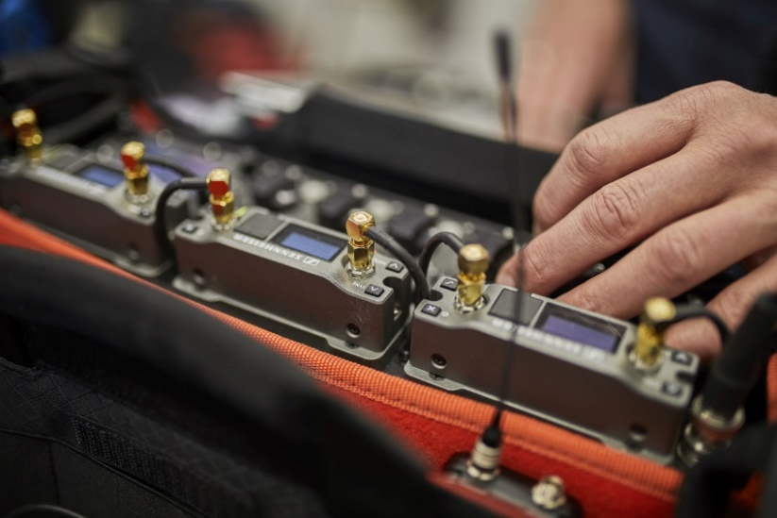 | The EK 6042 camera receiver works with analogue and digital Sennheiser transmitters

NAB will also showcase cherished RF wireless solutions for major broadcast events and shows, such as Sennheiser’s Digital 6000 wireless microphone series and 2000 IEM series.

The MKE 400 is an ideal tool for situations that require a small set-up with quick and reliable audio capture | 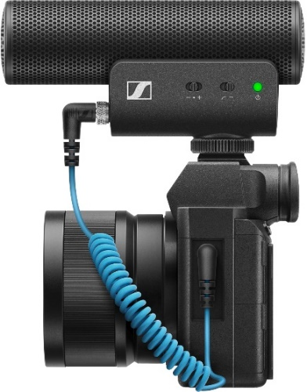

For ENG professionals and creators, Sennheiser will be bringing both its analog evolution wireless G4 camera system and the popular digital counterpart, the AVX, to NAB. For creators and mobile journalists who work with their DSLR camera or mobile phone, the MKE 200, MKE 400, MKE 600, XSW-D Portable Lav Mobile Kit and XS Lav Mobile Kit are ideal solutions.

Sennheiser will also present the full MKH studio microphone line, monitoring headphones and broadcast headsets as well as Evolution Wireless Digital, a wireless microphone system that is as easy to use as an app.

The Neumann showcase
As part of the experience zone, Neumann will show upcoming studio monitors with optional AES 67 interface in an exclusive sneak preview for NAB visitors.

The new Neumann Miniature Clip Microphone System is also making its NAB debut. Taking electret technology to a new level, this microphone can be combined with nine clever mounting solutions for close-miking instruments. The rugged and fully modular system is set to become a firm favorite with live music broadcasts.

The new Neumann Miniature Clip Microphone System takes electret technology to a new level | 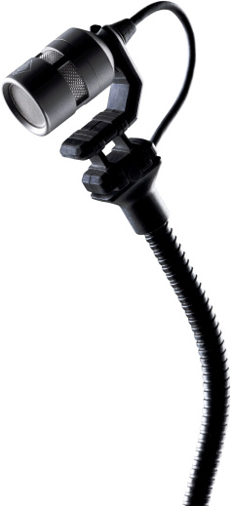

No audio show would be complete without the famous Neumann studio mics: The classic U 87 is joined by the TLM 102 and TLM 103, plus the BCM 705 for radio hosts. Also on show are the KU 100 binaural head and the KMR 81 and KMR 82 shotgun mics. The popular Neumann NDH 20 studio headphones will be shown alongside a brand-new sister model.

Immersive audio software from Dear Reality
Dear Reality will present plug-ins and application software for professional mixing studios and remote productions. The state-of-the-art dearVR PRO spatializer plugin offers best-in-class externalization and true-to-life immersion, enabling sound engineers to mix in 26 multi-channel output formats, from stereo to 7.1.2, 7.1.4, and 9.1.6.

The dearVR SPATIAL CONNECT controller application connects a VR headset to selected DAWs, where it offers an efficient and intuitive 360° mixing environment. Complete with head-tracking functionality and gesture-controlled positioning, the software is an ideal choice for advanced spatial audio production.

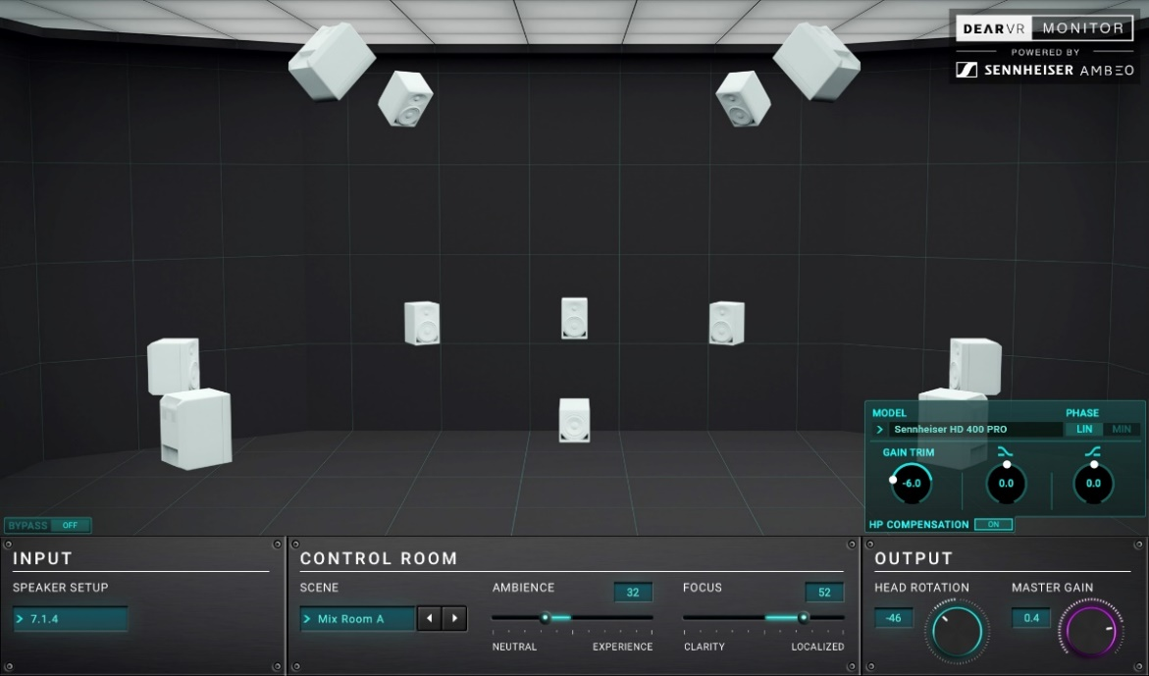
The intuitive user interface of dearVR MONITOR showing a 7.1.4 set-up

As Dear Reality’s top-of-the-range product for headphone mixing, dearVR MONITOR brings carefully designed virtual immersive mix rooms to any pair of headphones, making mixing fully independent of a studio. With a total of 26 multi-channel speaker formats, five virtual reference-grade mix room models and 11 typical listening environments, dearVR MONITOR enables an engineer to monitor immersive productions up to 7.1.4 and 9.1.6 directly through headphones.

(Ends)

The images accompanying this press release and additional photos can be downloaded here.
Dolby and Dolby Atmos are registered trademarks of Dolby Laboratories.

