FOH Engineer David Loy Relies on RME During Packed Summer of Country Festivals
From Country Thunder in Wisconsin to the North Dakota State Fair, Loy deployed RME gear for its reliability against grueling outdoor and touring conditions while mixing FOH for Kane Brown

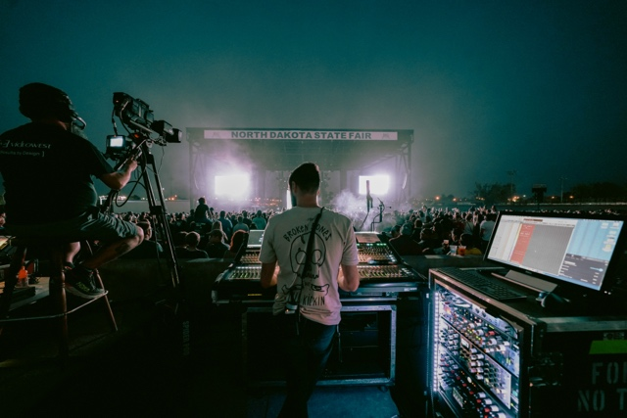
Nashville, Tennessee, September 14, 2021 — After a nearly year-and-a-half break from touring and live performances, David Loy, FOH engineer for country superstar Kane Brown, was ready to hit the road this summer with a packed schedule of country festivals, concerts and state fairs. And with a rigorous schedule based almost solely around outdoor shows, Loy knew he needed an interface and converter that could not only withstand the rigors of tour life but also unpredictable weather conditions. After using a Ferrofish A32 converter on the road for nearly two years and, according to Loy, “beating the life out of it with no issues,” he turned to RME’s MADIface XT interface and the M-32 DA analog converter to start out the summer touring season this past May.
“When you headline country shows and country festivals, you deal with a lot of unknowns, such as gear rattling around in trucks and unexpected weather conditions,” Loy said. “Basically, a lot of things you wouldn’t want to put electronics through. I needed something that could ride on a truck and not break, but also deal with the rain and dust. I needed something durable. And RME has been that for me. The RME MADIface XT and M-32 have handled it all. Every time I turned them on, they were good to go.”
High-Channel Counts & MIDI Capabilities
A self-proclaimed “MIDI nerd,” in addition to requiring a high channel count at a high sample rate — he’s currently recording 76 channels at 96 kHz every show — Loy also needed MIDI capabilities.
“I needed to integrate and route MIDI I/O in and out of my console,” he explained. “I love MIDI, and all it enables me to do, so now I’m recording LTC timecode through the MADIface XT, converting it to MTC, and then outputting that to my console via the MIDI stream. This way, I can fire my snapshots using timecode values for more accurate programming. Other engineers might have to get another laptop or interface for this, but all I need is one app connected to my computer and it runs in the background. It allows me to program the show even more creatively.”
Loy tracks into his DAW via the MADIface XT allowing him to have the ability to do a virtual playback of a captured soundcheck or show at FOH.
“By doing this, Kane and the band can listen at FOH with me, and I can show them certain clips of the recorded rehearsal or soundcheck,” Loy said. “This allows me to accurately portray how it sounds at FOH for them.”
“Every time I hit record on the MADIface XT, it never misses a beat,” he continued. “The conversion is super clean, and honestly, it’s such a relief knowing that it will work every time.”
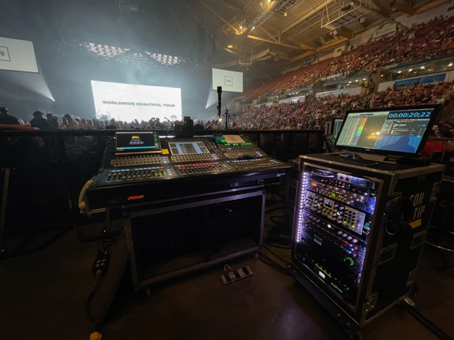
‘Hearing the Full Spectrum’
Loy’s entire playback system is RME, adding that he uses an ADI-4 DD ADAT AES converter for vocal processing.
“In our tracks playback world, there are four different RME devices that are clocking and talking together,” he explained. “Using the MADIface XT for redundant playback has been amazing, because our tracks used to be analog, so we were converting twice by the time audio got to the consoles. By using a MADIface XT, I’ve noticed a shift in the ends and beginnings of the audio spectrum. Sometimes poor conversions can cause the higher ends (15kHz-20kHz) and lower ends (20Hz-40Hz) of the audio spectrum to sound weak, but there’s none of that with the MADIface XT. I’m literally hearing the full spectrum. When there’s a sub-hit, I feel it go all the way down. It really allows us to get even more creative sonically.”
P.A. Tuning Improved
Ahead of a live show, when tuning the venue’s P.A.s, Loy mentioned he has begun playing his tuning music via AES through the MADIface XT.
“There’s no conversion, therefore I know the song I’m listening to through the P.A. is properly reproduced and of the right quality.”
Overall, Loy said the MADIface XT has been a game-changer — and the small form factor only adds to its long list of benefits.
“I needed an interface that did a ton of stuff in a small form factor, and I was genuinely shocked when I started using the MADIface XT. It allows me to continue archiving high channel counts and now that I’m using the MIDI integration, it allows me to keep my snapshots on the grid, all at 96 kHz. And best of all, it fits in my work box.”
For more on RME, visit rme-usa.com

About Synthax, Incorporated
Synthax Inc. is the exclusive USA distributor for RME digital audio solutions, Digigram broadcast audio systems, Appsys digital audio tools, Ferrofish advanced audio applications, myMix personal monitoring systems and ALVA cableware. We supply a nationwide network of dealers with these products for professional audio, broadcast, music industry, commercial audio, theater, military and government applications. For additional information, visit the company online at http://www.synthax.com.

Media Contacts:
Katie Kailus
Public Relations
Hummingbird Media
+1 (630) 319-5226
katie@hummingbirdmedia.com

Jeff Touzeau
Public Relations
Hummingbird Media
+1 (914) 602 2913
jeff@hummingbirdmedia.com

