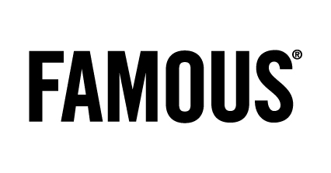

Press

Uncensored site & Facebook application: credits

Agency: Famous
Client: Musée Royal de l’Afrique Centrale – Kristien Opstaele
Account Director: Mieke Van de Gehuchte
Creative Directors: Tim Driesen, Joeri Van Den Broeck & Christophe Ghewy
Creative Team : Gijs Sluijters & Joris Tol
Interactive Director: Jonathan Detavenier
Project Manager: Katrien Dupon
Webdesign: Pieter Nijs
Web development: Thomas Mattheussen
PR Management: Liesbeth Pyck, Anne-Cécile Collignon

