Hear, there, and everywhere.
Sennheiser introduces All-Day Clear: a new class of over-the-counter hearing aids
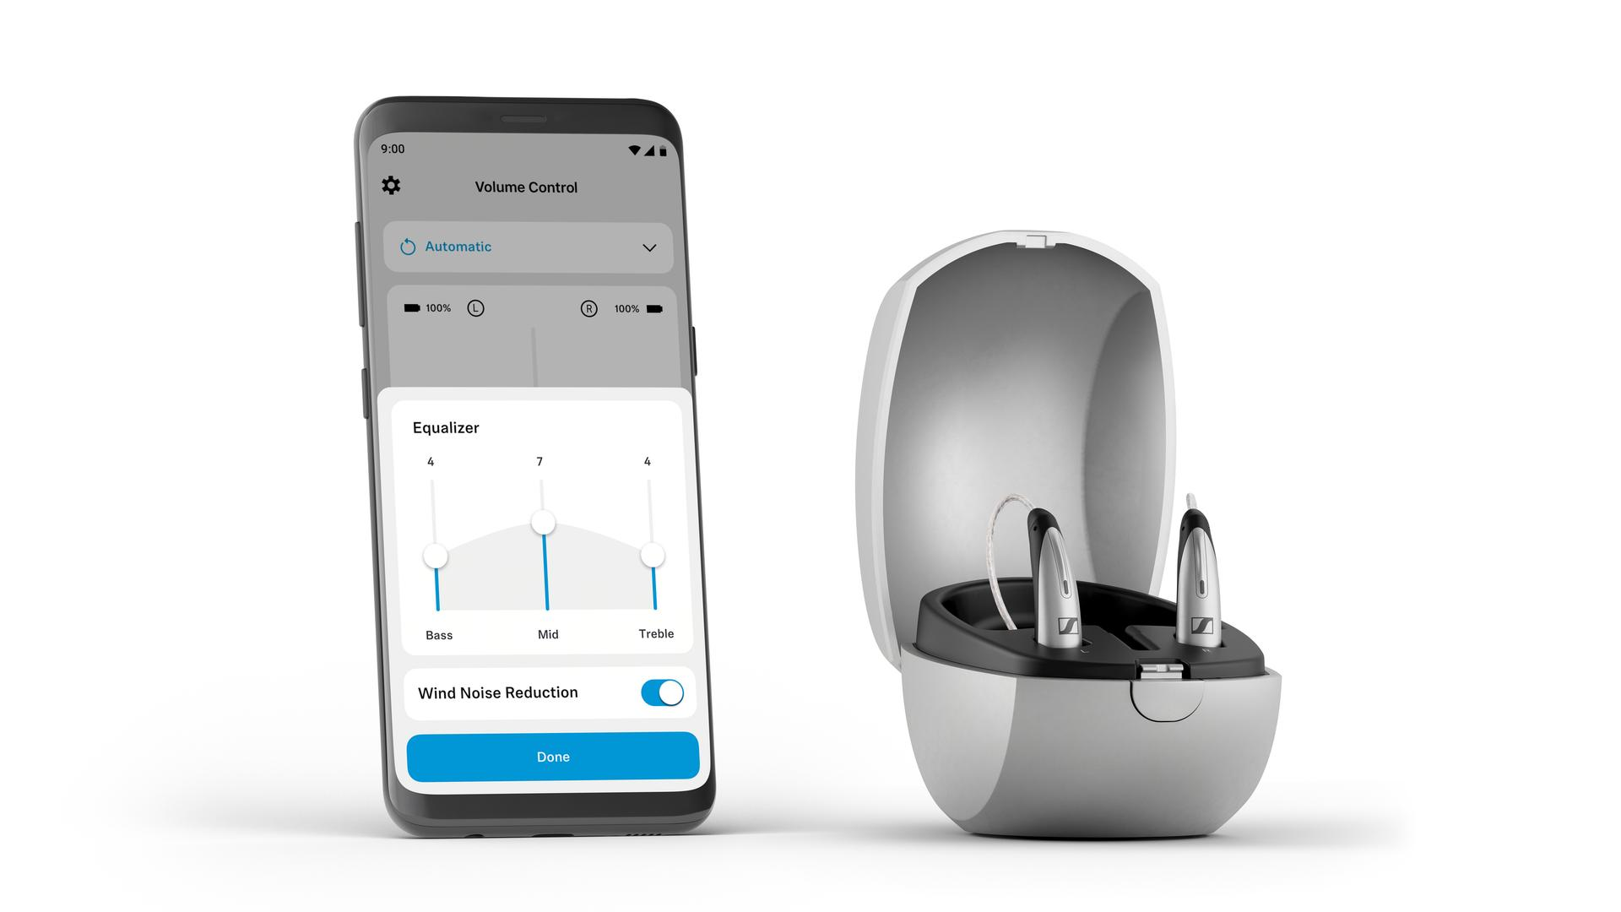
Pictured: All-Day Clear Slim and the All-Day Clear App

CHICAGO, IL – June 20, 2023 – The all-new Sennheiser OTC hearing aids give US consumers access to powerful assistive hearing technology on their own terms. The FDA-cleared All-Day Clear and All-Day Clear Slim deepen the audio technology brand’s devotion to enriching the world through sound. The duo features superb acoustics and speech enhancement coupled with self-fitting features to complete a refreshing, uncomplicated ownership experience.

"All-Day Clear comes at a time when US consumers are seeking technology that can instantly improve their lives,” says Clara Beck, Sennheiser Hearing Category Director. “The over-the-counter legislation allows us to bridge a sizeable gap in the hearing devices market by enhancing ready-to-wear solutions with our extensive acoustics and speech enhancement expertise.”

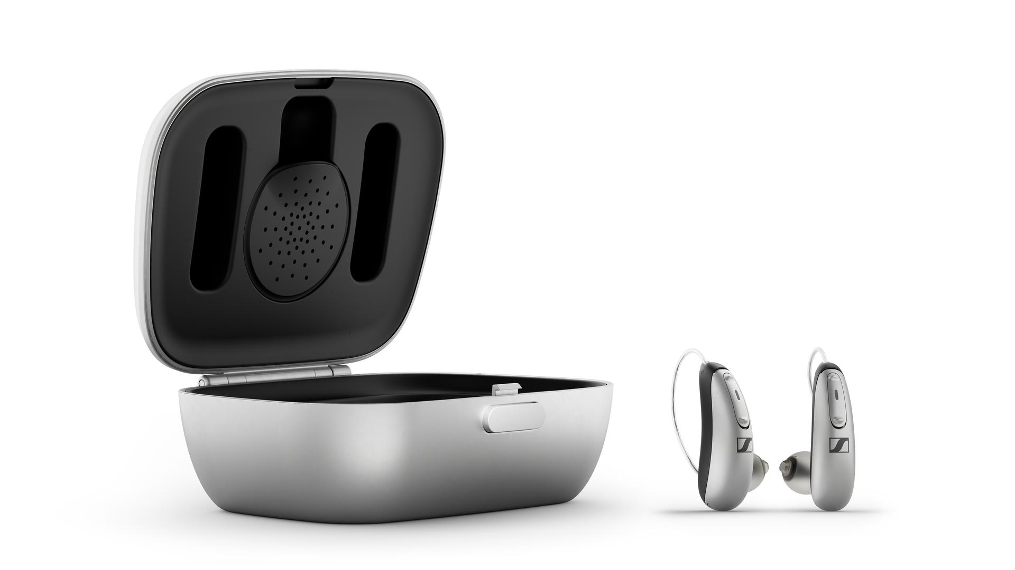Pictured: All-Day Clear and the included charging dock

Ready-to-wear care
From the initial unboxing to that first blissful conversation, All-Day Clear’s thoughtful features put the wearer’s needs first. All-Day Clear and All-Day Clear Slim are two uniquely sleek designs with matching benefits focused on speech intelligibility and a host of practical accessories. Powered by Sonova technology—a leading hearing care company—the Sennheiser OTC hearing devices deliver clear, vibrant sound and feature intelligent scene detection that monitors the person’s environment for seamless optimization of dialogue. Wearers can expect up to 16 hours of class-leading hearing performance and featherlight comfort from the compact rechargeable devices. Each comes with a set of hearing devices, a charging case and accessory kit, while the Slim wear style also includes an equally compact carrying case. On both Android and Apple mobile devices, each style can be set up and customized in less than five minutes, guided by the intuitive All-Day Clear app. Each is packed with additional capabilities such as Bluetooth® music and podcast streaming from your mobile devices, a personalized sound profile, wind noise management and much more.

Take it home tonight
The All-Day Clear experience is friction-free; consumers can research, purchase, and customize Sennheiser’s hearing aids from the comfort of their smartphone. And for those seeking the simplicity of an over-the-counter purchase and the peace of mind that a local hearing professional can provide, consumers have an option to purchase an In-Clinic Care Package. Furthermore, every All-Day Clear purchase from sennheiser-hearing.com comes with a reassuring 45-day risk-free trial.

Jill Goosen, Sennheiser All-Day Clear Product Manager adds: “We made the entire ownership path effortless — especially for those who feel they’re not ready for the prescription approach. Still, for those DIY consumers that may want the safety net of a hearing care professional at a later date, or to purchase their hearing aids from a hearing care professional, All-Day Clear provides the best of both worlds.”

Pricing and availability
All-Day Clear and All-Day Clear Slim will be available starting from mid-July at sennheiser-hearing.com and via select retailers and hearing care professionals at an MSRP of $1,399.95 and $1,499.95, respectively. The free All-Day Clear App will be made available for download on the App Store (iOS) and Google Play Store (Android) at that time. For more information, visit sennheiser-hearing.com.

About the Sennheiser brand
We live and breathe audio. We are driven by the passion to create audio solutions that make a difference. Building the future of audio and bringing remarkable sound experiences to our customers – this is what the Sennheiser brand has represented for more than 75 years. While professional audio solutions such as microphones, meeting solutions, streaming technologies and monitoring systems are part of the business of Sennheiser electronic GmbH & Co. KG, the business with consumer devices such as headphones, soundbars and speech-enhanced hearables became part of the Sonova Holding AG group of companies in 2022, who have licensed the Sennheiser trademark for this purpose.

www.sennheiser.com
www.sennheiser-hearing.com

About Sonova Consumer Hearing
Sonova Consumer Hearing offers premium headphones and hearables – primarily in the true wireless segment – as well as audiophile headphones, hearing solutions and soundbars under the Sennheiser brand. The business is part of the Sonova Group, a global leader in innovative hearing care solutions with headquarters in Switzerland and more than 17,000 employees worldwide.

Press contact
Sonova Consumer Hearing GmbH
Paul Hughes
Head of PR and Influencers, Sennheiser Headphone and Soundbars
T +49 (0) 162 2921 861
paul.hughes@sonova.com

