Africa Health Exhibition & Congress
Gallagher Convention Centre, Midrand, Johannesburg
7 – 9 June 2017

MEDIA BRIEF
Africa Health, organized by Informa Life Sciences Exhibitions, was launched in May 2011 in Johannesburg, South Africa. Over the years, the show has grown substantially reflecting the increasing importance of Sub-Saharan Africa as a global healthcare hub.

Africa Health 2017 Highlights

- 13 scientific conferences with 9 CPD accredited tracks
- All conference proceeds will be donated to local charities – Surgeons for Little Lives and Just Footprints
- Dealers and Distributors wall
- A chance to win R25,000 every day of the show
- 540 exhibitors
- 62 countries
- 15 country pavilion
- 9,300 attendees

Who organises Africa Health?
Africa Health is organised by Informa Life Sciences Exhibitions which is part of the Informa Group.
Informa Group is an independent organization, formed in December 1998 by the merger of IBC Group plc and LLP (Lloyd’s of London Press) in London, United Kingdom. Currently the head office resides in Zug, Switzerland. Informa Group provides academics, businesses and individuals with educational and knowledge opportunities, and with around 8,000 employees working in some 150 offices in over 40 countries, Informa is the largest publicly-owned organiser of exhibition, conference and training events in the world. Other main office locations are in London, Johannesburg, Sao Paulo, Dubai, Mumbai, Singapore, Beijing and Melbourne.

The Life Sciences Division of Informa Group (Informa Life Sciences Exhibitions) consists of 26 exhibitions and more than 100 conferences yearly covering the European, African, Middle Eastern and Asian markets. Over the course of the year, the Life Sciences events attract over 5,000 exhibitors, 100,000 visitors and 15,000 conference delegates, all healthcare professionals. Informa Life Sciences Exhibitions is primarily concerned with providing accredited medical education to healthcare professionals who are interested in updating and furthering their clinical knowledge and skills. By ensuring that our conferences are accredited and our speakers are leading experts in their fields, Informa Life Sciences Exhibitions is committed to providing the best possible medical education available within the regions that we operate.

For more about Informa Life Sciences Exhibitions, visit www.informalifesciences.com.

Africa Health Exhibition 2017

The 2017 edition of the Africa Health Exhibition is a free-to-attend three-day trade show. The exhibition will host 540 of the world’s leading manufacturers, distributors and service providers sharing the latest insights into new technologies and trends within the healthcare industry. The show will also attract more than 9,300 healthcare industry professionals.

More than 540 local and international exhibitors will showcase their products and services, including the world's leading manufacturers, wholesalers and distributors specialising in:

Medical Technology
Laboratory Equipment
Diagnostics
Physiotherapy / Orthopedic technology
Commodities and consumer goods for hospitals
Information and communication technology in healthcare
Surgical Products and services
Facility Management
Medical disposables
Healthcare building technology
Medical Services
Radiology
Imaging and Diagnostics
Cardiology
Publications
Consulting services in healthcare
And more…

In what ways has Africa Health diversified to keep up with visitor and exhibitor needs?

The Gallagher Convention Centre in Johannesburg will once again be the venue for the 7th Africa Health Exhibition and Congress. The event was moved here in 2014 to offer the best possible facilities for the exhibitors and visitors of Africa Health.

Alongside the exhibition, a range of multi-track accredited conferences will be available for all healthcare professionals to attend, in order to gain valuable information through scientific presentations, discussion and interaction. As the title of the exhibition suggests, the main focus of all the conferences will be Africa and the topics that are pertinent to the population.

The diversity of the exhibition and innovative conference programmes, together with CPD accreditation, makes this a must-attend global event and a vital platform for participants to gain and exchange knowledge, network, learn and share experiences and focus on issues that are relevant to them.

Africa Health Conferences 2017:

CONFERENCE | DATES | Supported by | PRICE (ZAR) | ONSITE PRICE (ZAR) | NOTE
Leaders in Healthcare | 7 June |  | R300 | R400 | NEW + INVITE ONLY
Medical Devices Procurement | 7 June | SAMED | R150 | R300 | NEW
Decontamination & Sterilisation (CSSD) | 7-8 June | CFSA | R150 | R300
Obs-Gyne Case Reviews | 7-8 June |  | R150 | R300 | NEW
Public Health | 7-8 June | PHASA | R300 | R400
Imaging & Diagnostics | 7-8 June |  | R150 | R300
Health Technology Lifecycle Management | 8 June | CEASA, IFMBE & SAHTAS | R150 | R300
Healthcare Management | 8-9 June |  | R300 | R400
Hospital Build | 8-9 June |  | R150 | R300
Ethics, Human Rights & Medical Law | 9 June |  | R150 | R300
Quality Management | 9 June | COHSASA | R150 | R300
Surgery | 9 June |  | R150 | R300 | NEW
Nursing | 9 June | ANSA | R150 | R300

Africa Health will feature 13 conferences (with 9 CPD accredited tracks) for all healthcare professionals to attend. With more than 200 regional and international speakers, each conference programme has been scientifically prepared to offer continuing education and information on the latest advances in healthcare.

All conferences are not for profit and are charged at a nominal fee between ZAR150 – ZAR300 per conference, which will be donated to Surgeons for Little Lives and Just Footprints in South Africa.

What kind of regional and global trends are you seeing in the exhibition industry sector?
Exhibitions are platforms for networking and commerce. Ten years ago, exhibitions did not feature on the corporate budget for media investment or business development. Today, exhibitions are viewed as an essential part of the marketing mix and one of the most efficient mediums. The return on investment from exhibiting at the right industry Exhibition is often extremely high. And it is readily measurable, as both the costs and the return are visible, with contracts signed on-site or leads generated that subsequently result in a deal.
As global exhibitions organisers, retaining our competitive edge in the market and appealing to our target audience has meant that it has been necessary to stay up-to-date with market fluctuations and to identify new trends in the global healthcare industry. By acknowledging and identifying the niche opportunities available for our exhibitors, Informa Life Sciences Exhibitions continues to be the preferred platform for our customers to market their products, garner intelligence, debate industry issues and network with each other.
Research into new markets is a priority in order to develop the Informa Life Sciences Exhibitions brand portfolio. Ongoing efforts are made to identify which territories are poised for healthcare expansion and how we can assist our clients with establishing a reputation within these countries.
Informa Life Sciences Exhibitions view the healthcare market in the African region to be one of the most sought after markets for healthcare investments in the world. The healthcare market has experienced stellar growth over the last decade and is projected to maintain its growth momentum driven by a multitude of factors including demographic growth, high and expanding medical needs, more active investments by governments and private sector in the healthcare market, development of social welfare systems, introduction of private insurance market, increased healthcare regulation, introduction of compulsory health insurance in a number of countries, to name a few.
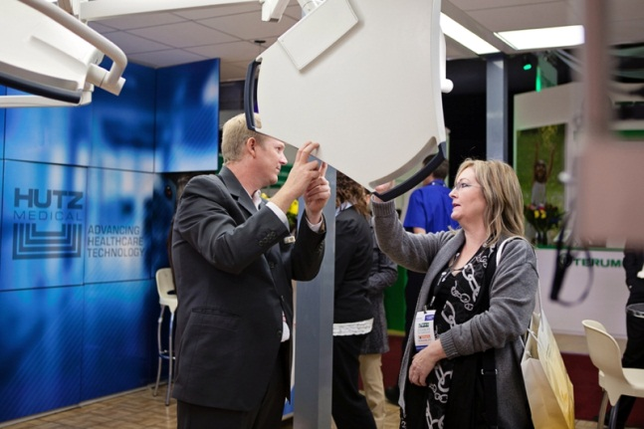

Have you seen any particular shift in target audience demographic?
We attract a wide range of healthcare companies, services and products from across the globe including the world’s leading manufacturers, wholesalers and distributors specialising in medical technology, laboratory equipment, diagnostics, physiotherapy / orthopedic technology, commodities and consumer goods for hospitals, information and communication technology in healthcare, surgical products and services, facility management, medical disposables, healthcare building technology, medical services, radiology, imaging and diagnostics, cardiology, medical publications and consulting services in healthcare.
The main objectives for exhibitors at Africa Health are to find new business, build new and existing relationships with the industry, educate their audience and build brand awareness.

Who is a typical conference delegate at Africa Health?
It would be extremely difficult to describe a typical delegate at Africa Health. Our past conference delegates are extremely varied as we cover nearly all medical disciplines but, ultimately, our delegates are medical professionals who want to further their medical education by gaining the CPD points we offer on the 9 conferences, as well as staying up to date with latest trends and industry updates.
The Congress attracts a wide range of delegates including:
GPs and Private Practitioners
Resident Doctors (Registrars)
Procurement managers
Hospital managers
Biomedical Engineers
Pharmacists
Social Workers
Psychologists (Clinical Psychologists)
C-level executives from hospitals and clinics
Traditional Medicine Practitioners
Laboratory Scientists/Technicians
Medical Law Professionals
Doctors
Professors
CSSD Technicians
Sterile Service Managers
Hospital Decontamination Coordinators
Decontamination & Sterilisation Personnel
Infection Prevention & Control Personnel
Emergency and Trauma Nurses
ICU Nurses
Medical Students
And many more…

How is the Africa Health brand showing signs of growth?
The African healthcare sector is increasingly showing signs of improvement in its overall quality and availability of care. Active government support in recent years means a continued focus on healthcare expansion in Africa and, Informa Life Sciences Exhibitions has identified this gap in the market and set about enhancing private sector investment by providing a platform for the world’s leading manufacturers, wholesalers and distributors to meet the medical community from the Southern African region and beyond.
In addition to Africa Health, Informa Life Sciences Exhibitions also organise an existing healthcare event in Nigeria, Medic West Africa. Working with our strategic partners in the region, the next

edition of Medic West Africa will be held from 11-13 October 2017 in Lagos, Nigeria. Medic West Africa is the biggest medical show in the West African region and will continuously grow in size with the global recognition that the Informa Life Sciences Exhibitions’ brand brings.
Informa Life Sciences Exhibitions’ also believes that Medic East Africa, taking place this year from 3-5 October 2017, plays a pivotal role in the endeavour to accelerate healthcare on the African continent. Informa also organizes the largest healthcare show in North Africa – Mediconex which takes place from 14-16 April 2018 at Cairo, Egypt. Mediconex Exhibition and Congress brings together leading medical experts, manufacturers, researchers and professionals to exchange and share their experiences and research results on all aspects of healthcare.
We are seeing very buoyant growth in emerging market territories where trade shows continue to be a major source of buyer and seller interaction. We predict this will continue strongly and that the Informa Life Sciences Exhibitions portfolio will be expanding even further as we move into the events pipeline for 2017-2018.
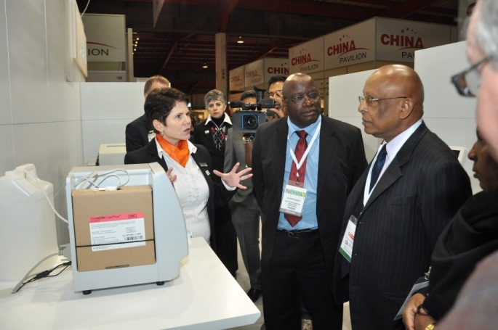
Are you optimistic about the future of the healthcare exhibitions industry?
There is immense potential for all aspects of medical provisioning in the region, namely in the transfer of know-how, training, the building of clinics and hospitals and in the import and export of pharmaceutical products and medical supplies.
These factors have caused governments in the region to pay closer attention to meeting the healthcare needs in their respective countries by putting in place plans for several large-scale projects in the sector as well as reforming rules and regulations governing the industry with the view of attracting more private sector investment in the space.
We trust that Africa Health Exhibition & Congress will continue to play an important part in the growth of the healthcare exhibitions industry in the region.

PR contact:

Bradly Howland
bradly@hwb.co.za
M: +27 72 850 3792

Website:

www.africahealthexhibition.com

Social Media:

https://www.facebook.com/AfricaHealthExhibition
@africahealthexb

