TEC Award for Neumann's headphone debut!
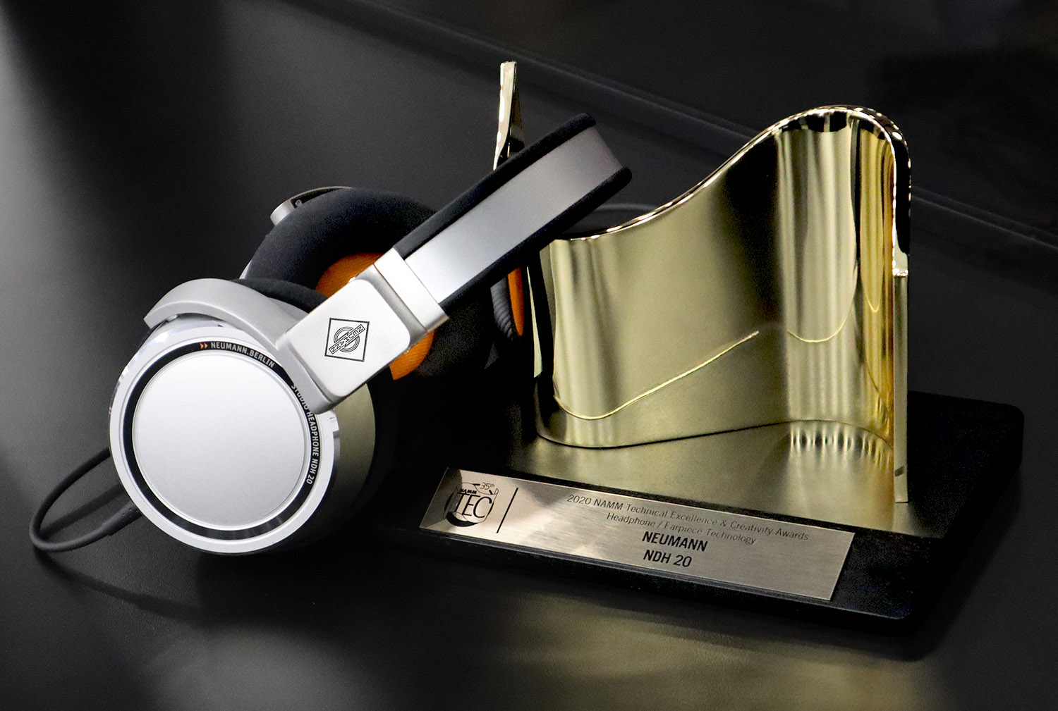

Anaheim/Berlin, January 2020:
On Saturday evening of this year's 35th NAMM show in Anaheim, California, the NDH 20 studio headphones were honored with the TEC Award in the category "Headphone / Earpiece Technology". Exactly one year ago, Neumann presented the NDH 20 as its first headphone at the NAMM Show, thereby expanding its product portfolio to include a new segment.

The NDH 20 is a premium quality closed-back headphone for monitoring, editing and mixing. Due to its excellent sound isolation, it is also suitable for mobile working in noisy environments or for live applications. The extremely detailed and well-balanced sound image – similar to Neumann’s acclaimed studio monitors – allows easy switching between headphone and speaker monitoring.

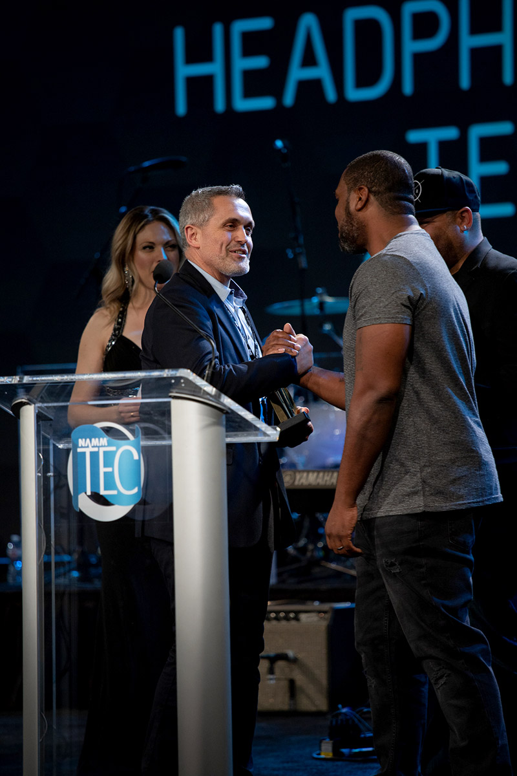
Customer feedback as well as numerous reviews in recent months have confirmed that the high development effort was worthwhile and that the NDH 20 fully meets the high expectations for sound, design, and manufacturing quality of a product bearing the Neumann name.

Further product information at:
https://en-de.neumann.com/ndh-20

Link to photo and text material:
https://www.neumann.com/exchange/Tec_Ndh20.zip

Medzid Veseli (Neumann.Berlin) receives the TEC Award
for the NDH 20

About Neumann
Georg Neumann GmbH, known as “Neumann.Berlin”, is the world’s leading manufacturer of studio microphones and the creator of recording legends including the U 47, M 49, U 67 and U 87. Founded in 1928, the company has been recognized with numerous international awards for its technological innovations. Since 2010, Neumann.Berlin has expanded its expertise in electro-acoustic transducer design to also include the studio monitor market, mainly targeting TV and radio broadcasting, recording, and audio productions. The first Neumann studio headphone was introduced at the beginning of 2019. Georg Neumann GmbH has been part of the Sennheiser Group since 1991, and is represented worldwide by the Sennheiser network of subsidiaries and long-standing trading partners. Website: www.neumann.com.

Press contact:
Andreas Sablotny
andreas.sablotny@neumann.com
T +49 (030) 417724-19

