For immediate distribution
Man on Fire: Dierks Bentley Brings the Burning Man Tour to Calgary, Powered by PK Sound
From a Calgary garage to the city's largest indoor arena, Dierks Bentley brings his PK Sound rig back to its hometown
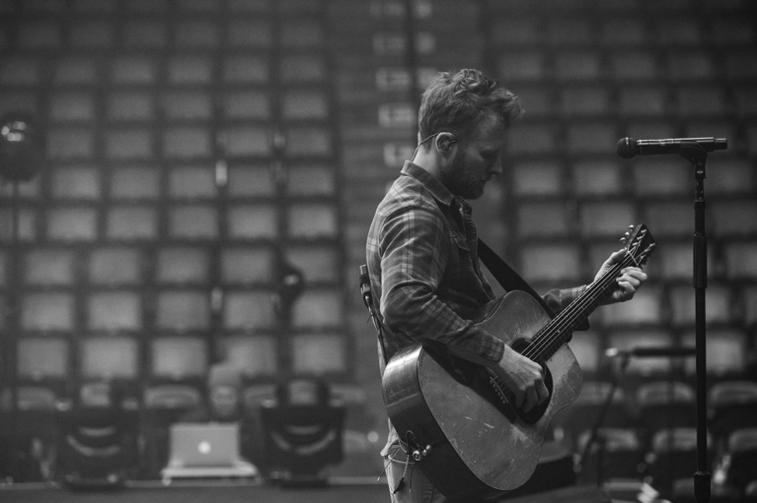
Calgary, Alberta, February 19, 2019 — Country music superstar Dierks Bentley is a busy man. After wrapping his six-month Mountain High tour last October, he's back on the road again in support of his ninth studio album The Mountain with the 2019 Burning Man tour. Bentley kicked off the winter leg of the 27-date tour in Canada, making his way to Calgary, Alberta — the birthplace of the PK Sound Trinity Advanced Robotic Line Arrays and Gravity Subwoofers that he has been wowing his audiences with for the past year. Bentley played the 19,000 seat Scotia Saddledome on January 26, representing a new peak for PK Sound, as the company got a chance to look back on the climb from its humble beginnings in a garage, to powering one of country music's top acts in Calgary's largest indoor arena.
PK Sound CEO and Chief Engineer Jeremy Bridge began building loudspeakers at home until he launched the loudspeaker manufacturing company in 2009, which now operates out of a 14,000-square-foot office space, warehouse and R&D lab. With a multiplatinum recording artist like Dierks Bentley using PK Sound loudspeakers, the show served as a massive celebration for PK Sound, as it expands its footprint into other music genres.
“Historically, a large portion of our partner’s successes and our own have been in the client-driven specification of PK Sound products on some of the largest Electronic Dance Music events in North America,” explains Darryl Ross, Senior Business Development Executive at PK Sound. “Being able to partner with Dierks however has allowed us to expand into different genres, and show the strength and versatility of our Trinity Line Arrays for any kind of live sound application.”
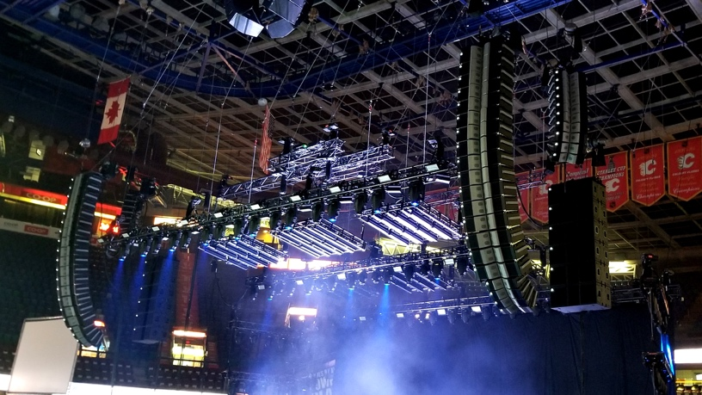
Pristine Sound
Dierks Bentley has been trusting PK Sound to deliver pristine sound quality and reliable performance in venues of all shapes and sizes. Making full use of Trinity's three-dimensional wavefront technology, Dierks Bentley's FOH and System Engineer James “Pugsley” McDermott has unparalleled control over the vertical and horizontal polar directivity of the entire array, letting McDermott carve the sound field toward the audience while avoiding unwanted reflections, and making Trinity the ideal sound system for a large indoor arena like the Scotiabank Saddledome.
PK Sound's Kontrol™ software makes adjusting the sound field even easier for Dierks Bentley's crew by granting remote access to each module's internal functions, allowing each array to be flown straight and adjusted in the air. Once flown, PK Sound’s Kontrol™ Auto-Array feature communicates with each module and automatically arranges modules into the proper position in each array, removing the need for time-consuming manual arrangement.
Scaling Musical Heights
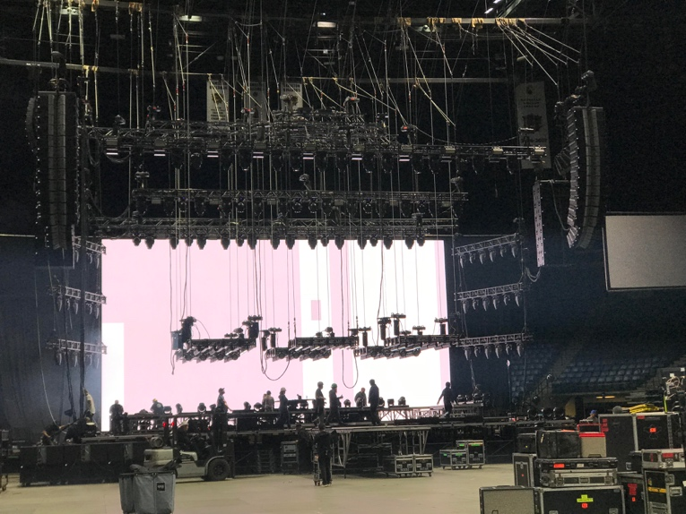
Bentley's Burning Man tour sails along in the wake of success brought on by The Mountain, which earned him the highest debut sales of his career and became his seventh chart-topping album to date. Influenced by the sounds of traditional bluegrass music, as well as a hefty dose of rock and roll, Bentley co-wrote 10 of the album's 13 tracks. The Mountain has garnered multiple nominations, including "Album of the Year," from the Country Music Association (CMA).
While PK Sound has powered countless shows in world-class venues throughout North America, never before have they supported a tour of this magnitude in its hometown, and the opportunity to showcase their homegrown audio exports to Calgary audiences made his latest show in the Scotiabank Saddledome into an experience like no other.
Please see below for a complete list of dates for Dierks Bentley's Burning Man tour, powered by PK Sound.
Jan. 17 — Hamilton, Ontario, Canada @ FirstOntario Centre
Jan. 18 — Ottawa, Ontario, Canada @ Richcraft Live at the Canadian Tire Centre
Jan. 19 — Oshawa, Ontario, Canada @ Tribute Communities Centre
Jan. 22 — Winnipeg, Manitoba, Canada @ Bell MTS Place
Jan. 23 — Saskatoon, Saskatchewan, Canada @ SaskTel Centre
Jan. 24 — Edmonton, Alberta, Canada @ Rogers Place
Jan. 26 — Calgary, Alberta, Canada @ Scotiabank Saddledome
Jan. 28 — Kelowna, British Columbia, Canada @ Prospera Place
Jan. 29 — Vancouver, British Columbia, Canada @ Pepsi Live at Rogers Arena
Jan. 31 — Spokane Washington @ Spokane Arena
Feb. 1 — Tacoma, Washington @ Tacoma Dome
Feb. 2 — Eugene, Oregon @ Matthew Knight Arena
Feb. 14 — Ontario, California @ Citizens Business Bank Arena
Feb. 15 — Fresno, California @ Save Mart Center
Feb. 16 — Reno, Nevada @ Reno Events Center
Feb. 21 — Lexington, Kentucky @ Rupp Arena
Feb. 22 — Nashville, Tennessee @ Bridgestone Arena
Feb. 23 — Columbia, Missouri @ Mizzou Arena
Feb. 28 — Sioux Falls, South Dakota @ Denny Sanford PREMIER Center
March 1 — Wichita, Kansas @ INTRUST Bank Arena
March 2 — Omaha, Nebraska @ CHI Health Center Omaha
March 7 — Moline, Illinois @ TaxSlayer Center
March 8 — Duluth, Minnesota @ AMSOIL Arena
March 9 — Grand Forks, North Dakota @ Alerus Center
March 28 — Toledo, Ohio @ Huntington Center
March 29 — Columbus, Ohio @ Nationwide Arena
March 30 — Grand Rapids, Michigan @ Van Andel Arena
For more information, please visit PK Sound’s website at: https://www.pksound.ca/
For more information on the Burning Man tour visit: http://www.dierks.com
For tickets to the Burning Man tour visit: http://www.dierks.com/tour

About PK Sound
At PK Sound we are passionate about providing a powerful connection between artist and fan. We believe that every audio experience should be exceptional. Our loudspeakers are well known for their transparent, full bodied, powerful sound; a result of new technologies created by people who love music, focusing on the evolving demands of artists, engineers and fans.

Media contacts

Steve Bailey
Public Relations
Hummingbird Media
+1 (508) 596 9321
steve@hummingbirdmedia.com

Jeff Touzeau
Public Relations
Hummingbird Media
+1 (914) 602 2913
jeff@hummingbirdmedia.com

