Kre8 Media Selects Xytech’s MediaPulse to Streamline Employee Scheduling
Las Vegas-based outdoor advertising firm chooses MediaPulse to optimize the scheduling of its 200-plus employees

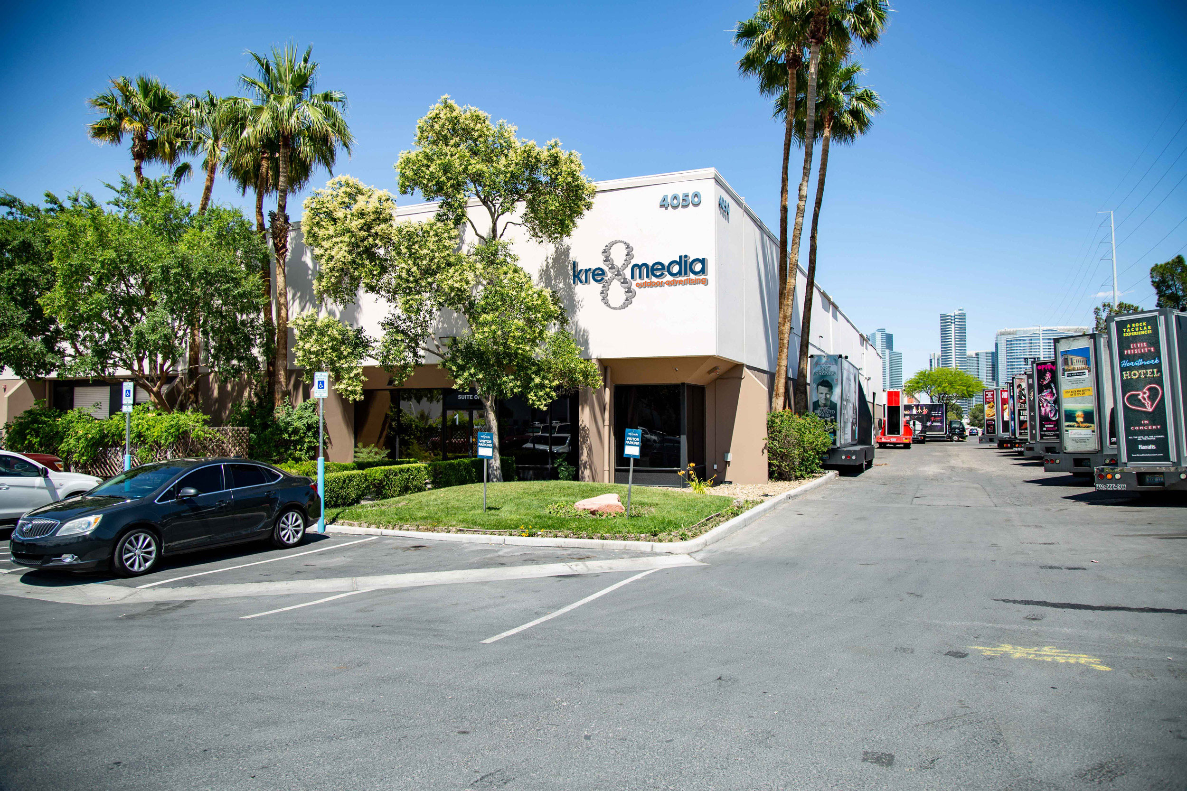
Las Vegas, December 11, 2019 — When Jamie Watkins left her position at Warner Brothers in Los Angeles to run operations at her husband’s growing outdoor advertising company, Kre8 Media in Las Vegas, she brought one takeaway with her: Xytech’s MediaPulse facilities management software to handle the busy company’s scheduling, bidding and billing.

“When I first started at Kre8 Media, they were using Excel spreadsheets to schedule employees,” Watkins explained. “It was very manual and really easy to make a mistake or double-book someone as there was no way to flag it. There were really no checks and balances.”

To fix this, one of Watkins’ first initiatives as Kre8 Media’s Director of Operations was to improve the scheduling of the company’s nearly 220 employees. From mobile billboard truck drivers to on-foot brand ambassadors, Watkins needed a robust, redundant solution featuring live updates. By teaming with Xytech account managers, Watkins implemented a custom version of MediaPulse, streamlining the company’s scheduling process.
“Our configured instance of MediaPulse allows me to have two scheduling views: a warehouse and driver view, and a hotel and property ambassador view,” Watkins said. “It’s great because we now have tracking as well as ways to forecast and book ahead to see what’s available and what we can target as far as selling goes. Plus, we can create utilization reports. We couldn’t do any of this before.”

In addition to using the scheduling module, Kre8 Media also uses MediaPulse for bidding, work orders and billing.

“We used to do all our billing in QuickBooks, and with our scheduling formerly in Excel, nothing really spoke to each other,” Watkins explained. “Now we’re doing all of our billing in MediaPulse as well.”

‘An All-in-One Solution’
With top-level clients including Cirque Du Soliel, Door Dash and major Vegas acts like Mariah Carey and David Copperfield, Kre8 Media also offers advertising opportunities on the “touchdown elevator towers” lining Las Vegas Boulevard, in addition to its mobile billboards and brand ambassadors. With a number of plates spinning at all times, Watkins’ favorite feature of MediaPulse is having all Kre8 Media’s information in one place.

“I love how it’s an all-in-one system. From scheduling to forecasting to billing, everything I need is in one place,” she explained, adding in addition to tracking employee schedules, MediaPulse also tracks the company’s equipment including its 50 mobile billboard trucks that drive up and down the Vegas Strip. “Our trucks break down sometimes, and MediaPulse allows us to go in and program when one of them goes down and detail what the issue is. The program is really like having one giant database.”

Since its founding in 2012, Kre8 Media has experienced steady growth year after year and now MediaPulse will help Watkins and her team manage the growth.

“We sometimes will expand outside of Las Vegas into cities like Los Angeles and Tucson, Arizona,” Watkins said. “As we grow, having MediaPulse in place will help us streamline our operations and better handle our growth.”

About Xytech
For more than 30 years, the world’s premiere media companies have depended on Xytech to run their businesses. MediaPulse is the only end-to-end solution for the complete content lifecycle. MediaPulse provides scheduling, automation, asset management, billing and cost recovery for broadcasters, media services companies and transmission facilities in a scalable platform-independent solution. For more information, visit xytechsystems.com.

Media Contacts:

Katie Kailus
Public Relations
Hummingbird Media
+1 (630) 319-5226
katie@hummingbirdmedia.com

Alexis Lipoff
Public Relations - EMEA
Hummingbird Media
alexis@hummingbirdmedia.com

Jeff Touzeau
Public Relations
Hummingbird Media
+1 (914) 602 2913
jeff@hummingbirdmedia.com

