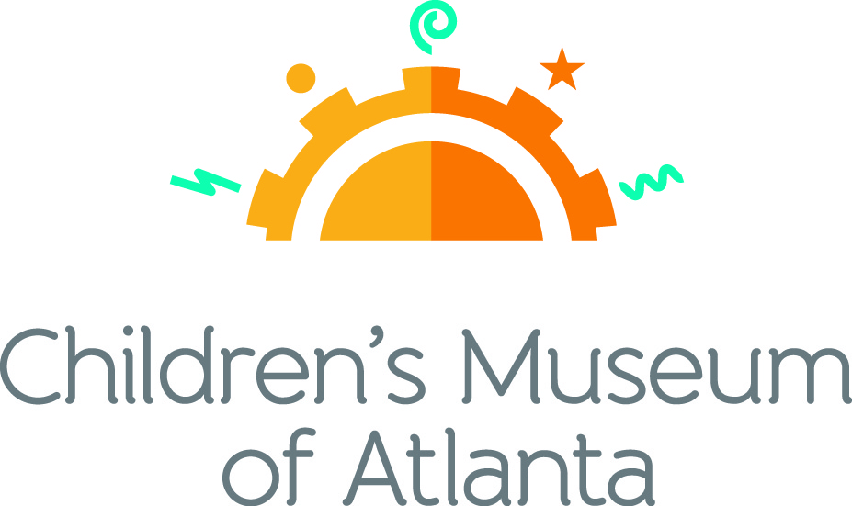

CONTACT
Becca Meyer/Jennifer Walker
BRAVE PR, 404.233.3993
bmeyer@bravepublicrelations.com/
jwalker@bravepublicrelations.com
FOR IMMEDIATE RELEASE

Fifth annual golf outing ‘Tournament for PLAY’ raises $170,000
for Children’s Museum of Atlanta
Proceeds support Museum’s early childhood educational programming and community outreach

ATLANTA (August 29, 2017) – Last week, 120 golfers hit the green for a good cause during Children’s Museum of Atlanta’s fifth annual golf outing Tournament for PLAY, held on Monday, August 21 at the prestigious Peachtree Golf Club. Presented by PNC, the event raised $170,000 through generous donations and golfer registration in support of the Museum’s early childhood educational programming and community outreach initiatives.

“Year after year we’re overcome by the generous support we receive from the golfers and our wonderful sponsors,” said Jane Turner, executive director of Children’s Museum of Atlanta. “With the funds raised through this tournament we’re able to continuously provide access to exhibits and opportunities that allow for underserved children to be immersed in a highly interactive learning environment outside of the classroom.”

Proceeds from the tournament directly impact more than 200,000 children and caregivers annually. Children’s Museum of Atlanta’s mission is to spark imagination and inspire discovery and learning for all children through the power of play. Serving children, families and schools in Atlanta and throughout Georgia, the Museum has welcomed over 2.6 million visitors since opening in 2003. Since reopening in December 2015 following a massive renovation project, the Museum is further committed to serve the community as a world-class children’s museum and to continue to help ignite curiosity, imagination, problem-solving skills and a love of learning in the next generation of youth.

“We place a high value on our relationship with Children’s Museum of Atlanta and the opportunities it creates for the youth in our community,” said Eddie Meyers, PNC regional president for Georgia. “This event provides a fun and engaging way for public and private partners to come together to raise awareness and funding for quality early education programs.” PNC supports local pre-K programs through PNC Grow Up Great®, its $350 million school readiness initiative.

In addition to a charitable round of golf, players were treated to a special birdie breakfast presented by sponsor LexisNexis to kick off the day’s festivities. In honor of the eclipse, attendees were provided special eyewear by sponsor Georgia Eye Associates. The event wrapped up with a reception and awards ceremony to honor top players. Other event sponsors included Mellow Mushroom, Atlanta Consulting Group, Homrich Berg and Novare Group.

“We can’t thank our participants, sponsors and everyone involved enough for the incredible outing we had this year,” said Chair of Tournament Matt Bartelt, senior director, strategic marketing at Equifax, Inc.
###
About PNC Bank:
PNC Bank, National Association, is a member of The PNC Financial Services Group, Inc. (NYSE: PNC). PNC is one of the largest diversified financial services institutions in the United States, organized around its customers and communities for strong relationships and local delivery of retail and business banking including a full range of lending products; specialized services for corporations and government entities, including corporate banking, real estate finance and asset-based lending; wealth management and asset management. For information about PNC, visit www.pnc.com.

About Children’s Museum of Atlanta:
Children’s Museum of Atlanta is the only educational venue of its kind in Atlanta, presenting educational programs and exhibits designed for young children ages 0-9. The Museum’s mission is to spark imagination and inspire discovery and learning for all children through the power of play. With six permanent learning zones consisting of bright, creative and hands-on exhibits, the Museum supports inventive play-based exploration and experiential learning focused on the whole child. Core competencies for literacy, math and science are promoted throughout all exhibits and programming in alignment with the state and national Core Performance Standards. Children’s Museum of Atlanta also offers parties, memberships, field trips, summer camp and private events. For more information or to support Children's Museum of Atlanta, visit childrensmuseumatlanta.org or call 404.659.KIDS [5437].

Museum Admission: General Admission is $15.95 (plus tax) for anyone 1 – 100 years old. Babies and members are admitted for free. All daily programs are included in price of admission. Group rates and military discounts are available. For more information regarding ticket and membership options, visit childrensmuseumatlanta.org/plan-your-visit/faqs/.

Museum Hours: Monday, Tuesday, Thursday and Friday 10:00 a.m. – 4:00 p.m.; Saturday and Sunday 10:00 a.m. – 5:00 p.m.; Closed on Wednesdays. Please check the Museum website to confirm hours of operation.

Facebook: https://www.facebook.com/childrensmuseumatlanta
Twitter: https://twitter.com/ChildMuseumATL
Instagram: https://www.instagram.com/childrensmuseumatlanta
Pinterest: http://pinterest.com/cmatlanta

