Sennheiser launches two-bay network charger and Sennheiser Control Cockpit 5.0 for campus-wide audio installations
The latest software version enables monitoring and control of the new CHG 2N network charger for SpeechLine Digital Wireless and integrates the MobileConnect Manager

Wedemark, 19 August 2021 – Sennheiser has announced two important updates as part of its on-going commitment to making digital workflows on campus as simple and productive as possible. With the new CHG 2N charger, the company meets the requests of higher education institutions for a two-bay networkable charger for its SpeechLine Digital Wireless microphone system. The company has also launched a major update of its Sennheiser Control Cockpit software, making remote management of Sennheiser audio devices even easier. Version 5.0 not only allows AV and IT staff to control the new charger but for the first time also enables them to monitor the status of the MobileConnect Manager, linking this assistive listening system with the microphone systems in Sennheiser’s education portfolio.

Sennheiser’s new CHG 2N two-bay network charger for SpeechLine Digital Wireless transmitters will benefit education institutions that require smaller setups in their seminar rooms and lecture halls | 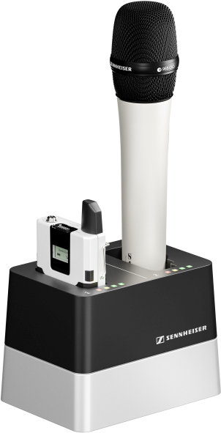

New networkable charging station for smaller applications
The new CHG 2N is a two-bay version of the SpeechLine CHG 4N four-bay charger. Like its big brother, the CHG 2N is network-enabled and features individual bays for recharging SpeechLine bodypack and handheld microphones. Each bay has four LEDs to indicate the battery charging status. The flexible network interface provides IPv4 and IPv6 compatibility for seamless integration. All settings and battery status information can be monitored and remotely controlled using the latest version of Sennheiser Control Cockpit (v5.0.1).

New features with major software update
Whether AV and IT staff remotely manage just a few rooms or the entire campus, Sennheiser Control Cockpit will ensure a convenient and efficient experience. For the first time, version 5.0 now links to the MobileConnect Manager, enabling operators to monitor both microphone and assistive listening systems from one software, and allowing them to receive status notification via text or e-mail.

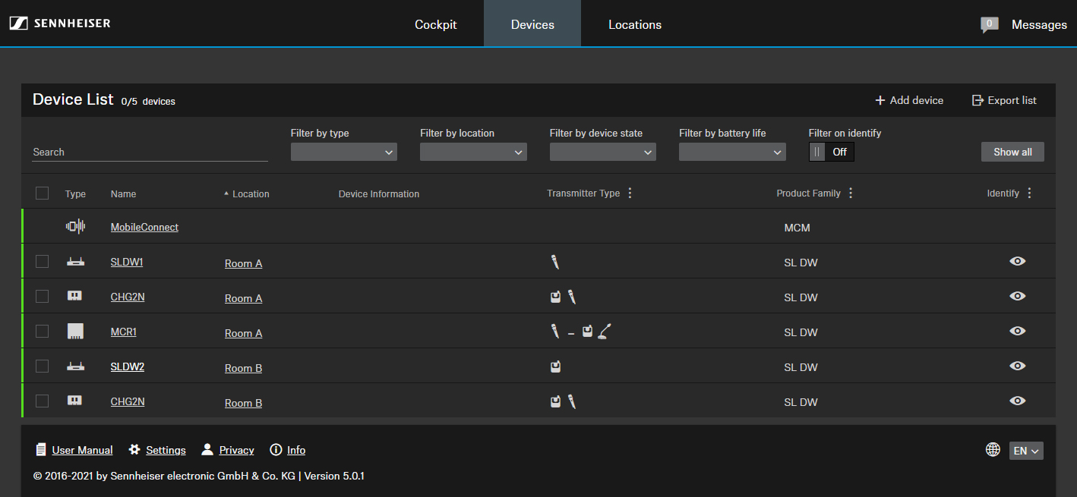 | Sennheiser Control Cockpit 5.0 integrates the MobileConnect Manager

Software version 5.0 also helps save energy by enabling AV and IT staff to remotely power down transmitters. Also, transmitters can be set up in such a way that they switch off automatically after a set amount of time when there is no link going to the receiver.

To avoid accidental operation during use, the Power and Pairing buttons on the portable SpeechLine transmitters can now be locked remotely.

For the SpeechLine Multi-Channel Receiver, Sennheiser Control Cockpit now supports the reset of individual channels to audio default settings, while evolution wireless G3 and G4 benefit from more precise mute mode labels for better differentiation between RF mute, RX mute and TX mute.

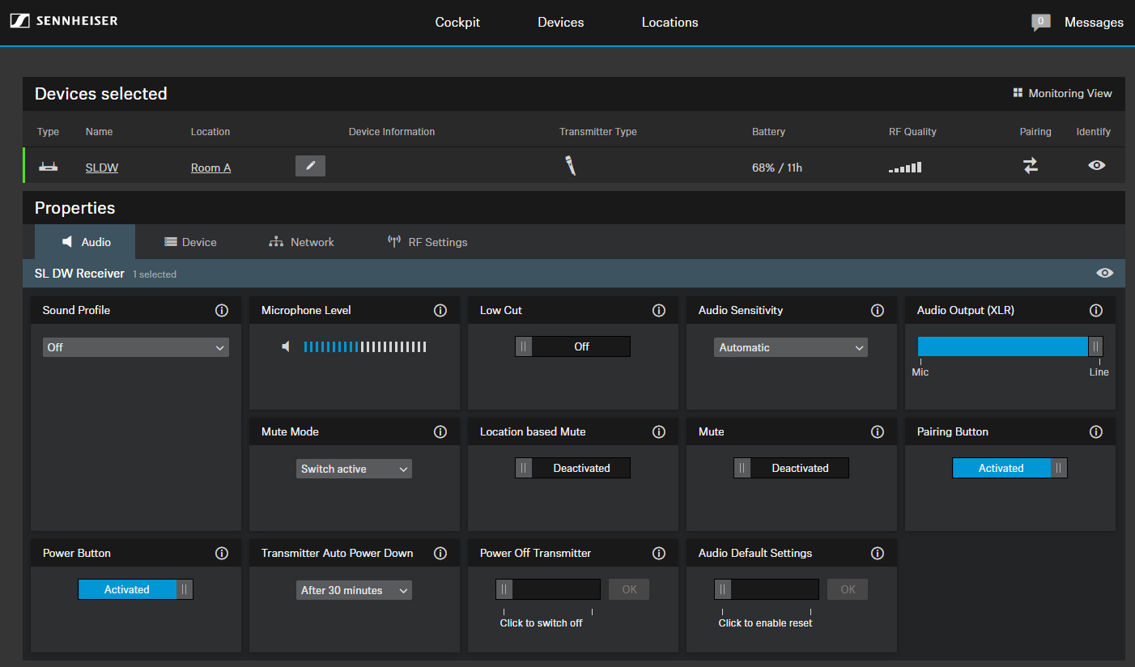 | Sennheiser Control Cockpit 5.0 brings new control and monitoring options for SpeechLine microphones

“We are delighted to bring these two latest offerings to the education sector which will allow technical teams to support teaching staff even better and with added convenience,” says Madhav Jain, Sennheiser’s Market Insights Manager for Education. “While the two-bay network charger for SpeechLine Digital Wireless offers a cost-effective solution for higher education institutions that do not require larger setups for their auditoriums, Sennheiser Control Cockpit’s newest features will further optimize on-campus processes. In fact, thousands of devices are being controlled by the free Sennheiser Control Cockpit software every day – it’s loved by our customers worldwide.”

The latest version of Sennheiser Control Cockpit can be downloaded here.

(Ends)

The images included with this press release can be accessed here.

About Sennheiser
Shaping the future of audio and creating unique sound experiences for customers – this aim unites Sennheiser employees and partners worldwide. The independent family company, which is managed in the third generation by Dr. Andreas Sennheiser and Daniel Sennheiser, is today one of the world’s leading manufacturers of headphones, loudspeakers, microphones and wireless transmission systems. In 2020, the Sennheiser Group generated turnover totaling €573.5 million. www.sennheiser.com

Global Press Contact

Stephanie Schmidt
Stephanie.schmidt@sennheiser.com
+49 (5130) 600 – 1275

Local Press Contacts

Sarah James Maik Robbe
sarahj@gasolinemedia.com maik.robbe@sennheiser.com
+44 (0) 1483 223333 +44 (0) 7393 462484

