SALVADOR OLIVER

La Barbería de Oliver

Salvador Oliver runs this barber shop that gathers the tradition inherited by his father combined with the latest trends and techniques of the sector. His passion for hairdressing runs in his family, his father founded this barbershop in 1969 on Calle San José de Fuente Álamo (Murcia) to move it in 1981 to Calle Onésimo Redondo, now Calle Ganaderos.
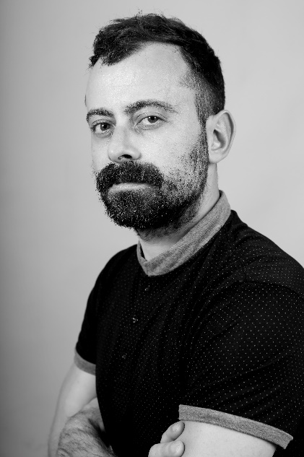
In 2000 he began to do internships in the family salon while he began his training at the Dambell Academy in Murcia, ending it in 2001. Since 2005 he has been the director of the barbershop and in 2014, he inaugurated a new stage in the barbershop with the transformation of the salon that changes its name to “La Barbería de Oliver”. But he also combines his work in the barbershop with teaching. He is a teacher at Nefer Center (Official Private Center of the Ministry of Education) and has collaborated with several of the most important brands in the world such as American Crew or Proraso, offering training. Likewise, he is ambassador for Matakki Scissors since 2019, he is part of the artistic education team of Barberos 3.0, which only has five stylists in Spain, he is a member of the national and international technical-artistic team of Tahe and gives training in different schools of professional hairdressing education. Salvador Oliver is a member of Club Fígaro, the most prestigious association in the Spanish creative hairdressing sector.
As a result of the recognition received by his colleagues, he has been hired by several of the most prestigious hairdressing firms in our country such as Olga García Estilistas, Salón Blue by Raquel Saiz and Centro Beta by Gonzalo Zarauza.
He was nominated for Best Male Collection at the 2018 TCT Awards, international hairdressing awards. The stylist continues to develop his career with enormous success, creating men's collections that make the front pages of the professional press and with publications of collections both nationally and internationally. In addition, La Barbería de Oliver was selected as the barbershop of the month in Peluquerías Magazine.
In 2020 & 2021 he’s chosen as a finalist at the prestigious International Visionary Awards, Mens category.

