For more information, please contact Marta de Paco
On +34 670 780 664 or email press@comunicahair.com

Important:
These images are only available for editorial content.
Credits must be included.
Notification of their publication is expected.

IVAN RODRÍGUEZ
MÉXICO
Crescent Collection

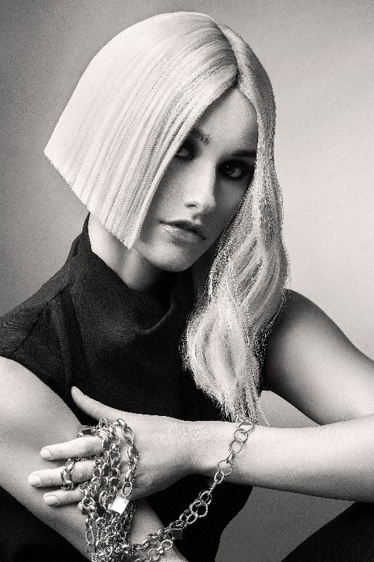
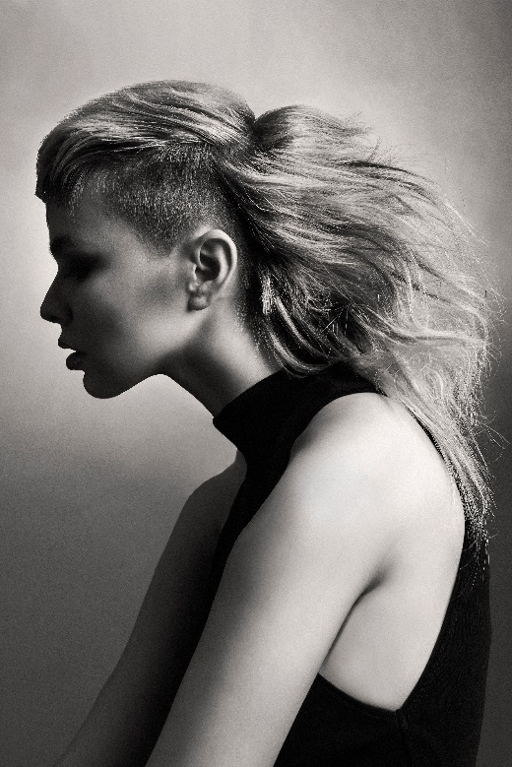
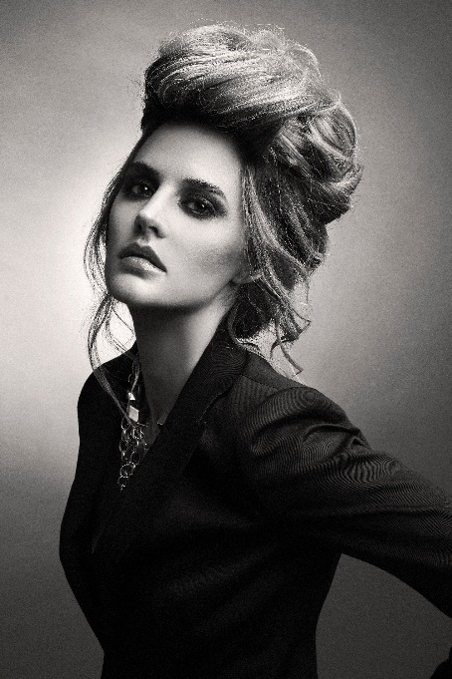

Hair: Ivan Rodríguez @ivanrohair
Photography: Jell Loya @jellloya
Make up: Thessa Peralta & Greg del Toro @thessaperalta_mua
Styling: Melissa Web @melwebbg

#ivanrohair #ivanrodriguezhairdresser

IVAN RODRÍGUEZ
MÉXICO
Crescent Collection

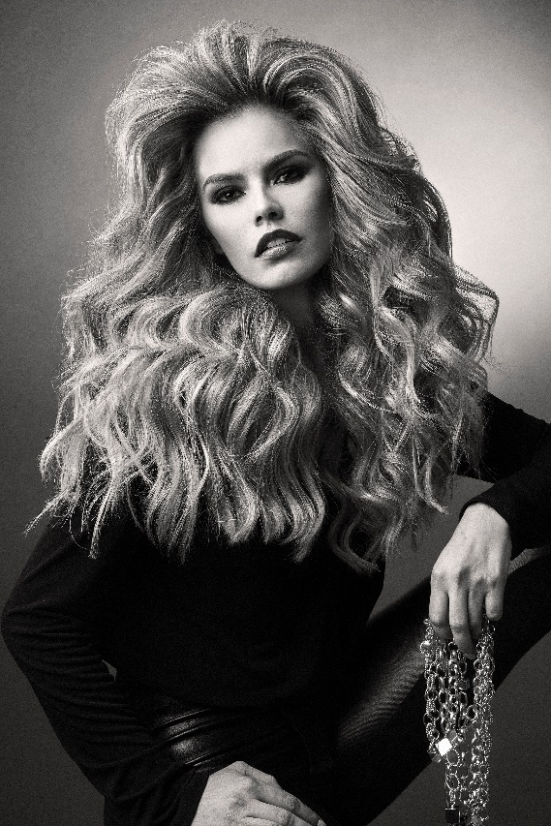

Strength is in the hair, and the path taken to claim power is never predictable or heterogeneous. The same happens with empowerment, a fluid that runs like water, uncatchable, yet palpable. In this collection, the surprise and the unheard are reflected in asymmetric haircuts, some of which are impeccable straight, and contrast with forms that seem to escape the established. Volumes that show the extraordinary, and textures that reproduce the freedom of what is liquid.

