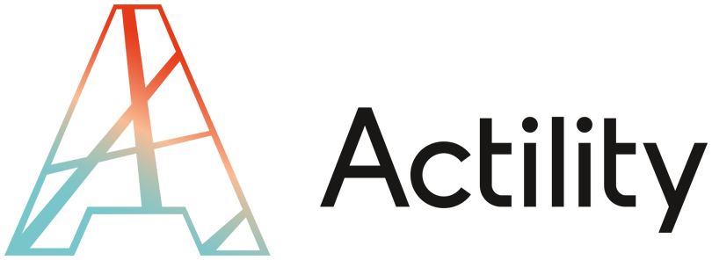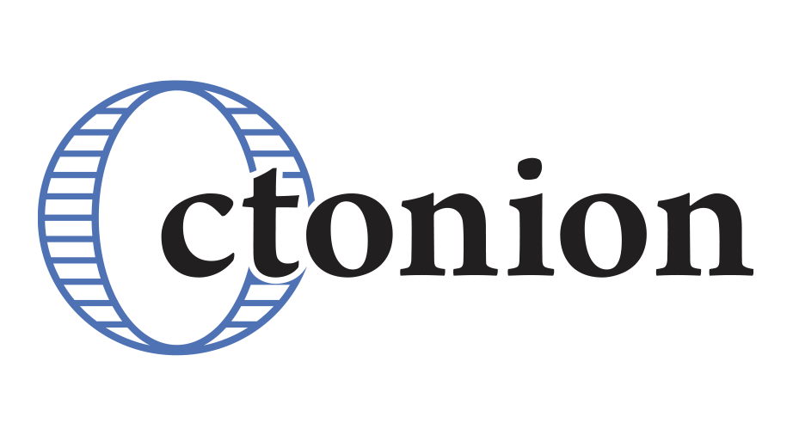
Actility and Octonion announce a commercial partnership to accelerate the industrialisation of LoRaWAN™ IoT projects

Paris, June 12th 2017 - Actility, the global leader in LPWA networks for the IoT is pleased to announce a partnership with Octonion, the end-to-end IoT software platform. Octonion will join the ThingPark ecosystem, providing its platform to IoT developers and clients, accelerating time to market by up to four times.

For the IoT to deliver on its potential, there is a clear demand for tools to enable the easy and swift delivery of IoT solutions. The Actility/Octonion solution meets those requirements with a modular approach, delivering fast time-to-market, and focusing on the user experience.

A modular approach
The Octonion platform is comprehensive and unique in today’s market, managing the end to end experience from the device or sensor, to the gateway, to cloud-based frameworks. Because each layer of the platform is device-agnostic and compatible with any hosting solution, it allows customers to address any vertical or horizontal use-case, developing and operating their own IoT solution.

Speedier implementation
Octonion’s expertise allows clients to deploy a connected project in 6 months, as opposed to the 18 to 24 months currently needed with most other IoT platforms. The Octonion platform has a track record of quickly delivering big projects to big-brand names such as Everlast, Babolat, and Rossignol. Today, the Octonion platform already manages millions of sport data points. From today, Actility’s clients can also benefit from that expertise.

A user-centric approach.
Today, most LoRaWAN projects are currently focused on machine-to-cloud scenarios without human interaction. Octonion brings a user-centric perspective – in the design of interfaces that provide an unparalleled experience to the end-user on various platforms (iOS, Android, Tablet, PC…).

Mike Mulica, Actility’s CEO, comments “Actility is thrilled to be collaborating with Octonion to provide developers with a flexible and modular IoT framework that enables them to build the IoT solution they need. Thanks to its user-centric approach, the Octonion platform will enhance Actility’s total value proposition.”

Empowering the ThingPark community.

Octonion is joining the ThingPark program, the one-stop-shop for any IoT deployment. Developers within the ThingPark ecosystem can take full ownership of their projects and will be able to use the Octonion platform as a base to tailor their projects as they see fit. They will have access to a full IoT end-to-end experience combining devkit (device+sensors), a network server (ThingPark), and an application server (Octonion platform) to create solutions based on LoRaWAN technology powered by ThingPark.

Cédric Mangaud, CEO of Octonion concludes “We’re incredibly proud to have earned the trust of a world leader and its clients. I’m confident our modular platform will help Actility’s developers and clients massively speed up the deployment time of their IoT projects.”

About Octonion
Octonion is an IoT software platform that meets today’s complete IoT requirements from the embedded layer to the cloud based services. Octonion was created in 2014 in Switzerland and has since raised €16m from Taiwanese Foxconn (FIH Mobile Ltd), Ginko Ventures, Orkos Capital, Swisscom, and Almaz Capital. Octonion’s team includes 50 engineers to tackle all use-cases and provide new entrants in IoT (transport, insurance, security, home, smart cities…) with a plug and play IoT software offering.Its major achievement to date has been the launch of the PIQ brand with major partners such as Everlast, Babolat, Rossignol, and North Kiteboarding.

About Actility & ThingParkTM
Actility is the industry leader in LPWA (Low Power Wide Area) large-scale infrastructure and the innovator behind the ThingPark IoT Solution platform. Actility’s ThingPark enables scalable LPWA networks and interoperable IoT applications and services. ThingPark Wireless is a core network management and supervision solution for LPWA connectivity designed from the beginning for carrier-grade solutions, and already deployed in over half the national LPWA network rollouts globally. ThingPark OS is a central IoT management service to connect sensors to applications with bidirectional interaction. ThingPark X is a data analytics and control framework which exposes data from connected things to applications and connects with cloud platforms, and also offers off the shelf IoT industrial applications. ThingPark Market is a B2B ecommerce platform for buyers and sellers, aggregating, distributing and connecting IoT devices and applications to the ThingPark platform. Actility is a founding member of the LoRa Alliance.

Contact Presse PIQ : Charlotte Mouraret et Romain Griere – Image 7
+33 (0)1.53.70.78.28 - +33 (0)1.53.70.05.47
cmouraret@image7.fr – rgriere@image7.fr

