
bettergamingagency.prowly.com

Press release under embargo until November 21 at 7:30 PM CET / 6:30 PM UTC / 1:30 PM EST / 10:30 AM PST

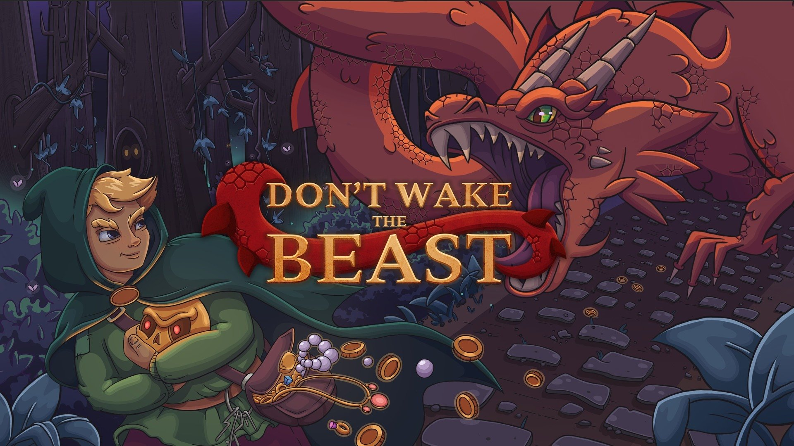

Hooked on riches? Just “Don’t Wake the Beast” while you push your luck in Artificial Disaster’s latest stealth roguelite

Just a little bit more, and you’ll be rich... Artificial Disasters presents its latest stealth roguelite title – Don’t Wake the Beast. As a lonely dungeon crawler, you’ll seek wealth and treasures armed only with your cunning, patience… and a grappling hook. Upgrading your equipment will help you navigate deadly traps and avoid hideous creatures. But if the true lord of the underground awakens from its slumber – fly, you fool!

Beasts sure do like a nice village above their lair. Terrorizing local folk can be a great source of income – just the thing every monster needs the most. Too bad for the original residents – a town atop a greedy creature isn’t prime real estate. In Don’t Wake the Beast you are an adventurer, who solves the “greedy creatures” problem and also gets something out of it (i.e. wealth beyond comprehension).

Wake your inner wealth-seeking beast by watching the game’s reveal trailer here:
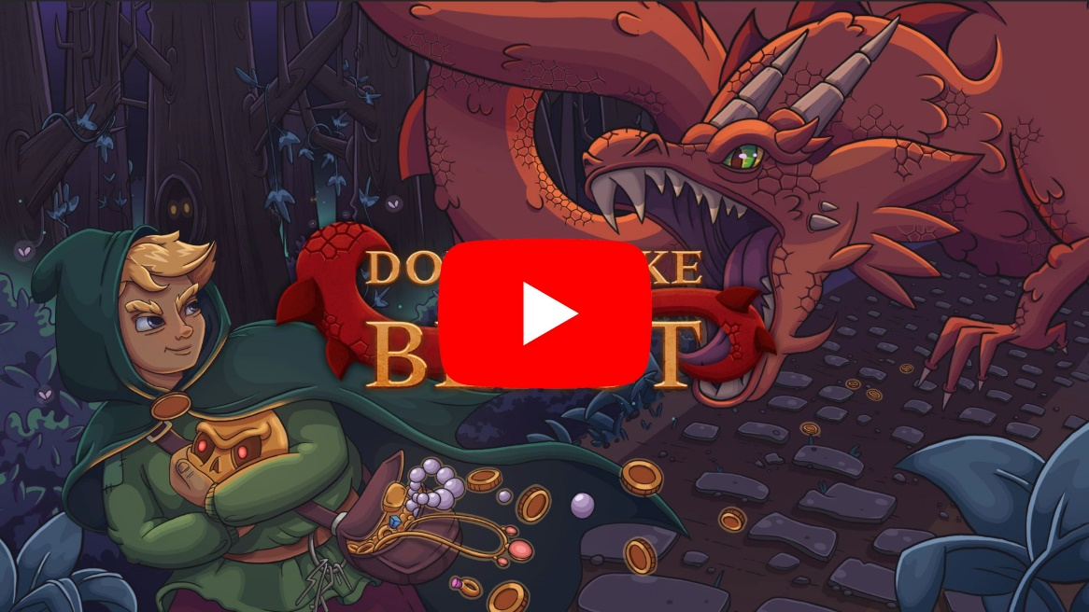
Youtube
https://youtube.com/embed/oAE7xReD7oo

What makes you perfect for the job? Definitely the fact that you already own a grappling hook. This essential tool will aid any soon-to-be millionaire diving into the dark lair beneath. But this is no “get rich quick” scheme – you will die a lot, so maybe the hook won’t be enough. Better equipment will increase your chances of reaching the final chamber with the ultimate treasure, but first you’ll have to scavenge enough to afford your must-have upgrades. Death takes all your hard-earned prizes away, so maybe it’s wiser to resist the temptation of more loot and exit the dungeon early to come back better prepared… But remember, there’s no telling what awaits you next time, as the dark corridors twist and change with each run. And one small caveat – once you reach your final goal, be ready for a frantic, adrenaline-pumping escape – dragons are very protective of their property. Not to mention other beasts in surrounding areas.

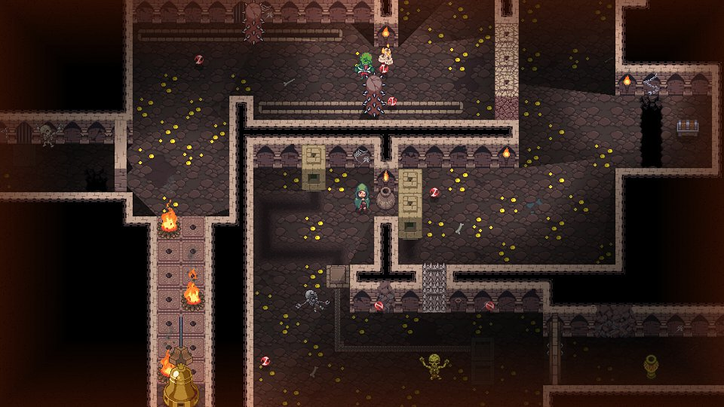

Main Features:

👑 Push your luck – Each dungeon run presents new opportunities, but failure is also part of the game. Roguelite elements allow you to be better prepared for the next run, but it’s your decision whether to quit the dungeon while you can or push for one more trinket. Each treasure adds weight and makes more noise – you decide if the reward is worth the risk.

💎 Silence, shadow, and... a grappling hook – Your hero isn’t a high-level barbarian. You rely on stealth to explore the dungeon. Hide from enemies, distract them, move quietly. There’s always a way out – even if it means clinging to the ceiling while monsters prowl below. Your grappling hook is also essential for solving puzzles and traversing the dungeon, especially when enhanced with special powers, which can open new paths and alternative solutions.

🧈 The walls are alive! – Each run means a new dungeon. Procedurally generated levels ensure every adventure is different and poses a challenge for the unprepared. Spikes, arrows, endless falls, skeletons, flying skulls – you name it. Everything underground wants to kill you. Plan as much as you can, and remember to use your hook and other equipment wisely. Clever puzzles will block your way, but the prize is worth it. With one final catch...

💰 Fly, you fools! – In the lowest parts of the dungeon lies the most prized trinket of all. Each is guarded by an evil monster that treasures its possession. Once you grab it, all hell breaks loose. You must run, avoiding traps with death breathing down your neck. Hopefully, you’ve prepared your escape route – the time for planning or stealth is over.

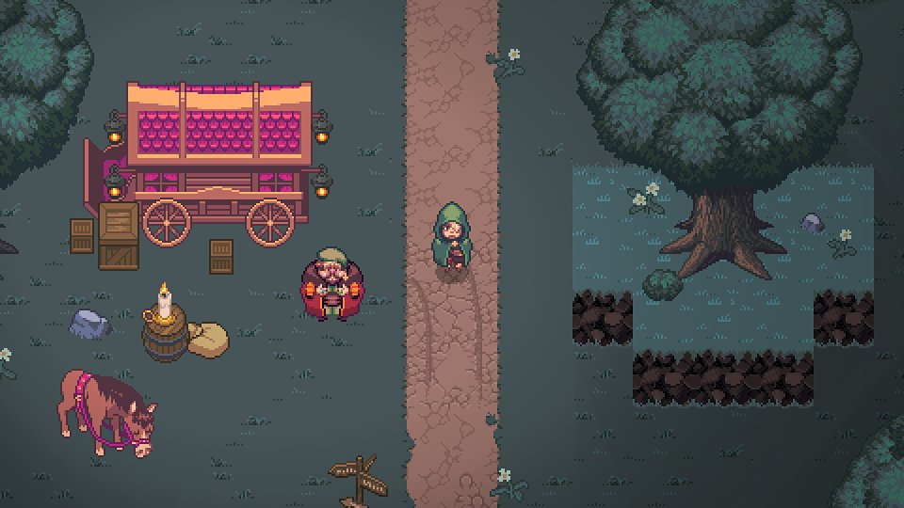

Don’t Wake the Beast is developed by Artificial Disasters. The game will be released in 2025 on Steam, GOG and Epic Games Store – wishlist now!

The full press kit is available here.

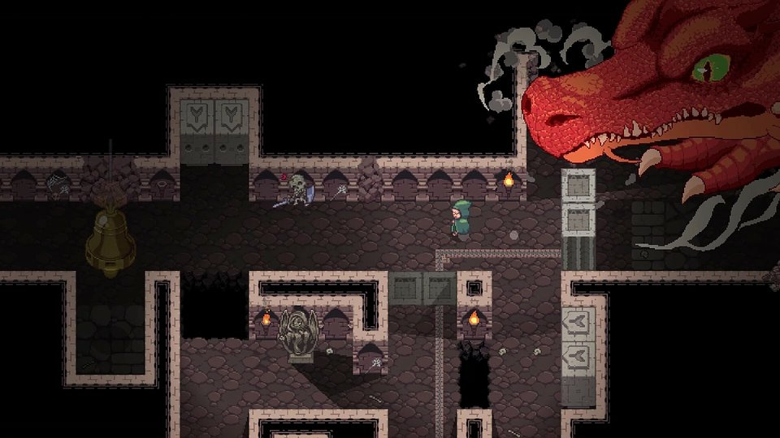

About Artificial Disasters

Artificial Disasters is a single-developer studio founded by Tymoteusz Piasek, who fell in love with video games thanks to classics like Captain Claw, Gothic 2, and Icewind Dale. In 2023, he released his first full-fledged game – Flooded – but his portfolio also includes numerous smaller projects that stand out for their creativity. The process of creating games has always fascinated him, and he developed his skills by following and participating in various game jams. He is currently working on Don’t Wake the Beast – a stealth roguelite title set to launch on PC in 2025.

