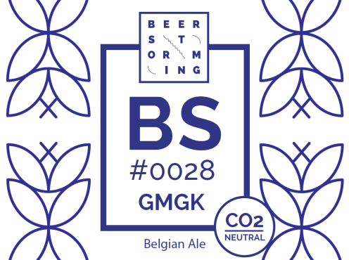

Brussels brewery to offset residual emissions by supporting climate project in Uganda

Beerstorming launches CO2-neutral beer

Brussels, 7 February 2018 - The Brussels-based brewery Beerstorming has been awarded the CO2-Neutral label for the beer BS#0028 GMGK by the independent climate advice agency CO2Logic and the inspection and certification organisation Vinçotte. Doing so, Beerstorming stresses its ambition to reduce the climate impact of beer. It also offers a unique project in Belgium that makes tasters reflect on the climate impact of each drink and gives them the opportunity to give something back to the climate. To offset its residual emissions, the brewery will support a certified climate project in Africa.

The CO2-neutral BS#0028 GMGK is a local beer from Sint-Gillis and will be on the shelves starting 1 March 2018 at a number of partner shops and cafés.

Why a CO2-neutral beer?
On average, brewing one liter of beer results in the production of 3 kg of CO2 (raw materials, agriculture, transport ...), the equivalent of a journey of about 21 km with a diesel or petrol car. This means that a 33 cl beer corresponds to a 7 km drive with a non-electric car. In 2016, Belgians consumed approximately 7.7 million hectoliters or 770 million liters beer, accounting for an annual emission of 2,310,000 tons of CO2. This is comparable to the annual climate impact of 280,000 inhabitants or 320,000 times around the world with the car. As many as 1155 windmills are needed to generate the amount of energy required to brew this much beer.

"Of course we do not want to point the finger at our Belgian pride," says Antoine Geerinckx, founder of CO2Logic. "Beer creates jobs and is good for our international image, tourism and of course a lot of fun. According to a Stanford University study, every ton of CO2 emitted costs our society and future generations about 175 euros. That must be paid. Yet, as a brewery, compensating the CO2 emissions of one liter of beer by supporting a certified climate project, costs only € 0.07. This is a fraction of the cost of a can of beer. You do the math."

While multiple breweries abroad already are making efforts for our climate, Beerstorming is the first of its kind in Belgium. Arthur from Beerstorming: "We have switched to green electricity, we reuse our growlers as much as possible and we are working on various other measures to reduce our climate impact. This is the least we can do when you see that the cost of giving back to nature in exchange for all it offers us, is actually very low. We do not want others to have to pay for our climate impact."

Compensation for CO2 emissions
Despite the various measures that Beerstorming is taking to reduce its CO2 emissions, residual emissions are unavoidable in the production process of the BS#0028 beer. In order to completely reduce its impact on the climate, Beerstorming decided to compensate for its production processes by supporting Gold Standard certified climate projects.

For this, the brewery relies on CO2Logic, an independent climate advice agency specializing in all climate issues. In addition, CO2Logic has also calculated the CO2 reductions that Beerstorming has made, while the inspection and certification organisation Vinçotte has verified these calculations. The climate project that Beerstorming will support is 'Saving Trees' in Uganda (www.savingtrees.org).

Antoine Geerinckx of CO2Logic: "Obtaining the CO2-Neutral label signifies the guarantee that this beer is in fact CO2-neutral. This was determined following an accurate calculation, different reduction measures and eventually the compensation of the current residual emissions. The CO2-Neutral label can only be achieved through serious climate action."

Press info
About CO2-neutrality: Antoine Geerinckx (CO2logic) : +32 478 413 007, www.youtube.com/watch?v=nQ49xt0aTps & www.co2logic.com
About Beerstorming: Arthur (Beerstorming) : +32 472 897 401, www.beerstorming.net

