DSP Power for all analog Neumann Monitors

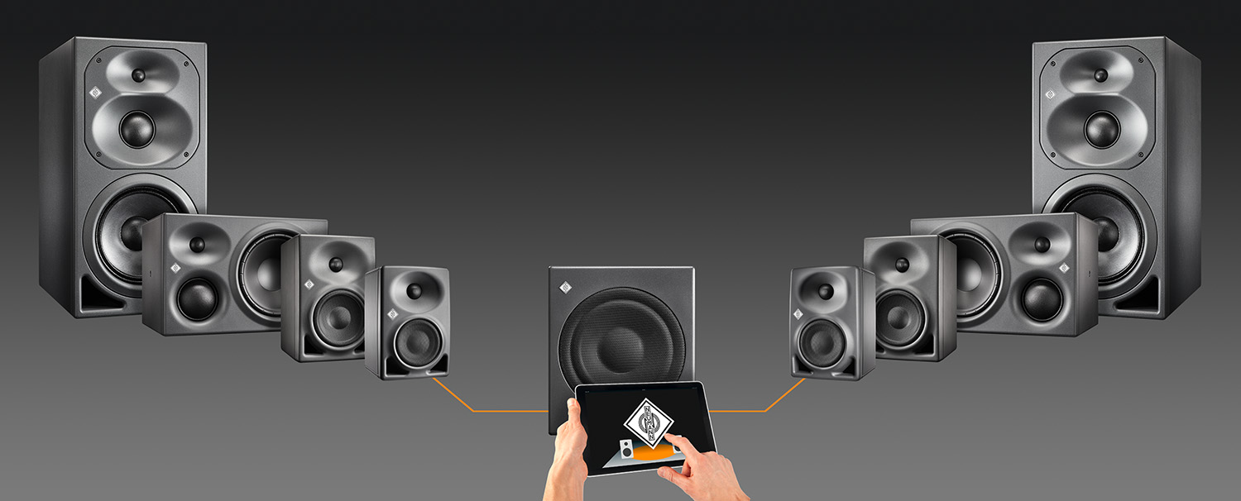

Neumann has greatly enhanced the features of the KH 750 DSP subwoofer, which was launched in 2019, with the release of the latest version of the Neumann.Control iPad® app (version 3.0).

The “Guided Alignment” and “Manual Alignment” functions that allow for easy acoustic adjustment to the room now not only work with KH 80 DSP near-field monitors, but also in stereo setups with all other Neumann KH Line monitors (KH 120/310/420). Simply connect these monitors to the stereo outputs of the KH 750 DSP subwoofer and, in conjunction with the iPad® app, they can now also benefit from its DSP power. In this way, the KH 750 DSP can now serve as the intelligent control center of every Neumann stereo setup.

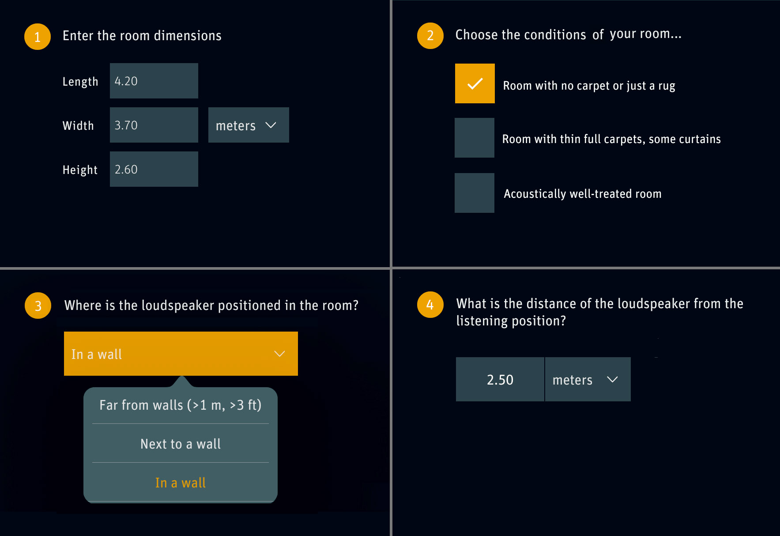
“Guided Alignment” is a patented wizard where you are asked simple questions about the room and the loudspeaker/subwoofer position and the app adjusts the response of each loudspeaker/subwoofer accordingly.

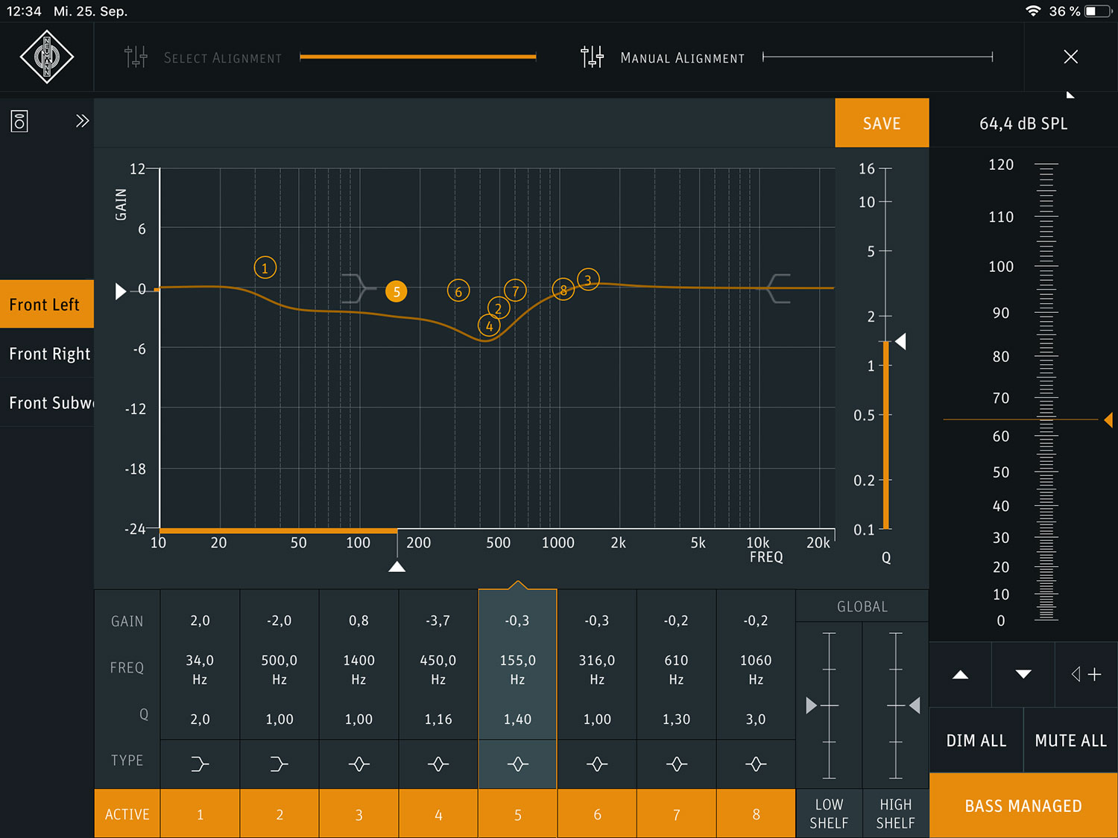
With “Manual Alignment” expert users have complete freedom to adjust an 8-band fully parametric equalizer, levels and the time-of-flight delay in each loudspeaker or subwoofer as they wish. “Manual Alignment” can also be used to edit Guided Alignments in a more detailed way.

Furthermore, this configuration offers the following advantages:
- Individual X-Over optimization between the subwoofer and the connected Neumann monitors, depending on the monitor model used.
- DSP-based phase linearization of the connected analog Neumann studio monitors for an even more transparent sound image.
- Use of the digital inputs (S/P-DIF and AES3) of the subwoofer for the entire system.
- Lip sync delay for the complete setup.

Further information at: https://en-de.neumann.com/kh-750-dsp-neumanncontrol

iPad® is a trademark of Apple Inc., registered in the U.S. and other countries.

Link to Photo and text material:
https://www.neumann.com/exchange/KH750-NeumannControl.zip

About Neumann
Georg Neumann GmbH, known as “Neumann.Berlin”, is the world’s leading manufacturer of studio microphones and the creator of recording legends including the U 47, M 49, U 67 and U 87. Founded in 1928, the company has been recognized with numerous international awards for its technological innovations. Since 2010, Neumann.Berlin has expanded its expertise in electro-acoustic transducer design to also include the studio monitor market, mainly targeting TV and radio broadcasting, recording, and audio productions. The first Neumann studio headphone was introduced at the beginning of 2019. Georg Neumann GmbH has been part of the Sennheiser Group since 1991, and is represented worldwide by the Sennheiser network of subsidiaries and long-standing trading partners. Website: www.neumann.com.
Press contact:
Andreas Sablotny
andreas.sablotny@neumann.com
T +49 (030) 417724-19

