Bag Raiders had Sennheiser on their Horizon

Sydney, 15 January 2020 - Australian electronic music duo, the Bag Raiders have chosen Sennheiser ahead of their tour across the United States, Australia and Asia for their new album release Horizons. The duo, Jack Glass and Chris Stracey, rose to fame in 2008, with their hit single “Shooting stars” which went triple platinum and made the top 20 for Triple Js hottest 100. Over the years the pair have built their reputation for strong dance releases, firmly establishing themselves as one of the leading acts in Australia’s dance music scene. The new album, Horizons, features 12 electro-pop/house tunes that document their journey over the last 10 years since their debut self-titled album.

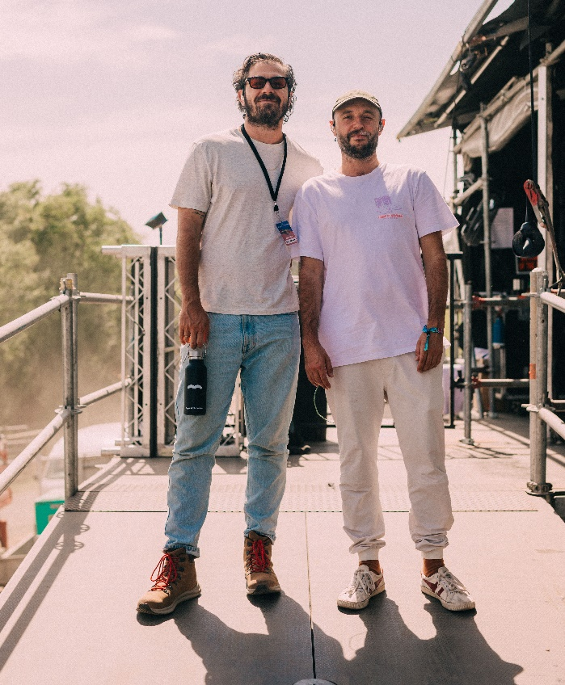 | The Bag Raiders, backstage at Beyond the Valley festival, on tour for the new Horizon album. Image from @liampethickphoto

The boys have been using Sennheiser equipment since they first started out, with Jack stating, “We’ve used Sennheiser since our very first live show way back in the day. It’s great for us to be aligned with a brand we already know and love”. Both Glass and Stracey were already using HD 25s for DJing as well as HD 650s as studio headphones so expanding on their gear with Sennheiser was a natural progression.

In the lead up to the Horizon Tour the team were looking to revamp their live gear. With guidance from the local Sennheiser Australia team the duo have chosen the 5000 series from Sennheiser’s professional wireless range for their vocals, plus a selection of wired instrumental mics including the e901, e904, e614 and e914. Further the boys were also keen on upgrading theirs IEMs for use during live performance and chose the new EW IEM G4 kits, which Jack commended saying, “Upgrading to the new packs has made a big difference to our ears”.

Chris Stracey performing live at Beyond the Valley with the Sennheiser SKM 5200-II and MD 5235 dynamic microphone capsule. Image from @liampethickphoto

To check tour dates and to discover more about the Bag Raiders visit: https://www.bagraiders.com/

About Sennheiser
Shaping the future of audio and creating unique sound experiences for customers – this aim unites Sennheiser employees and partners worldwide. Founded in 1945, Sennheiser is one of the world’s leading manufacturers of headphones, microphones and wireless transmission systems. With 21 sales subsidiaries and long-established trading partners, the company is active in more than 50 countries and operates its own production facilities in Germany, Ireland, Romania and the USA. Since 2013, Sennheiser has been managed by Daniel Sennheiser and Dr. Andreas Sennheiser, the third generation of the family to run the company. In 2017, the Sennheiser Group generated turnover totaling €667.7 million. www.sennheiser.com
Press Contacts

Sennheiser Australia & New Zealand Hausmann
Heather Reid Lauren Benson
Communications Manager Senior Consultant
T +61 (0)448 119 609 T: +61 (0)404 242 262
heather.reid@sennheiser.com lauren.benson@hausmann.com.au

