
bettergamingagency.prowly.com

Press release under embargo until November 21 at 7:30 PM CET / 6:30 PM UTC / 1:30 PM EST / 10:30 AM PST

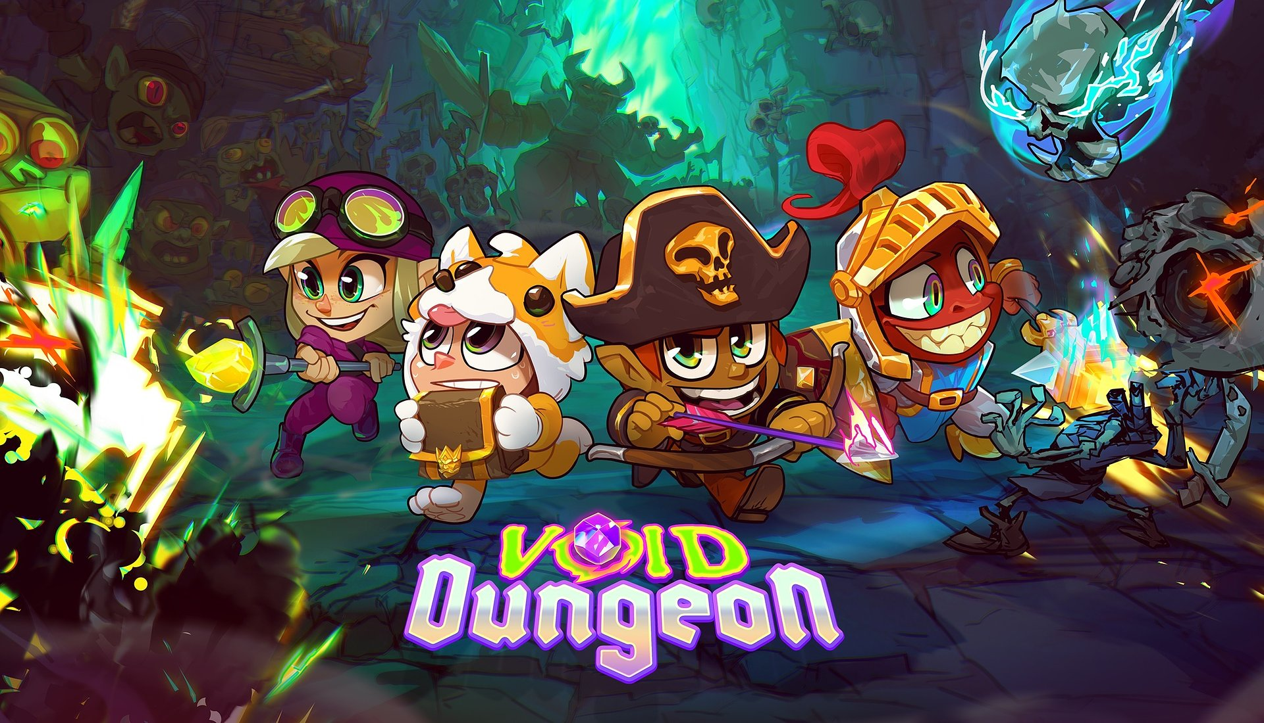

Void Dungeon – a hack and slash that hits with a blast from the past

Stay awhile and listen

Developers from the Polish studio TRIK Soft have officially announced Void Dungeon, a pixel action RPG, which will be released on PC next year on Steam, GOG and Epic Games Store. The game was announced during The MIX, accompanied by a special trailer offering a glimpse of what awaits those brave enough to venture into the dungeons.

Dungeons, monsters, and loot – Void Dungeon has everything that’s on the checklist of the hack and slash genre. Inspired by classics, the game takes players to a world full of magic and danger, where monsters lurking around every corner provide precious XP. Those seeking an old-school experience will feel right at home, like a certain wanderer in a certain cathedral, and the endgame activities in the open world will be so addictive, it’ll be hard to stop searching for more treasures.

Void Dungeon – check out the latest trailer
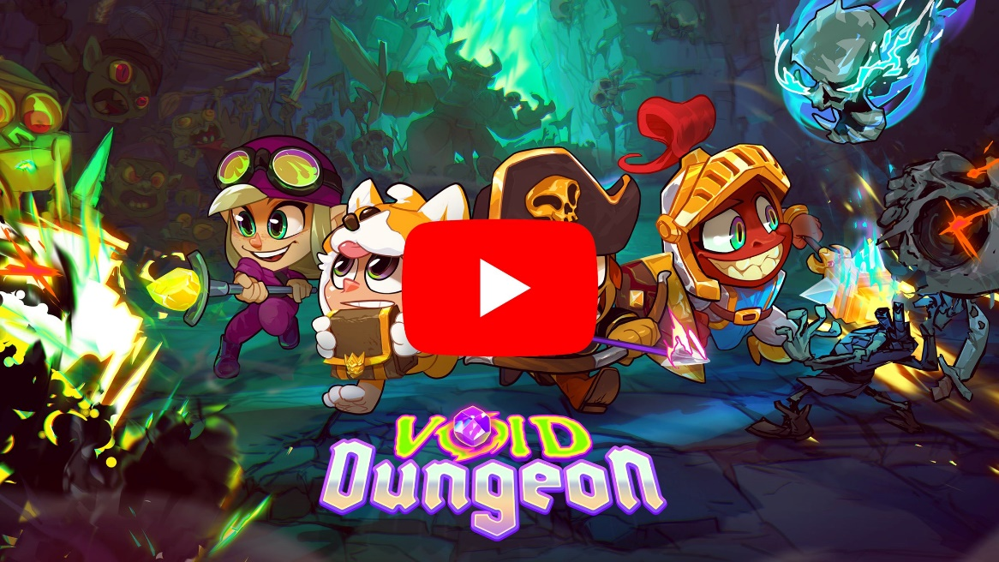
Youtube
https://youtube.com/embed/DtlAwvuse6M

Each hero brings their own unique strengths to the fight, and in Void Dungeon, you’ll shape your character’s journey from the very beginning. Choose between three distinct classes – knight, archer, or mage – and select one of eight races, each with its own passive bonuses. With a huge variety of equipment elements that alter your appearance (what’s stopping adventurers from wearing a spacesuit or an animal onesie?), consumables, and abilities, you’ll be ready to face hordes of enemies in the pixelated depths. The more monsters you defeat, the greater the rewards, so team up with friends in online co-op mode, where up to four players can join forces to battle the forces of evil.

Similar to other games in the genre, in Void Dungeon, the fun doesn't end after finishing the main campaign – it only gets better. Regularly updated events will challenge players, offering not only rewards, but also the opportunity to compete for a spot at the top of the leaderboards. Rifts, portals, and cursed towers – all of this awaits those who welcome the "just one more level" syndrome with arms wide open.

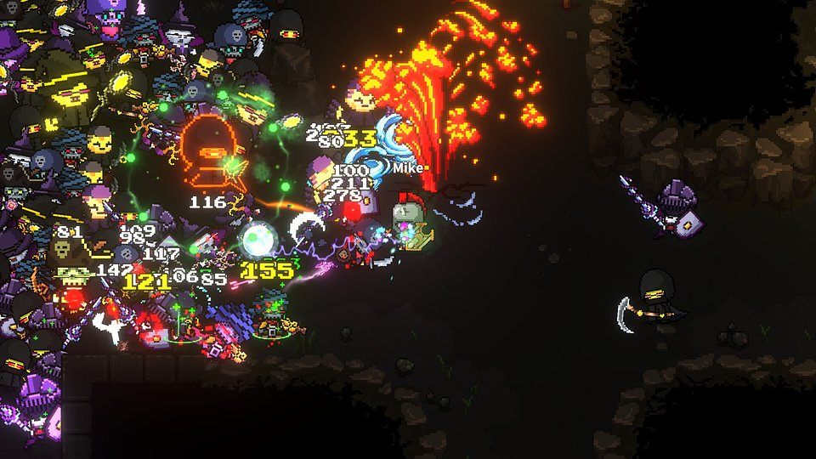

Because of these key features, Void Dungeon brings players into the depths:

⚔️ Back in the day… – Void Dungeon is a tribute to old-school hack and slash games and MMOs that a whole generation grew up on. The dynamic gameplay, combined with a satisfying progression system and endgame content, makes it difficult to pull yourself away from the next challenge.

⚔️ Gold for the bold – the wide range of available abilities and equipment means that defeating the toughest enemies and bosses will require the right strategy and proper planning. Every choice matters, and the key to success is skillfully matching your resources to the challenges lurking in the pixelated abyss.

⚔️ To be continued – the main campaign is just an introduction to the open world, where evil awaits around every corner. Endgame activities and special events will make it hard to leave Void Dungeon behind.

⚔️ Dream team – embark on an adventure with your friends in online cooperative multiplayer mode, where each team can include up to 4 players.

⚔️ You’ve got the vibe – if you’re going to spread evil, do it with style! Over 100 cosmetic items are waiting to be collected, allowing you to create a character that enemies will remember for a long time. Unless you kill them – then it’s just for a short while.

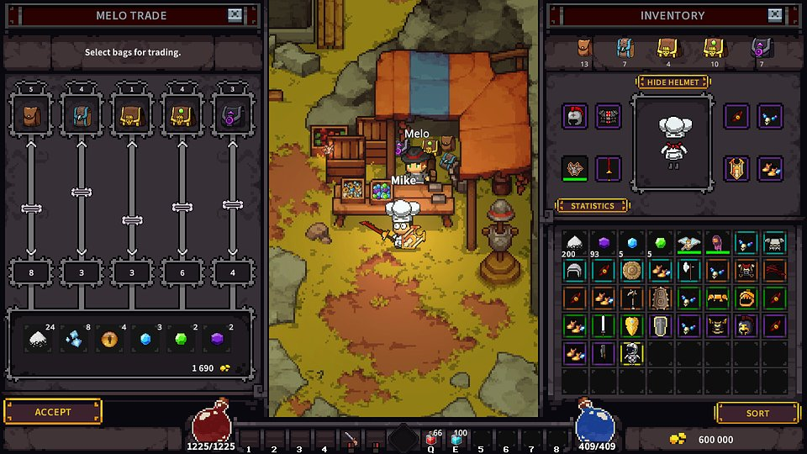

The release of Void Dungeon is scheduled for 2025, and the game is being developed for PC. Anyone interested in exploring pixel dungeons can already add the game to a wishlist on Steam, GOG and Epic Games Store.

To stay updated, follow the game's and studio's profiles on social media:

● Discord: Void Dungeon
● Twitter: Void Dungeon
● Twitter: TRIK Soft

The full press kit is available here.

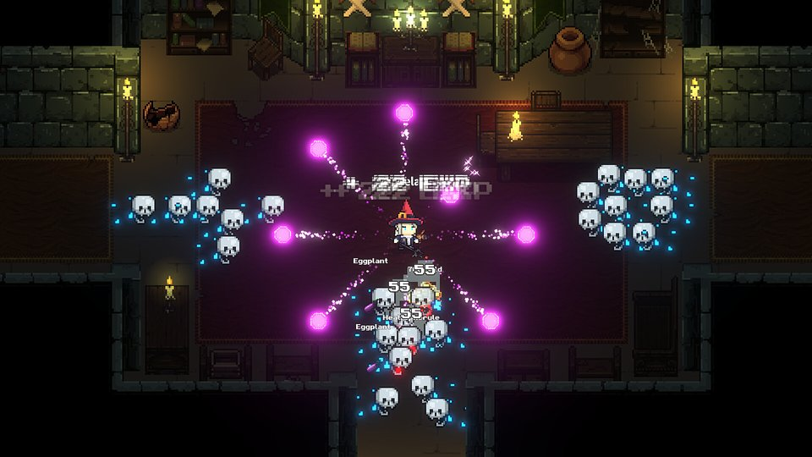

About TRIK Soft:

TRIK Soft is a small indie game studio that brings back the spirit of old-school challenges in the world of modern games. We are inspired by classic games from the 90s, where reflexes, precision and determination mattered. Our games are a nod to players who are looking for something more than just quick entertainment - with us, every victory must be fought for.

