Embargoed until January 16th, 2020

Introducing Subsequent 25
Today, Moog Music announces a new 2-note paraphonic synthesizer, the Subsequent 25, and debuts Building Your World, an animated film created by renowned graphic designer Julian House and scored by prolific producer Flying Lotus using Moog’s newest synth.

In the spirit of continuous improvement, Moog Music is transitioning production of the award-winning Sub Phatty analog synthesizer to make way for a new standard: the Subsequent 25. Implementing upgraded sonic modifications and functional improvements, the new Subsequent 25 becomes the standard production model moving forward.

Subsequent 25 builds on the success of its predecessor by implementing the ultra-popular paraphonic functionality of Duo Mode, upgrading to wood side pieces, and featuring the familiar Subsequent series of user-requested performance adjustments:

- Twice the headroom for access to a new range of classic clean tones in mono and duo modes.
- Reshaped gain staging in the Ladder Filter to boost harmonic saturation and analog compression, resulting in an overall richer low end.
- Re-tuned Multidrive circuit that extends well beyond the original grit and growl of the Sub Phatty.
- Upgraded keybed for improved playability.
- High-powered headphone amplifier strong enough to drive the most demanding headphones.

Building Your World
To illuminate the enhanced sonic vocabulary of the new Subsequent 25, Moog Music collaborated with prolific producer Flying Lotus and renowned graphic designer Julian House. The resulting film, Building Your World, animated by House and scored by Flying Lotus using the Subsequent 25, invites the viewer to slip into the mysterious and magical sci-fi world of analog circuits and waveforms.

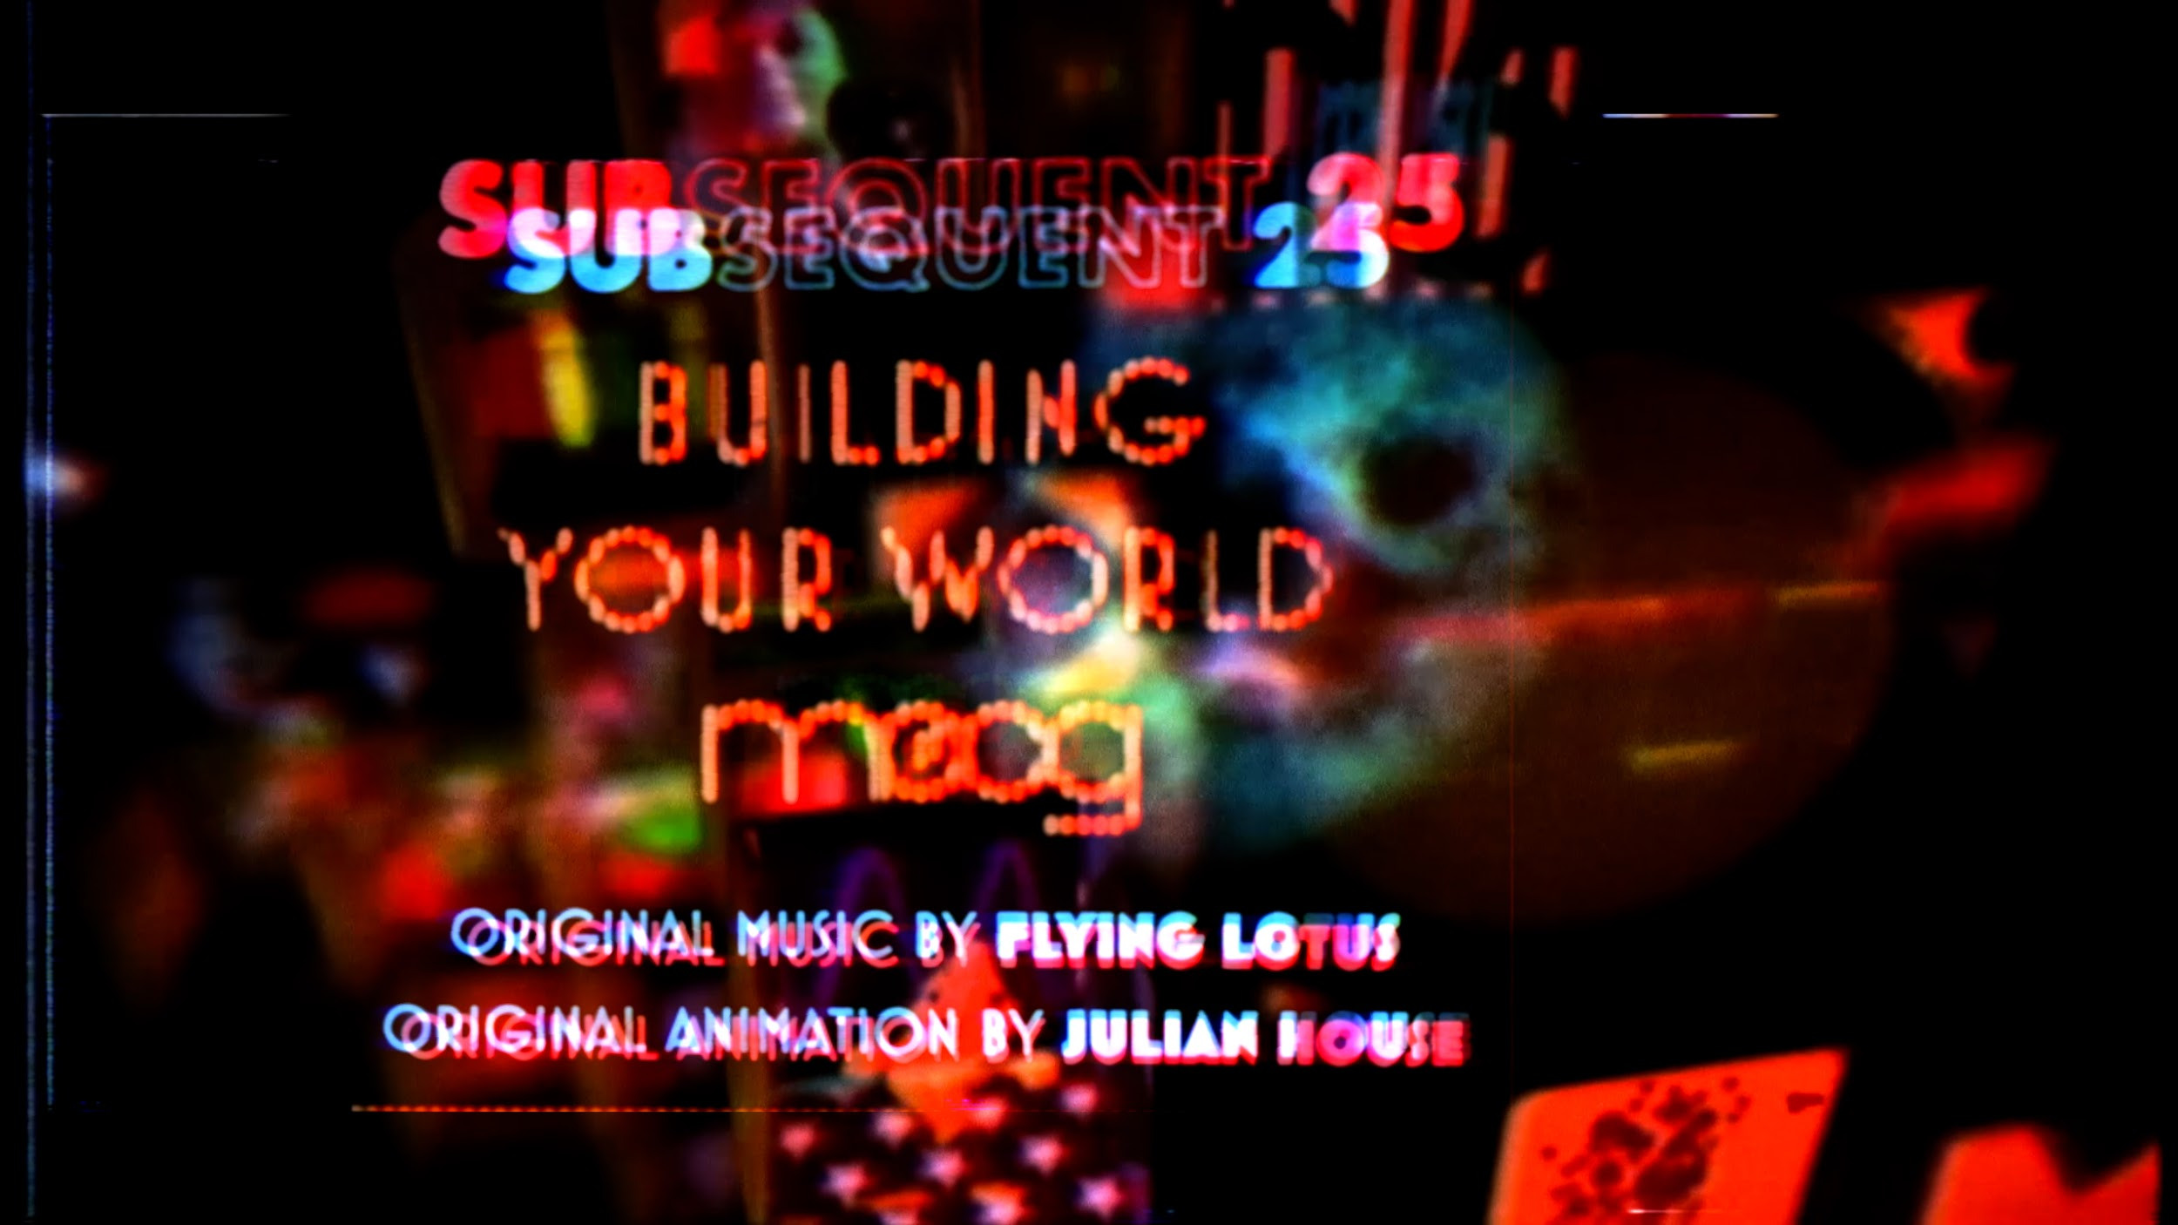

Building Your World brings the journey from Sub Phatty to Subsequent 25 full circle, evoking 2013’s New Machine For Living, the animated film scored by Flying Lotus to celebrate the release of the original Sub Phatty synthesizer.

Watch Building Your World Here.

Subsequent 25: Now Available For Order Worldwide
Built with love by the employee-owners at Moog, Subsequent 25 production is in full swing at the Moog Factory in Asheville, NC. A number of dealers are already stocked with more shipments currently en route. Connect with an authorized Moog Dealer today to place an order for Subsequent 25 and receive the earliest possible shipment: www.moogmusic.com/dealers.

About Subsequent 25
Subsequent 25 is a 2-note paraphonic analog synthesizer that melds the hands-on analog soul of classic Moog instruments with the convenience and workflow of a modern sound-design machine. Moog’s most compact keyboard synthesizer, the Subsequent 25 delivers all of the rich sonic density that Moog synthesizers are known for.
Attain instant gratification with immediate access to expertly programmed preset patches that will have you creating right away, then explore the knob-per-function front panel to create something completely unique. Set yourself apart by designing your own library of signature analog sounds, then save and recall an infinite number of patches with the free Subsequent 25 Editor/Librarian Software.

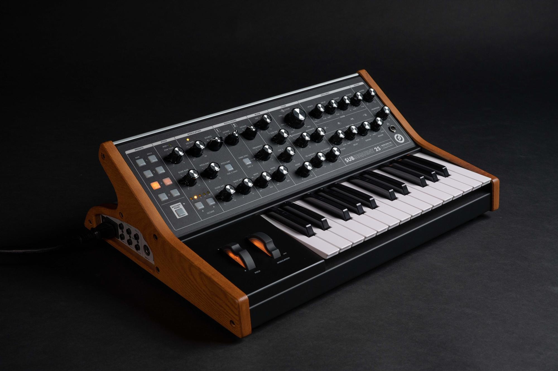

Dial up ground-shaking analog bass by stacking Oscillators in Unison Mode, or engage the new Duo Mode to split Oscillators 1 and 2, opening new doors of musicality by playing two different notes at once. Trigger the Subsequent 25’s analog sound engine any way you like – by integrating with other voltage-controlled analog gear via four onboard CV inputs, by interfacing with your favorite DAW using DIN & USB MIDI, or go fully manual with the ultra playable fast-action keybed.

Subsequent 25’s analog filter section contains the transformative Multidrive circuit, a unique combination of OTA distortion and FET drive – which acts as a key spark plug for the compact synthesizer’s powerful sound. Through the creative use of the Mixer Section (with expanded headroom), Ladder Filter, and Multidrive circuit, a wide range of classic analog colors and aggressive modern tones can be achieved.

Designed for portability, Subsequent 25 is the most agile full-size Moog synthesizer, equally reliable moving from stage to studio and every stop in between. Subsequent 25’s compact footprint fits into any situation and won’t overtake your studio desk – yet still fills any room with powerful synth bass, dynamic analog percussion, and harmonic-rich leads.

Balancing classic analog sound design with seamless integration into modern digital workflows and DAW environments, the Subsequent 25 features a full MIDI implementation, allowing MIDI automation and recall of all front panel and under-the-hood synthesis parameters.

Subsequent 25 is a versatile new instrument for unique sonic expression and realizing artistic vision. With its streamlined interface and sound design flexibility, this dynamic synthesizer fuses a revolutionary connection between human and machine, opening portals to new musical experiences.

Learn more at https://www.moogmusic.com/products/subsequent-25-0

Subsequent 25 Asset Links

Subsequent 25 | Product Description

Subsequent 25 | Sound Samples

Subsequent 25 | Photo Assets

Subsequent 25 Product & Beauty Photos

Subsequent 25 Detail & Studio Photos

Subsequent 25 Build Photos

