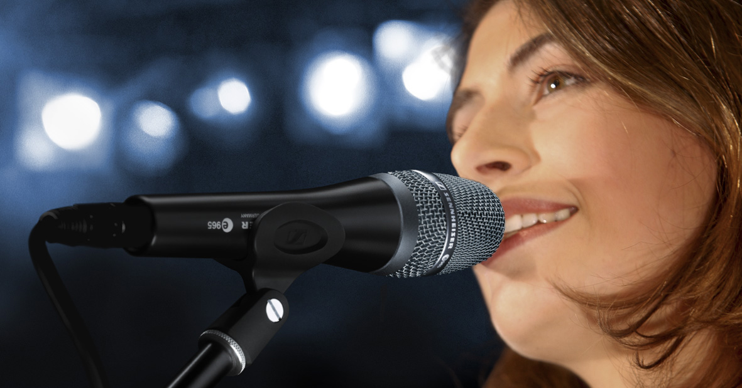

Sennheiser concludes anniversary promotions with top-of-the-range e 965

The switchable-pattern vocal mic is ideal for the stage and the studio

Sydney/Wedemark, 1 December 2020 – A truly exceptional offer for a truly exceptional microphone concludes Sennheiser’s anniversary promotions in December: The evolution e 965 is a large-diaphragm, true condenser handheld microphone that brings studio sound to the stage, and can be switched between a cardioid pick-up pattern and the tighter super-cardioid pattern. In December, the e 965 is available at the anniversary price of just $499.00 AUD / $579.00 NZD instead of $969.00 AUD / $1,109.00 NZD while stocks last. Please visit www.sennheiser.com/special-deals for a list of dealers offering this special promotion.

The e 965 leaves nothing to be desired in terms of sound, ruggedness and handling. The flagship model of the evolution series combines the advantages of a high-end studio microphone and those of a rugged stage mic: It offers a detailed, high-resolution sound while ensuring high feedback rejection and offering the rugged design needed for the tough demands of stage work.

The sophisticated sound of the e 965 true condenser microphone succeeds in being both balanced and powerful at the same time. The microphone gives vocals a silky sparkle in the treble and reproduces the lower mids in a warm yet well-defined manner. The microphone features fast transient response and captures even the finest nuances with rich detail. Its shock-mounted capsule excellently rejects handling noise.

Available as a special offer while stocks last: the e 965 is Sennheiser’s anniversary deal for the month of December

Depending on the stage situation, the pick-up pattern of the evolution e 965 can be switched between (gentler) cardioid and (more direct) super-cardioid. Switchable low-cut and pre-attenuation (-10dB pad), and pop and wind protection round off a truly exceptional microphone.

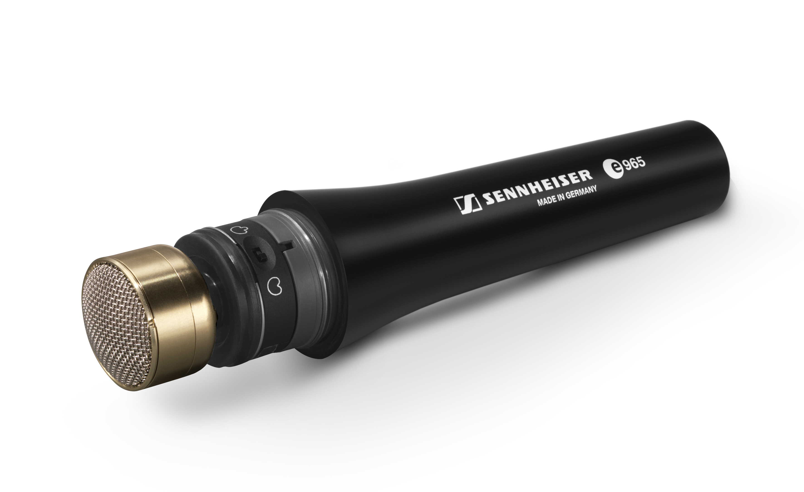 | Thanks to a dual diaphragm, the e 965 can be switched between cardioid and super-cardioid patterns

The images accompanying this press release can be downloaded at https://sennheiser-brandzone.com/c/181/vvfv5GSc.

About Sennheiser
Founded in 1945, Sennheiser is celebrating its 75th anniversary this year. Shaping the future of audio and creating unique sound experiences for customers – this aim unites Sennheiser employees and partners worldwide. The independent family company, which is managed in the third generation by Dr. Andreas Sennheiser and Daniel Sennheiser, is today one of the world’s leading manufacturers of headphones, loudspeakers, microphones and wireless transmission systems. In 2019, the Sennheiser Group generated turnover totaling €756.7 million.
www.sennheiser.com

Press Contact

Gabby Wallace
gabby.wallace@groundagency.com
0431 045 932

